  LUNES | MARTES | MIERCOLES | JUEVES | VIERNES | SABADO | DOMINGO
 |  |  |  | 1 | 2 | 3
4 | 5 | 6 | 7 | 8 | 9 | 10
11 | 12 | 13 | 14 | 15 | 16 | 17
18 | 19 | 20 | 21 | 22 | 23 | 24
25 | 26 | 27 | 28 | 29 | 30 | 31

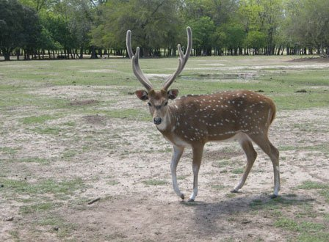

LUNES | MARTES | MIRCOLES | JUEVES | VIERNES | SABADO | DOMINGO
1 | 2 | 3 | 4 | 5 | 6 | 7
8 | 9 | 10 | 11 | 12 | 13 | 14
15 | 16 | 17 | 18 | 19 | 20 | 21
22 | 23 | 24 | 25 | 26 | 27 | 28

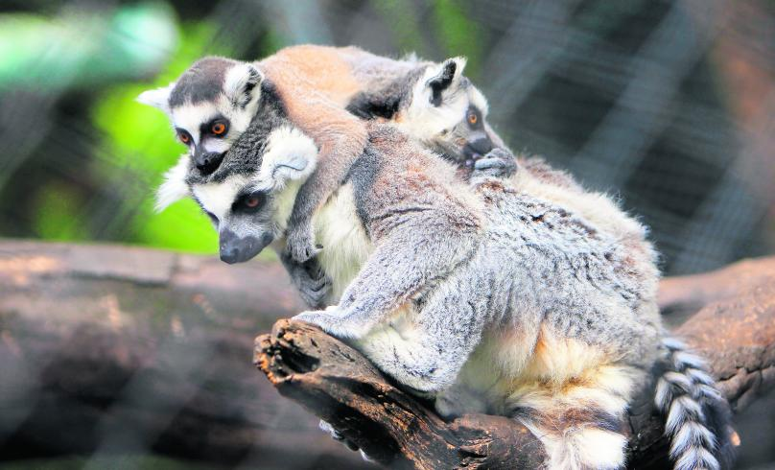  LUNES | MARTES | MIERCOLES | JUEVES | VIERNES | SABADO | DOMINGO
1 | 2 | 3 | 4 | 5 | 6 | 7
8 | 9 | 10 | 11 | 12 | 13 | 14
15 | 16 | 17 | 18 | 19 | 20 | 21
22 | 23 | 24 | 25 | 26 | 27 | 28
29 | 30 | 31

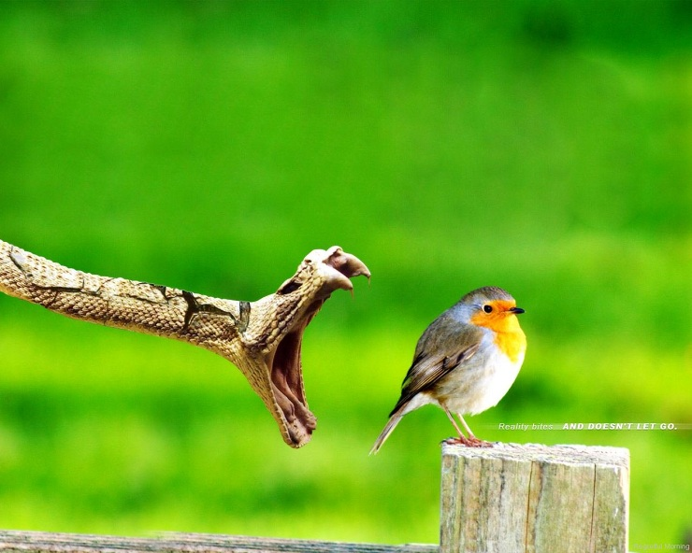  LUNES | MARTES | MIERCOLES | JUEVES | VIERNES | SABADO | DOMINGO
 |  | 1 | 2 | 3 | 4 | 5
6 | 7 | 8 | 9 | 10 | 11 | 12
13 | 14 | 15 | 16 | 17 | 18 | 19
20 | 21 | 22 | 23 | 24 | 25 | 26
27 | 28 | 29 | 30

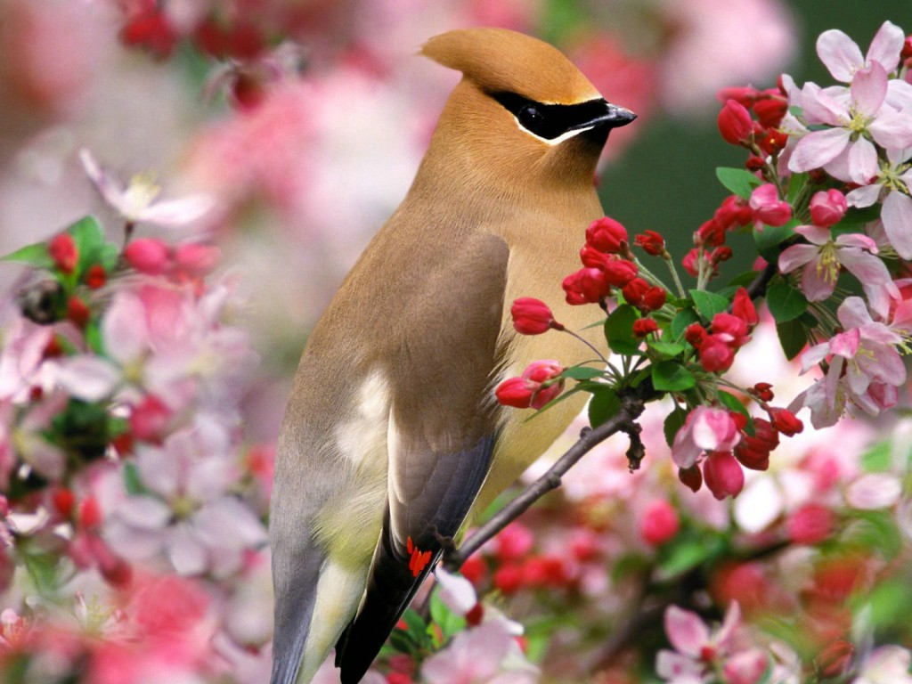  LUNES | MARTES | MIERCOLES | JUEVES | VIERNES | SABADO | DOMINGO
 |  |  |  | 1 | 2 | 3
4 | 5 | 6 | 7 | 8 | 9 | 10
11 | 12 | 13 | 14 | 15 | 16 | 17
18 | 19 | 20 | 21 | 22 | 23 | 24
25 | 26 | 27 | 28 | 29 | 30 | 31

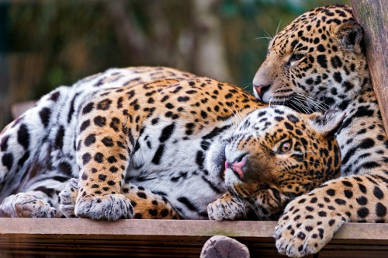  LUNES | MARTES | MIERCOLES | JUEVES | VIERNES | SABADO | DOMINGO
 | 1 | 2 | 3 | 4 | 5 | 6
7 | 8 | 9 | 10 | 11 | 12 | 13
14 | 15 | 16 | 17 | 18 | 19 | 20
21 | 22 | 23 | 24 | 25 | 26 | 27
28 | 29 | 30

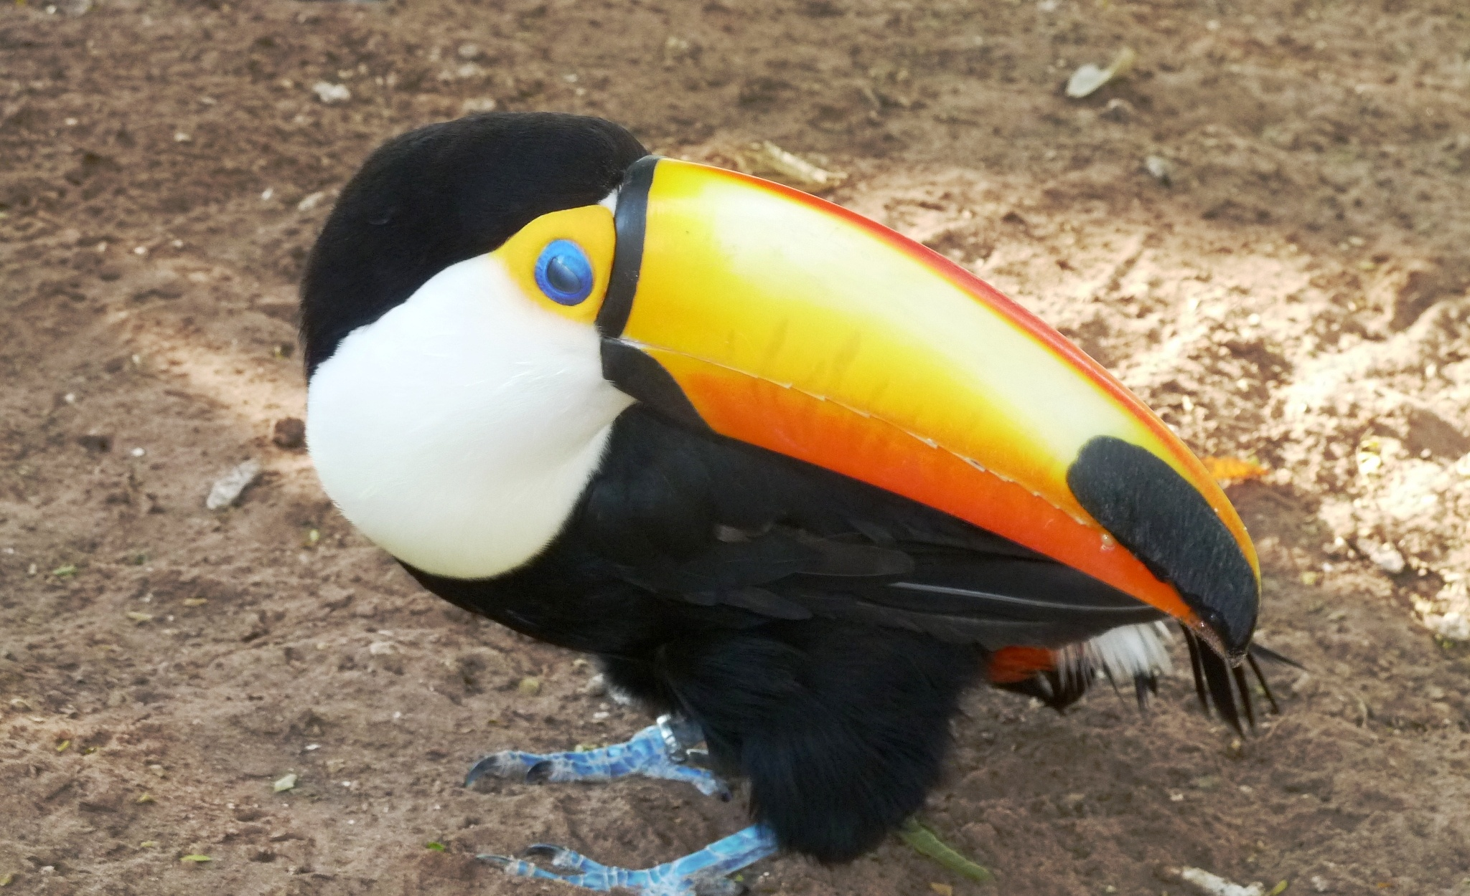  .lunes | MARTES | MIERCOLES | JUEVES | VIERNES | SABADO | DOMINGO
 |  | 1 | 2 | 3 | 4 | 5
6 | 7 | 8 | 9 | 10 | 11 | 12
13 | 14 | 15 | 16 | 17 | 18 | 19
20 | 21 | 22 | 23 | 24 | 25 | 26
27 | 28 | 29 | 30 | 31



lunes | martes | miercoles | jueves | viernes | sabado | domingo
 |  |  |  |  |  | 1
2 | 3 | 4 | 5 | 6 | 7 | 8
9 | 10 | 11 | 12 | 13 | 14 | 15
16 | 17 | 18 | 19 | 20 | 21 | 22
23 | 24 | 25 | 26 | 27 | 28 | 29
30 | 31

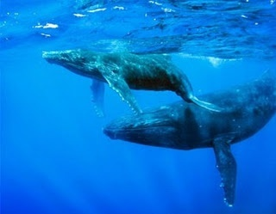

lunes | martes | miercoles | jueves | viernes | sabado | dominngo
 |  | 1 | 2 | 3 | 4 | 5
6 | 7 | 8 | 9 | 10 | 11 | 12
13 | 14 | 15 | 16 | 17 | 18 | 19
20 | 21 | 22 | 23 | 24 | 25 | 26
27 | 28 | 29 | 30

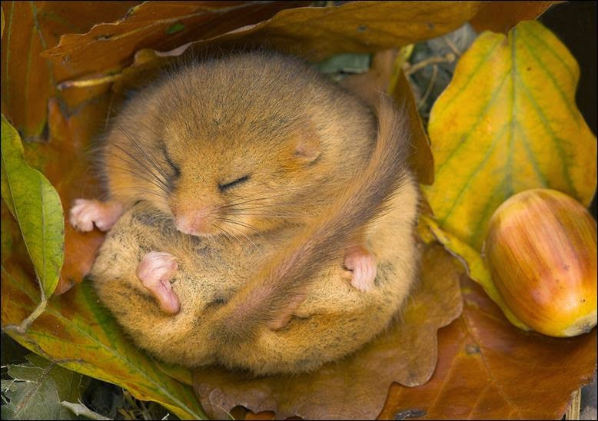

lunes | martes | mircoles | jueves | viernes | sabado | Domingo
 |  |  |  | 1 | 2 | 3
4 | 5 | 6 | 7 | 8 | 9 | 10
11 | 12 | 13 | 14 | 15 | 16 | 17
18 | 19 | 20 | 21 | 22 | 23 | 24
25 | 26 | 27 | 28 | 29 | 30 | 31

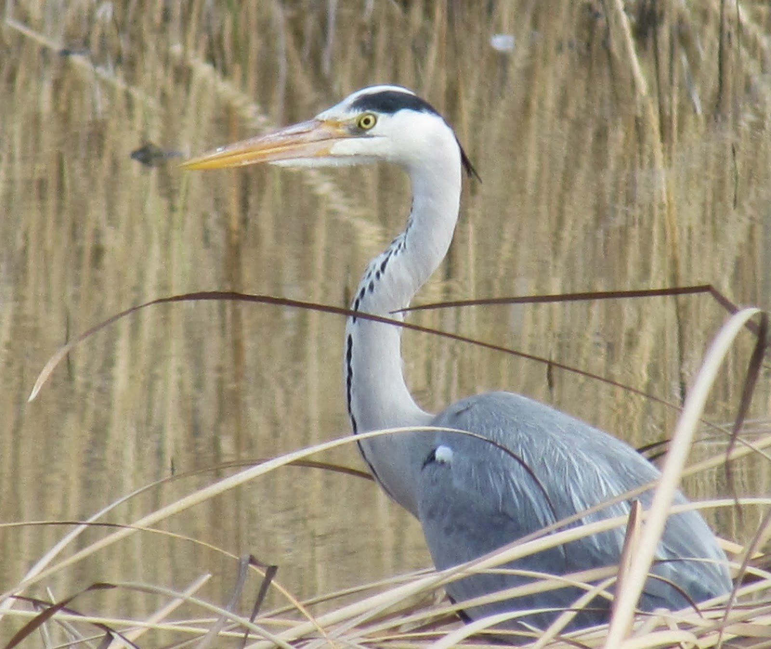

lunes | martes | miercoles | jueves | viernes | sabado | domingo
1 | 2 | 3 | 4 | 5 | 6 | 7
8 | 9 | 10 | 11 | 12 | 13 | 14
15 | 16 | 17 | 18 | 19 | 20 | 21
22 | 23 | 24 | 25 | 26 | 27 | 28
29 | 30

lunes | Martes | miercoles | jueves | viernes | sabado | domingo
 |  | 1 | 2 | 3 | 4 | 5
6 | 7 | 8 | 9 | 10 | 11 | 12
13 | 14 | 15 | 16 | 17 | 18 | 19
20 | 21 | 22 | 23 | 24 | 25 | 26
27 | 28 | 29 | 30 | 31


