Artifact Box Amy Hoffmeister
Tigris River Civilization
Grade: 6
Strand: History
Topic: Early Civilizations
Content Statement: #2: Early civilizations (India, Egypt, China and Mesopotamia) with unique governments, economic systems, social structures, religions, technologies and agricultural practices and products flourished as a result of favorable geographic characteristics. The cultural practices and products of these early civilizations can be used to help understand the Eastern Hemisphere today.

Strand: Geography
Topic: Places and Regions
Content Statement: #5. Regions can be determined, classified and compared using various criteria (e.g., landform, climate, population, cultural, or economic).

Strand: Geography
Topic: Human Systems
Content Statement: #7: Political, environmental, social and economic factors cause people, products and ideas to move from place to place in the Eastern Hemisphere in the past and today.

Strand: Economics
Topic: Scarcity
Content Statement: #14. When regions and/or countries specialize, global trade occurs.

The Civilization
The Tigris River Civilization is located in present-day Iraq, which, in ancient times was called Mesopotamia. The Tigris River begins in the mountains of present-day Turkey, flows southeast and eventually meets up with the Euphrates. It is about 1,200 miles long. The land between these two rivers is often called the Fertile Crescent because of its rich soil and the ability to produce abundant crops. The Tigris River Civilization began in 5000 BC and is considered the oldest ancient civilization. It ended in the 6th century BC, which is sometime between 600 BC and 501 BC. There were four major ruling groups during this time: Sumerians, Babylonians, Persians, and Assyrians.
Agriculture and trade were a major part of the economy of Mesopotamia. Many people who lived there were nomads, traveling from place to place frequently. The majority of those who worked were farmers, due to the rich soil of the Fertile Crescent. The people of the Tigris River Civilization were known for their metalwork, woolen textiles, and pottery. Each town was said to be protected by a god, and their pyramid temples were believed to connect heaven and earth. For being such an ancient civilization, these people were surprisingly advanced. They created dikes to control the flooding of the river and irrigation canals. The artifacts found in this box are a map of the region, a cuneiform writing tablet with a reed to write, a piece of pottery, a wheel, and a sundried brick.

Map
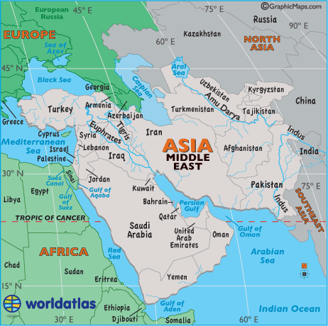http://www.worldatlas.com/webimage/countrys/meriv.htm
This is a map of the Tigris River
Civilization. It is an area known as Mesopotamia, in the present-day Middle East,
specifically Iraq. The Tigris River is east of the
Euphrates. It begins in the mountains fo
present day Turkey and flows southeast,
eventually meeting up with the Euphrates River
and emptying into the Persian Gulf.

The land between the two rivers is known as
the Fertile Crescent.

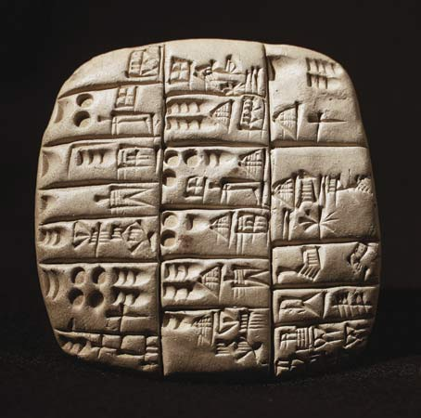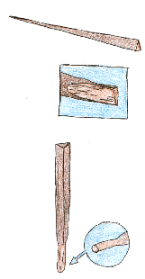
http://semiramis-speaks.com/wp-content/uploads/2012/06/Cuneiform-Writing-on-Tablet.jpg
http://www.richeast.org/htwm/cune/cune.html
Cuneiform
Writing originated in the region of Mesopotamia. Residents pressed reeds into clay in order to form the characters. The characters are made up mostly of wedges and lines. Some characters can have up to four meanings and they usually represent a whole word, number, idea, but more often just a syllable.
The characters began more as pictographs, but eventually became more abstract, as it was easier to make straight lines, wedges, and circles with the reed, rather than the curved lines needed in a pictograph.

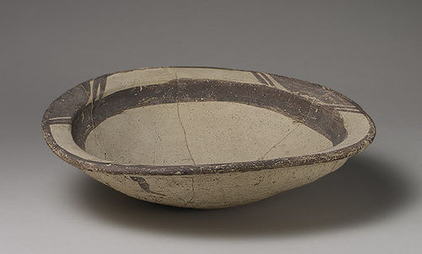http://www.metmuseum.org/toah/hd/ubai/hd_ubai.htm
Pottery
Pottery was an important part of
Mesopotamian life, as it was used for cooking
and storing food and water. It was made in a fairly advanced way, using a potter’s wheel, as early as 3000 BC. Pottery was often traded for
food, clothing, and jewelry.

Wheel
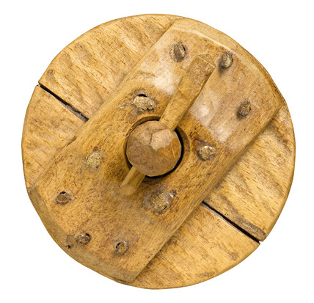http://www.ssplprints.com/image/133856/chariot-wheel-probably-c-2000-bc
The people of the Tigris River Civilization are given credit for the invention of the wheel, although this is sometimes still under debate. The first wheel was discovered 3000 years ago. It was originally used by potters and weavers, before being used to assist with transportation needs. The wheel was then used with chariots in Mesopotamia. The first wheels did not have spokes, rather, they were simply discs of wood.

Sundried Brick
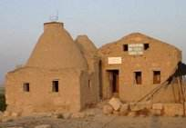http://mesopotamiadiv1.wikispaces.com/Architecture
The majority of houses in the Tigris River Civilization were made out of sundried brick. These rectangular bricks were made out of mud and set to dry in the sun. They were plastered together using more mud. Most houses were built with a square center with rooms coming off of it. Usually, whoever was going to live in the house, built it, and there were many variations in size.
Sundried mud bricks were also used to build the ziggurats, which were a type of temple built by the
Sumerians with a tiered appearance on the outside

Each artifact aligns with a theme of geography.

1) Location: the map of the region shows the absolute location of the Tigris River. However, we can also use it to show relative location, when mentioning how it is connected to the Euphrates River and the civilization that developed in between these two rivers.

2) Place: although the Cuneiform writing system does not fall specifically under the topic of place, people associate the invention of writing with the region of Mesopotamia. The Mesopotamians are known for inventing writing and they are probably most famous for this.

3) Human/Environment Interaction: the people of the Tigris River Civilization used the environment as a resource. Mud was plentiful and easy to find, and, therefore, became a useful resource in building houses. Their houses were fairly simplistic and did not take a toll on the environment.

4) Movement: although the wheel was initially used solely for making pottery and woven clothing, it eventually was used for transportation and helped people to get around much more easily. Before this invention, movement was primarily by foot or boat, because they were located on the river. Using wheels to aid in transportation greatly assisted the movement from place to place.

5) Regions this region is known for pottery. It was important to these people because they were able to store food and water. The pottery was often traded for goods, clothing, and jewelry. Also, the Mesopotamians were quite advanced, using a wheel to make their pottery.

Connections to Common Core
Integration and Knowledge of Ideas
7. Integrate visual information (e.g., in charts, graphs, photographs, videos, or maps) with other information in print and digital texts.

Students could create travel brochures of what to see when visiting this region. A requirement of the brochure would be a map that they would create, along with a description of specific places to visit or things to do. This relates to the following Common Core literacy standard for social studies grades 6-8:

Craft and Structure
4. Determine the meaning of words and phrases as they are used in a text, including vocabulary specific to domains related to history/social studies.

Students could create “River Civilization Dictionaries”. In these dictionaries, students could define words that they do not know, anytime they are doing reading on this topic. Included could be the word, the sentence it was found in, context clues to help them determine the meaning, the actual definition, and a picture to help them remember the word. For example, ziggurat might go in this dictionary, as it is probably a word they have never seen before.

Integration and Knowledge of Ideas
9. Analyze the relationship between a primary and secondary source on the same topic.

Students could look at primary source documents from the Mesopotamian, Tigris River Civilization period. They could compare these primary source documents to secondary source documents on the same topic. Perhaps they might fill out a graphic organizer or explain to a partner how they are similar or different.

References
Britton, P. (2013) Architecture. Time Maps. Retrieved from:
http://www.timemaps.com/civilization/Ancient-Mesopotamia#ss
Gascoigne, B. (2001). History of Writing. History World. Retrieved from:
http://www.historyworld.net/wrldhis/PlainTextHistories.asp?gtrack=pthc&Paragra phID=asf#asf
Invention of the Wheel. Science & Technology. Retrieved from:
http://library.thinkquest.org/C004203/science/science02.htm
Map of Middle East Rivers. World Atlas. Retrieved from:
http://www.worldatlas.com/webimage/countrys/meriv.htm.
The Use of Pottery. Arts & Culture. Retrieved from: http://library.thinkquest.org/C004203/art/art03.htm
Tigris/Euphrates River Valley Civilization. The River Valley Civilization Guide. Retrieved
from: http://www.rivervalleycivilizations.com/tigris-euphrates.php

