Morgan Gaus

Tigris River Valley Civilization

Ohio Academic Content Standards for Social Studies
Theme: Regions and People of the Eastern Hemisphere
- Strand: History
  - Topic: Early Civilizations
    - Content Statement 2: Early civilizations (India, Egypt, China, and Mesopotamia) with unique governments, economic systems, social structures, religions, technologies, and agricultural practices and products flourished as a result of favorable geographic characteristics. The cultural practices and products of these early civilizations can be used to help understand the Eastern Hemisphere today.
- Strand: Geography
  - Topic: Spatial Thinking and Skills
    - Content Statement 3: Globes and other geographic tools can be used to gather, process and report information about people, places, and environments. Cartographers decide which information to include and hot it is displayed.
  - Topic: Places and Regions
    - Content Statement 5: Regions can be determined, classified and compared using various criteria (e.g., landform, climate, population, cultural, or economic).
  - Topic: Human Systems
    - Content Statement 6: Variations among physical environments within the Eastern Hemisphere influence human activities. Human activities also alter the physical environment.
- Strand: Government
  - Topic: Roles and Systems of Government
    - Content Statement 10: Governments can be categorized as monarchies, theocracies, dictatorships, or democracies, but categories may overlap and labels may not accurately represent how governments function. The extent of citizens’ liberties and responsibilities varies according to limits on governmental authority.
- Strand: Economics
  - Topic: Scarcity
    - Content Statement 13: The fundamental questions of economics include what to produce, how to produce and for whom to produce.
    - Content Statement 14: When regions and/or countries specialize, global trade occurs.

Introduction
Mesopotamia is the ancient region of southwestern Asia, which is present day Iraq. Its central area lay between the Tigris and Euphrates rivers, which extend into today’s Syria and Turkey. The Tigris River Civilizations have had a great impact on the culture of the people living on the land today.
In the artifact box you will find objects, which represent many ideas within the Tigris River Civilizations, such as soap, a writing tool, soil, the social structure pyramid,

Communication
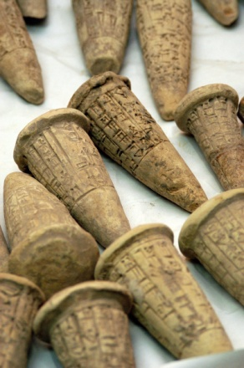
Artifact: Writing Tool (Cuneiform)
Mesopotamian people discovered a system of writing known as Cuneiform Script. This is one of the earliest known forms of writing. The cuneiform was a triangular-tipped stylus used to make wedge-shaped impressions in soft clay. This specific writing system was in place for more than 22 centuries.

Social Structure
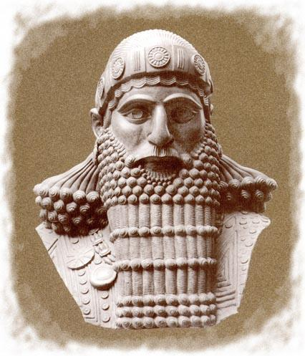
Artifact: Pyramid of Importance
The social structure of the Tigris River Valley Civilization was comprised of thee main groups: The nobles, commoners, and the slaves. The commoners worked farmers, merchants, and crafts people. The slaves worked in building development and they belonged to the palace officials.

Technologies
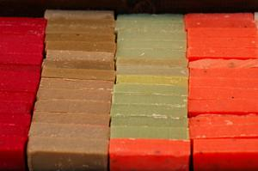
Artifact: Soap
The people of Mesopotamia were the first known chemists in the world. They were credited with the discovery of soap using different combinations of chemicals that when put together make soap, as well as, other remedies. People did not use soap for hygiene, but rather used it for cleaning cooking utensils, goods, and for medical purposed.

Agriculture
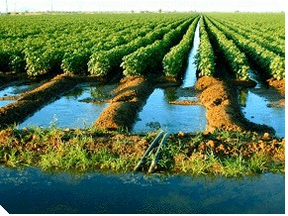
Artifact: Soil
Although there was a very low amount of rainfall each year, the soil in the area was extremely rich due to the Tigris River delivering nutrients via canals. The soil was also rich because there were layers of silt, which was deposited over many years. Due to the richness of the soil, 90% of Mesopotamian people were farmers and produced goods for their own benefit, as well as, for trade.

Religion
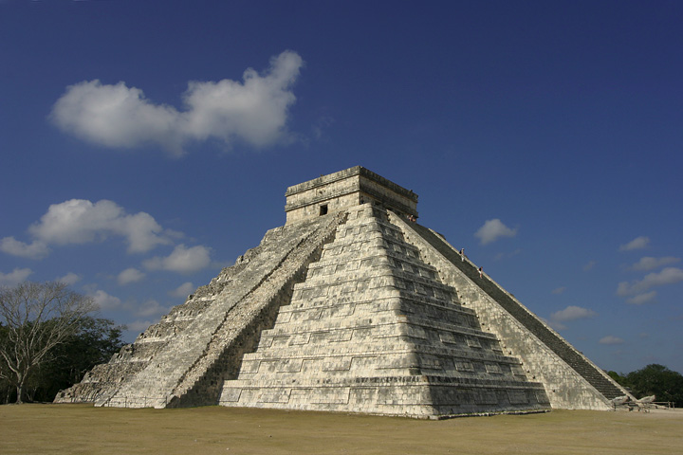
Artifact: Pyramid Temple
The Mesopotamian people believed that the pyramid temples connected heaven and earth. They believed a different god protected each town and the religious events were held at the pyramid since they could be connected to heaven. Mesopotamian people looked to religion to answer their questions about life and death, good and evil, and the forces of nature. The believed in four all-powerful gods that created and controlled the universe: An (the god of heaven), Enlil (the god of air), Enki (the god of water) and Ninhursag (the mother earth goddess).

Incorporation of Common Core:
CCSS.ELA-Literacy.RH.6-8: Cite specific textual evidence to support analysis of primary and secondary sources.
CCSS.ELA-Literacy.RH.6-8: Determine the central ideas or information of a primary or secondary source; provide an accurate summary of the source distinct from prior knowledge or opinions.
To incorporate project-based learning, as well as, English Language Arts standards, it would be interesting to break students up into groups of four and allow them to create their own River Valley Civilization based on what has been learned in the classroom. You could incorporate research standards and allow students to search the internet for ideas in creating their own civilization. You could provide students with a rubric that shows the ideas that must be included in their civilization (and incorporate each of the strands within Regions and People of the Eastern Hemisphere.

Resources
“Tigris/Euphrates River Valley Civilization.” The River Valley Civilization Guide. Web. 12 July 2013. < http://www.rivervalleycivilizations.com/tigris-euphrates.php>

“The River Valley Civilizations.” Web. 12 July 2013. < http://www.slideshare.net/MrKeatley/the-river-valley-civilizations>

“History of Soap and Soap Interesting Facts.” Web. 13 July 2013. < http://www.soaphistory.net/>

