
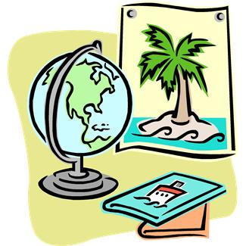
ATTENTION! Your help is needed! The local travel agency had a fire and lost many of their maps. They are recruiting you to recreate their travel brochures for the region of Mesopotamia to give to customers. They are in need of your expert knowledge about Mesopotamian life and culture, in order to make recommendations for tourists traveling to this region.
In your brochure, you must include the following:
1) A map of the region, labeling:
- the Tigris and Euphrates River
- the area known as the Fertile Crescent
- at least 2 ancient cities: Babylon, Ur, Uruk, Nineveh, etc.
2) How will you read the signs when you are traveling to Mesopotamia
3) The transportation you will be taking
4) The type of accommodations you will be staying in
5) The type of money you will use to trade for goods and food
6) The typical weather of the region
7) At least 3 activities you can participate in while you are there
Because this is a brochure, your descriptions do not need to be long, but they do need to incorporate facts and information you have gathered throughout this unit.
Additional Requirements:
- At least 3 citations and 3 facts from the information gathered during the unit.
- A one-paragraph insert that will be put in your brochure, explaining why they location of the river is so important to civilization. Connect it to the information in your brochure.
HAVE FUN!

