Astrobiology As an Illustration of A New Model for Education
By Joe Novak
December 15, 2004

This is a brief paper to sketch how the study of Astrobiology could be done much more dramatically and with far greater educational value than what is presented in a poster on the subject prepared by NASA. The paper builds on what Alberto Canas and I have been calling a New Model for Education (Canas and Novak, 2004). Briefly, we propose in this model that the use of the capabilities of CmapTools with small groups collaborating to build a complex Concept Map artifact, using the Internet and other resources. I shall illustrate how this could be done in the area of Astrobiology.

Figure 1 shows the general model of The New Model, where various activities usually done in schools can be integrated into a veritable
”portfolio” of texts, images, videos, URL’s, etc. using the capapbilities of CmapTools.
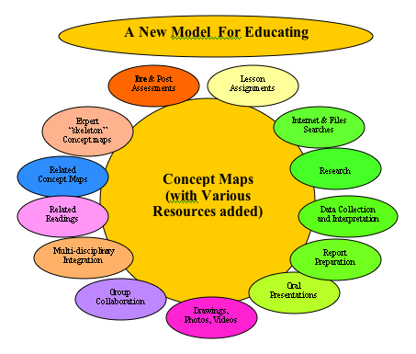
We see in Figure 1 above 13 different learning activities that can be integrated using CmapTools into a complex knowledge structure, preferably by 3-4- learner teeams cooperating in the work and discussing their progress. Any kind of material can be added to the scheme, perhaps beginning with a pretest on Astrobiology s shown in figure 2. Below
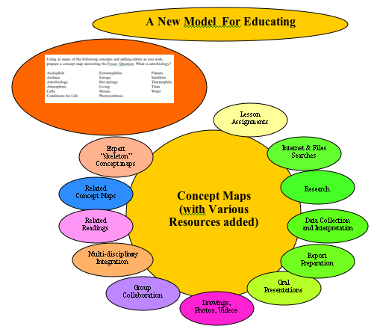
We might offer the use of what we have called an “expert skeleton” concept map to help the team get off on a solid footing. Figure 3 below shows an illustration of this:
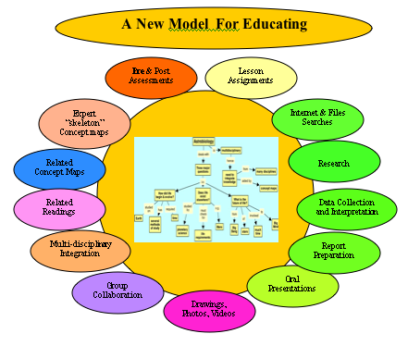
Using the “expert Skeleton concept map as a starting point, a team could add concepts and resources to this map, ioncluding resources such as the poster from NASA, and many other resources. This is illustrated in the figure below:
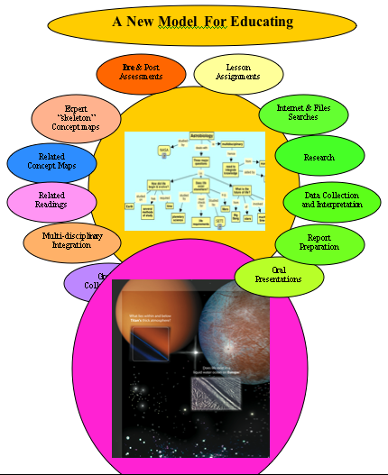
I think the above illustrations may suffice to give you the idea of how this New Model would work and the incredible potential for team learning, for archiving the product of the team’s work, and for bootstrappiong other teams. I would think this would be as useful to research teams as to learners in school settings.

