
G
R
U
P
--
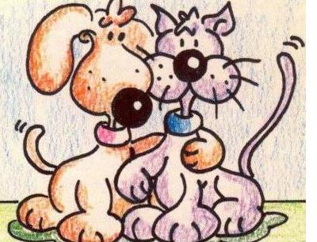

____________________ Data: _________
____________________
____________________
____________________

Dibuix o foto:
Dibuix o foto:

1.- Forma del cos _________________________________________
______________________________________________________
______________________________________________________

2.- Medi on viuen: ________________________________________
______________________________________________________
______________________________________________________
3.- Exemples: ___________________________________________
______________________________________________________
______________________________________________________

4.- Fotografies

