
G
R
U
P
--
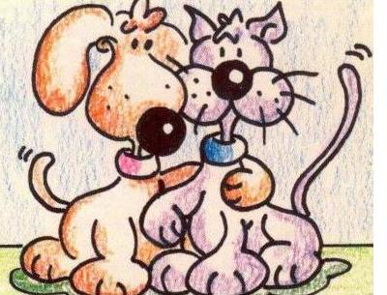

____________________ Data: _________
____________________
____________________
____________________

Dibuix o foto:
Dibuix o foto:

1.- Com tenen cobert el cos? ________________________________
______________________________________________________
______________________________________________________

2.- Extremitats: _________________________________________
______________________________________________________
______________________________________________________
3.- Temperatura: _________________________________________
______________________________________________________

4.- Reproducció: _________________________________________
______________________________________________________
______________________________________________________

1.- Respiració: ___________________________________________
______________________________________________________
______________________________________________________

2.- Medi on viuen: ________________________________________
______________________________________________________
______________________________________________________

3.- Exemples: ___________________________________________
______________________________________________________
______________________________________________________

4.- Fotografies

