Human Body Structure
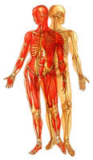
Human beings are arguably the most complex organisms on this planet. Imagine billions of microscopic parts, each with its own identity, working together in an organized manner for the benefit of the total being. The human body is a single structure but it is made up of billions of smaller structures of four major kinds:

Cells
Cells have long been recognized as the simplest units of living matter that can maintain life and reproduce themselves. The human body, which is made up of numerous cells, begins as a single, newly fertilized cell.

Tissues
Tissues are somewhat more complex units than cells. By definition, a tissue is an organization of a great many similar cells with varying amounts and kinds of nonliving, intercellular substance between them.

Organs
Organs are more complex units than tissues. An organ is an organization of several different kinds of tissues so arranged that together they can perform a special function. For example, the stomach is an organization of muscle, connective, epithelial, and nervous tissues. Muscle and connective tissues form its wall, epithelial and connective tissues form its lining, and nervous tissue extends throughout both its wall and its lining.

Systems
Systems are the most complex of the component units of the human body. A system is an organization of varying numbers and kinds of organs so arranged that together they can perform complex functions for the body. Ten major systems compose the human body:
- Skeletal
- Muscular
- Nervous
- Endocrine
- Cardiovascular
- Lymphatic
- Respiratory
- Digestive
- Urinary
- Reproductive

Anatomical Terminology
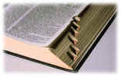
it is necessary to learn some useful terms for describing body structure. Knowing these terms will make it much easier for us to understand the content of the following learning units. Three groups of terms are introduced here: directional terms, terms describing planes of the body, and terms describing body cavities.

- Directional Terms
- Planes of the Body
- Body Cavities
Directional Terms
Directional terms describe the positions of structures relative to other structures or locations in the body.
Superior or cranial
toward the head end of the body; upper (example, the hand is part of the superior extremity).
Inferior or caudal
away from the head; lower (example, the foot is part of the inferior extremity).
Anterior or ventral
front (example, the kneecap is located on the anterior side of the leg).
Posterior or dorsal
back (example, the shoulder blades are located on the posterior side of the body).
Medial
toward the midline of the body (example, the middle toe is located at the medial side of the foot).
Lateral
away from the midline of the body (example, the little toe is located at the lateral side of the foot).
Proximal
toward or nearest the trunk or the point of origin of a part (example, the proximal end of the femur joins with the pelvic bone).
Distal
away from or farthest from the trunk or the point or origin of a part (example, the hand is located at the distal end of the forearm).

Planes of the Body
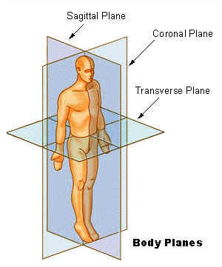
Medical professionals often refer to sections of the body in terms of anatomical planes (flat surfaces). These planes are imaginary lines - vertical or horizontal - drawn through an upright body. The terms are used to describe a specific body part.
Coronal Plane (Frontal Plane)
A verticle plane running from side to side; divides the body or any of its parts into anterior and posterior portions.
Sagittal Plane (Lateral Plane)
A verticle plane running from front to back; divides the body or any of its parts into right and left sides.
Axial Plane (Transverse Plane)
A horizontal plane; divides the body or any of its parts into upper and lower parts.
Median plane
Sagittal plane through the midline of the body; divides the body or any of its parts into right and left halves.

Body Cavities

The cavities, or spaces, of the body contain the internal organs, or viscera. The two main cavities are called the ventral and dorsal cavities. The ventral is the larger cavity and is subdivided into two parts (thoracic and abdominopelvic cavities) by the diaphragm, a dome-shaped respiratory muscle.  Thoracic cavity  The upper ventral, thoracic, or chest cavity contains the heart, lungs, trachea, esophagus, large blood vessels, and nerves. The thoracic cavity is bound laterally by the ribs (covered by costal pleura) and the diaphragm caudally (covered by diaphragmatic pleura). | 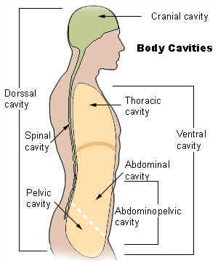
Abdominal and pelvic cavity
The lower part of the ventral (abdominopelvic) cavity can be further divided into two portions: abdominal portion and pelvic portion. The abdominal cavity contains most of the gastrointestinal tract as well as the kidneys and adrenal glands. The abdominal cavity is bound cranially by the diaphragm, laterally by the body wall, and caudally by the pelvic cavity. The pelvic cavity contains most of the urogenital system as well as the rectum. The pelvic cavity is bounded cranially by the abdominal cavity, dorsally by the sacrum, and laterally by the pelvis.
Dorsal cavity
The smaller of the two main cavities is called the dorsal cavity. As its name implies, it contains organs lying more posterior in the body. The dorsal cavity, again, can be divided into two portions. The upper portion, or the cranial cavity, houses the brain, and the lower portion, or vertebral canal houses the spinal cord

