DATA SET 5

SYNTHESIS OF EXISTING SCHOOL DATA WITH A FOCUS ON PACIFIC ISLAND STUDENTS ENROLLED IN PIMSIP.
The purpose of this analysis is to explore the patterns of attendance and attainment recorded in accessible school data in the .One School data

It is organised under the headings

WHAT we found.:- Results/findings

SO WHAT have we learned from this experience ?;- Key learnings

NOW WHAT we will do to inform our practice ? :- Recommendations for “Next practice”
An attached APPENDIX synthesizes the methodologies and evidence based accessed to inform the observations

WHAT we found.:- Results/findings
DEMOGRAPHIC ANALYSIS

http://cmapspublic.ihmc.us/rid=1K6FZH45Z-2CSX4XC-1V8/visual%20story%20of%20demography.cmap

Pacific Islanders have been described as ‘statistically invisible’ in Australia, because many have migrated from or through New Zealand, and are identified in Australian Census data as New Zealanders. (At 30 June 2010, Persons born in New Zealand accounted for 2.4% of Australia's total population,)
Migration policies between NZ and Pacific Island nations/ Australia define entry requirements that impact on access to welfare payments for families and funding to pursue earning and learning pathways for students.
Queenslanders from Pacific Islander backgrounds comprise approximately 1.92% of the Queensland population
The Pacific Islander populations are growing fast in Queensland.
There are inconsistent labeling conventions across ABS,, school data and student/parent supplied information to the extent that the term fails to capture the diversity of cultural capital these peoples bring to the school. Ie
- Of 1025 students enrolled in FLSHS 252 ( 19.4 % or 10 times Qld distribution rates )have been identified as Pacific Islanders .
- Parents have chosen to use Samoan, New Zealander, Maori,Tongan, Fijian to describe their cultural origins

The distribution of the five cultural groups represented in FLSHS enrolments are broadly congruent with Australian 2006 migration patterns

Students reside in the following post code areas
- 4078 FOREST LAKE /ELLEN GROVE 75% of P! students
- 4077 INALA /DOOLANDELLA 15% of PI students enrolled
- 4300 CAROLE PARK /SPRINGFIELD 4% of PI students enrolled
- The remainder are distributed across 5 other postcodes f

197 family groups reside in the full spectrum of housing available within the postcodes identified

113 family groups have given permission for 138 students drawn from all cultural backgrounds to be referred to PIMSIP during 2010/2011 to participate in the Engage; Aspire ;Inspire elements of the intervention .

Students engaged in PIMSI programs reflect program goals BUT high referrals of YR 8 in 2011 compared with 2010

ATTENDANCE

MEASURE | TOTAL ABSENCES | AVERAGE NUMBER OF DAYS ABSENT PER ANNUM | RANGE OF ABSENCES | TOTAL UNEXPLAINED ABSENCES | AVERAGE NUMBER OF UNEXPLAINED ABSENCES | RANGE OF UNEXPLAINED ABSENCES
2010 | 3199 | 25 | 0-117 | 1625 | 13 | 0-91
2011 | 3701 | 29 | 0-88 | 1639 | 13 | 0-71
Sample = 130 students referred to PIMSIP

TOTAL ABSENCES 2010 /2011
IMPROVEMENT ??
REGRESSION ???
TOTAL DAYS ABSENT 2011
TOTAL DAYS ABSENT 2010

UNEXPLAINED ABSENCES 2010 /2011
IMPROVEMENT ??
REGRESSION ???
TOTAL UNEXPLAINED ABSENCES 2011
TOTAL UNEXPLAINED ABSENCES 2010

For the sample of 130 students , more students increased their total absences than decreased them between 2010 to 2011
One student improved total absences from 79 total absences (28 Unexplained ) in 2010 to 32(17 unexplained ) in 2011 ; One student regressed from 22 total absences (6 unexplained )in 2010 to 61(13 unexplained ) in 2011.
ATTENDANCE BY PROGRAM REFERRAL
PROGRAM | 2010 AVERAGE DAYS ABSENT | 2011 AVERAGE DAYS ABSENT
I SPACE | 40 | 29
ASPIRE | 15 | 21
INSPIRE | 40 | 29
ATTENDED PROGRAMS IN 2010 & 2011 | 25 | 28

ATTAINMENT
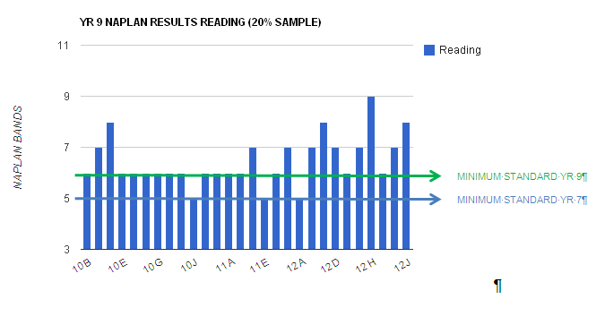

11 from the 40 students in the sample drawn from PIMSIP referrals attained a Year 9 minimum standard or above in the year 9 NAPLAN tests of reading
3 students from the sample of 40 students drawn from PIMSIP referrals attained a Year 7 minimum standard in year 9 NAPLAN tests of reading
2011
2010
Using the sample size of 40 randomly chosen students from PIMSIP referrals ,there are no consistent patterns of improvement or regression in school English results over the 2010 /2011 timeframe
One student improved for an E in English to a B in English while one student regressed
from an a to A in English to a C over the

On the available data , there appear to be no patterns that link attendance patterns with English attainment

BEHAVIOUR
NO ANALYSIS COMPLETED

SO WHAT
have we learned from this experience ?;- Key learnings

A STORY OF TWO STUDENTS

Student | Change in English results 2010/11 | Attendance patterns ( TOTAL DAYS ABSENT 2010/11 | Behaviour patterns 2010/11 | Cultural background | PIMSIP program engagement
1 | A TO C | 24 TO 25 | 0 TO 2 SUSPENSIONS FOR 1-5 DAYS | SAMOAN | 2010
2 | E TO B | 48 TO 47 | 2 SUSPENSIONS 1-5 DAYS TO 0 | SAMOAN | 2010

http://batchgeo.com/map/8c525fb85f13803a10e3ab3792dc2177 40 students used as the sample
http://batchgeo.com/map/3bb0fb6ca03ebc6d5425547b61bb69ba 138 students referred to PIMSIP
http://batchgeo.com/map/64102483106a4dda6ec9ace108ccee42 all 252 students enrolled in FLSHS and labelled PI

NOW WHAT
we will do to inform our practice ? :- Recommendations for “Next practice”

REALISTIC GOAL SETTING & TIME FRAMES
FROM INTERVENTION BASELINE
ACTUAL PERFORMANCE @ 2 POINTS

REAL TIME TRACKING BY EACH DIMENSION
ATTAINMENT ATTENDANCE BEHAVIOUR SOCIAL CAPITAL ???
PERFORMANCE SCALE

TREND ANALYSIS PREDICTION

TIME

Given the data limitations and the cautions about attributing outcomes directly to a single program intervention in a holistic school approach, there are enough indicators from this prototype analysis to suggest that such an exercise may add value to program design, monitoring and review with minimal effort.
The application of expertise to ensure the excellent One School data base can be converted to simple trend analysis to inform a priori intervention design, real time proactive program adjustment and post hoc outcome reporting , may provide a high Return On Investment.
The goal is to level the playing field between community partners and educators and allow each to have access to the same data in meaningful forms so each can contribute their specific expertise .where and when needed.
The measure of value added is that more individuals attend more ,behave better , attain more and hopefully reach their goals more often

APPENDIX 1
My assumptions
- Attendance is one indicator of a complex,interdependent set of factors that influence student behaviour

.

Reference :-http://conferenceonthenet.com/clients/niftey/docs/Silburn.pdf

- Within the schooling system attendance may be considered as
  - A lag indicator of student engagement
  - A lead indicator of attainment

Data limitations

ATTENDANCE AT SCHOOL & PIMSIP

- This information is based on a random selection of 40 students from the Engage, Aspire and Inspire elements of PIMSIP conducted 2010& 2011. The sample is drawn 138 students referred to PIMSIP identified from 252 student labeled Pacific Islanders in the One School database from the 1025 students enrolled in Forest lake SHS
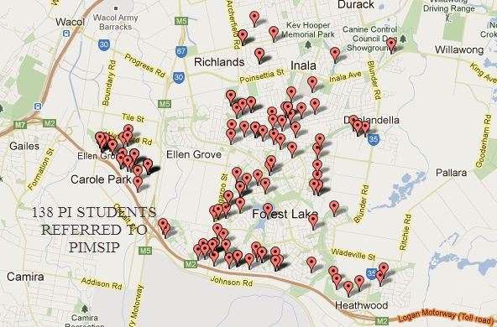
This is not a statistically sound sample Attribution of outcome data to a single program raises considerable issues of credibility The sample was taken as an attempt to develop a prototype system to apply data to a priori design , real time data monitoring to adjust program delivery and post hoc outcome evaluation to report on program outputs.
138 STUDENTS LABELLED PI REFERRED TO PIMSIP.
252 STUDENTS FROM 1025 ENROLLED IN FLSHS LABELLED PACIFIC ISLANDER (PI)

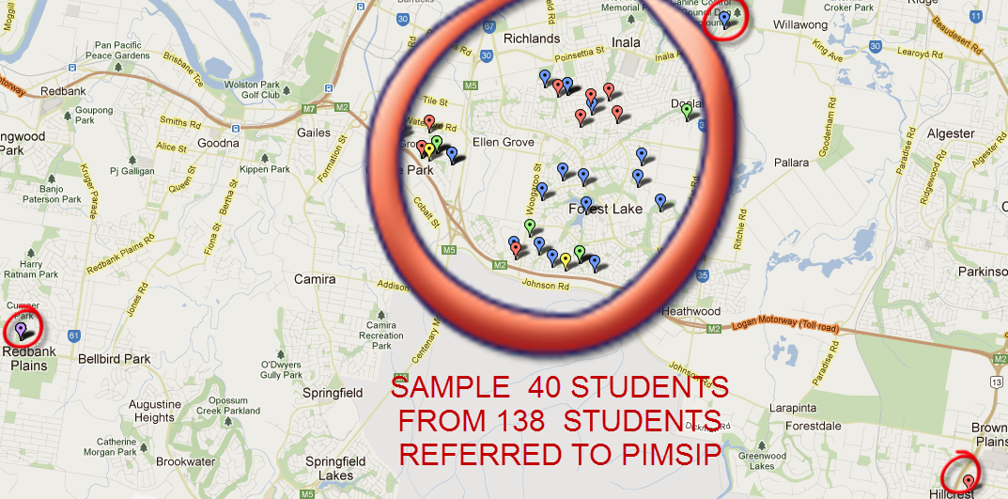
40 STUDENTS CHOSEN AS RANDOM STRATIFIED SAMPLE FOR PROTOTYPE STRATEGIC CONVERSATION

THE DEMOGRAPHIC STORY IN VISUAL FORM

Interactive maps http://batchgeo.com/map/8c525fb85f13803a10e3ab3792dc2177
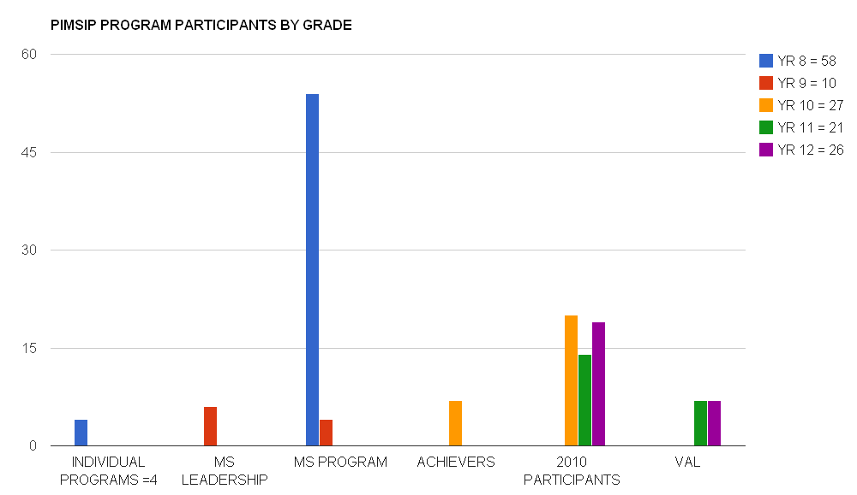

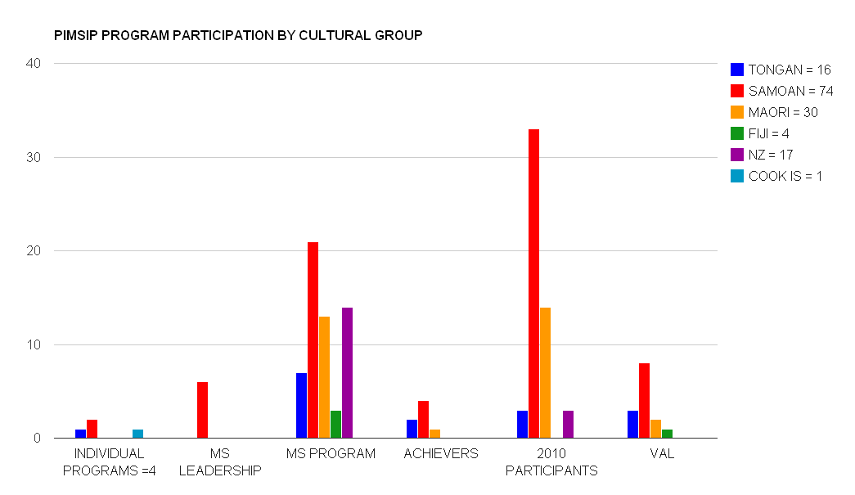

ATTENDANCE

MEASURE | TOTAL ABSENCES | AVERAGE NUMBER OF DAYS ABSENT PER ANNUM | RANGE OF ABSENCES | TOTAL UNEXPLAINED ABSENCES | AVERAGE NUMBER OF UNEXPLAINED ABSENCES | RANGE OF UNEXPLAINED ABSENCES
2010 | 3199 | 25 | 0-117 | 1625 | 13 | 0-91
2011 | 3701 | 29 | 0-88 | 1639 | 13 | 0-71
Sample = 130 students referred to PIMSIP

TOTAL ABSENCES 2010 /2011
IMPROVEMENT ??
REGRESSION ???
TOTAL DAYS ABSENT 2011
TOTAL DAYS ABSENT 2010

UNEXPLAINED ABSENCES 2010 /2011
IMPROVEMENT ??
REGRESSION ???
TOTAL UNEXPLAINED ABSENCES 2011
TOTAL UNEXPLAINED ABSENCES 2010

For the sample of 130 students , more students increased their total absences than decreased them between 2010 to 2011
One student improved total absences from 79 total absences (28 Unexplained ) in 2010 to 32(17 unexplained ) in 2011 ; One student regressed from 22 total absences (6 unexplained )in 2010 to 61(13 unexplained ) in 2011.
ATTENDANCE BY PROGRAM REFERRAL
PROGRAM | 2010 AVERAGE DAYS ABSENT | 2011 AVERAGE DAYS ABSENT
I SPACE | 40 | 29
ASPIRE | 15 | 21
INSPIRE | 40 | 29
ATTENDED PROGRAMS IN 2010 & 2011 | 25 | 28

ATTAINMENT INFORMATION SUMMARY
NAPLAN
Entry level data based on sample of 40 students as entry level reading capabilities
5 of the 15 Year 12 student in the sample ,1 of the 8 Year 11 students , 2 of 13 Year 10 students and 0 of the 4 Year 9 students had participated in NAPLAN

11 from the 40 students in the sample drawn from PIMSIP referrals attained a Year 9 minimum standard or above in the year 9 NAPLAN tests of reading
3 students from the sample of 40 students drawn from PIMSIP referrals attained a Year 7 minimum standard in year 9 NAPLAN tests of reading

ALL STUDENTS ATTENDING PIMSIP IN 2010 ( 2010 RESULTS )

Legend
CIRCLE DIAMETER = TOTAL ABSENCES 2010

On the available data , there appear to be no patterns that link attendance patterns in 2010 with English attainment 2010

ALL STUDENTS ATTENDING PIMSIP IN 2010 9 2011 results )
JIMMY 2011

Legend
CIRCLE DIAMETER = TOTAL ABSENCES 2011

CHARLES 2011
MARK 2011

CELESTE 2011
CAROLINE 2011

JAMIE 2011

On the available data , there appear to be no patterns that link attendance patterns in 2010 with English attainment 2010
One student improved for an e in English to a B in English while one student regressed from an a to A in English to a C

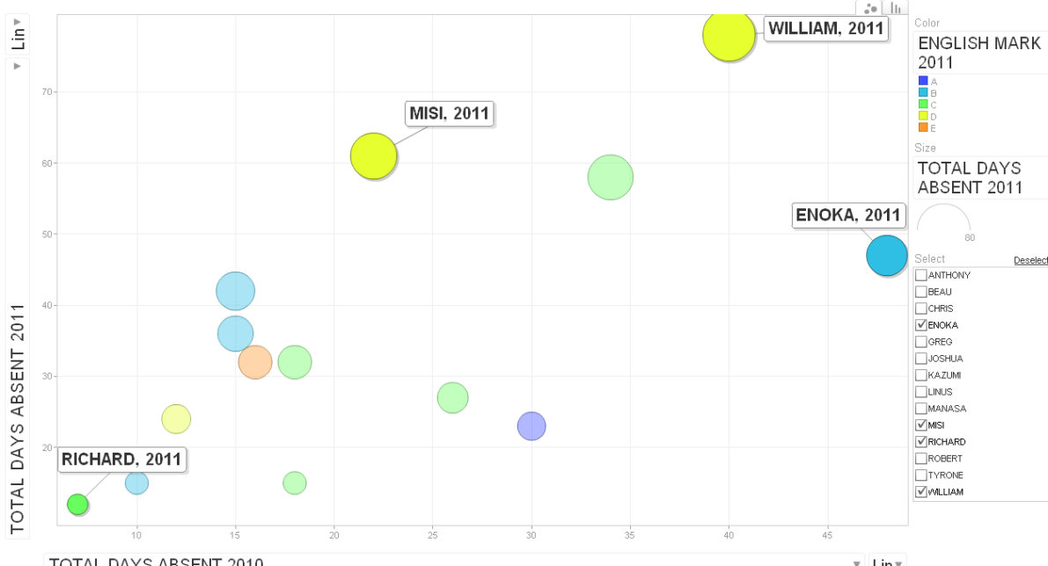
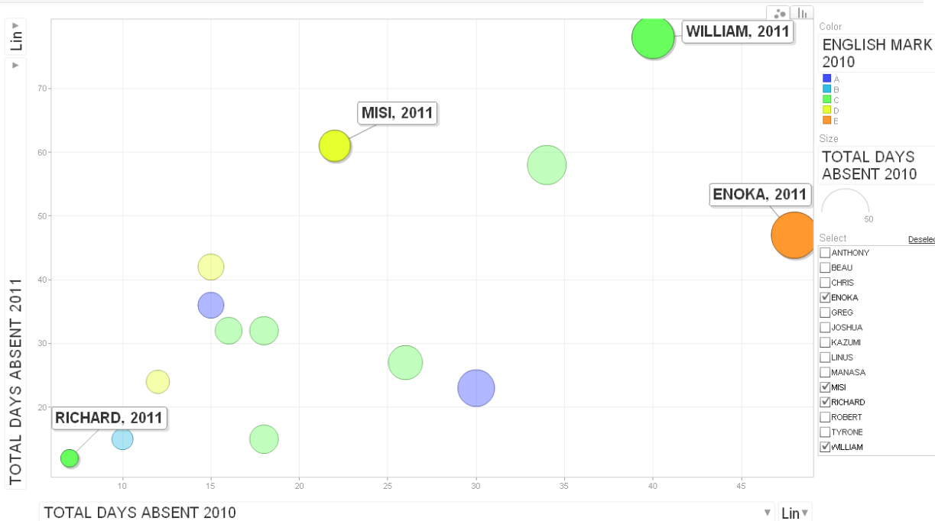
14 2011 STUDENTS chosen from sample of 40

9 students from the 14 achieved the same English rating in 2010 and 2011
2 students improved their rating
3 students regressed in their rating

Health status of Pacific Islander populations in Queensland http://www.health.qld.gov.au/multicultural/health_workers/hlth-status-pac-isl.
3412.0 - Migration, Australia, 2009-10 http://www.abs.gov.au/ausstats/abs@.nsf/Products/98A920DA262FBE81CA2578B00011979C?opendocument

