Name Alek Bouillon____________Date 11/18/11___
(Type answers and include question)
CS 360 Midterm I: Software Architecture and OO Detailed Design (Fall 2011)
- [10 pts] We have covered the architectural hierarchical decomposition process from your initial vision document. Describe:
  - Application architecture
Application architectures are designed to display the principle characteristics of a class of systems.
  - Information architecture
Information architecture is used to express a model or concept of complex systems.
  - Systems architecture
Systems architecture is used to define the structure, behavior, and views of a system.
  - UML architecture
UML architecture is used to specify, visualize, modify, construct, and document aspects of a system using an Object Oriented approach.
- [10 pts] In RUP, we are leveraging the axiomatic design process in the inception and elaboration phase. Describe the requirements engineering and elicitation process in more detail from initial gathering of VOC to CN to FR in axiomatic design, including risk concepts.
  - Design matrix results in which UML diagram type?
The design matrix results in the UML package diagram.
  - DSM results in which UML diagram type?
The design matrix results in the UML class diagram.
  - What is the V-Model?
This model represents a software engineering process and could be considered as an extension to the waterfall model.
  - QFD
This document is used to convert the user demands to design quality, deploy the functions forming quality, and deploy methods for achieving quality. Overall, it is the house of quality.
  - FMEA
This document is used to analyze potential failure modes within a system to classify them based on severity and likelihood of occurrence.
- [5 pts] We have covered how to establish class architecture first as a foundation to detailed design with UML. When using Axiomatic Design process to develop classes, how do the following map to OO Design object elements [hint: see paper handout on “Object Oriented Design with Axiomatic Design” :
  - FR
FRs could represent objects of the system.
  - DP
DPs could represent data or inputs for the FRs.
  - FR/DP design matrix intersection
The FR/DP intersection is used to identify which FRs can be satisfied based on the DPs for other FRs.
- [5 pts] Describe the purpose of these tools/software used in your project:
  - Acclaro DFSS
Acclaro DFSS is being used to create and edit the FR/DP, DP/DP, and FMEA for my project.
  - Visio
MS Visio is being used to create the UML diagram, the application architecture, and a debugging tool to be used later on in the development.
  - Basecamp
Basecamp is being used to task out certain milestones to each member of the group and to allow faster sharing of small files related to the project.
  - MS Project
  - MS Powerpoint
MS Powerpoint is being used to create the slideshows for presenting progress on the project.
- [5 pts] Describe the standards applied in this project
  - IEEE-830 SRS
The SRS is being used to give a complete description of the system behavior.
  - IEEE-1058 PMP
  - IEEE-1016 SDD
The SDD is being used to specify the system architecture and application design.
- [5 pts] In OO design, describe the concept [with symbol]:
  - Aggregation
Aggregation is used to form the UML diagram to show parts of the whole using diamonds to the next class in that represents the whole.
  - Composition
Composition is the process of integrating components with each other using ‘glue code’, the symbol used is an open circle from one component with a half circle to the other component.
  - Polymorphism
Polymorphism is applying an operation to object that has several alternative classes that have the defined operation then applying the operation to the object which determines the executed operation, uses an arrow in UML.
  - Inheritance
Inheritance is the ability for one class to inherit the same functionality of its parent class. It is shown using a solid, unfilled arrow in UML.
  - Blackbox
A blackbox is the symbol used to represent a system, device, or object solely based on the inputs and outputs.
- [5 pts] In OO design, describe the concept [with symbol]:
  - Public operations
Public operations are accessible to the entire system and are noted with a plus sign in the UML diagram.
  - Private operations
Private operations are limited to a specific method or class and are noted with a minus sign in the UML diagram.
  - Inclusions
Inclusions in OO design are when the base case includes the functionality of another case. This is shown with a dashed line and open arrow.
  - Extensions
An extension is shown with an unfilled arrow with the word, uses, on it. Extensions are used when a system process has a number of subtasks that are used by it and other processes.
- [5 pts] You were given a handout on software project management by Fairley. Describe how the following concepts are used in your project.
  - Architecture Decomposition View (ADV)
  - Work Breakdown Structure (WBS)
- [5 pts] In Object oriented (OO) design, describe the concept [with symbol]:
  - Association
An association is a relationship in which one instance of an object can cause another to perform an action on its behalf. An association can be either unidirectional, shown with a solid line and open arrow, or bidirectional, shown with a solid line between the two classes.
  - Generalization
Generalization is the identification of commonalities among a set of entities, be it classes, objects, attributes, etc. It is shown in a generalization/specialization hierarchy.
  - Dependency
Dependency is the degree at which each module of a program relies on the other modules. It is shown using a dashed line and open filled arrow.
  - Realization
Realization is when one element realizes the specified behavior of its supplier element. It is shown with a dashed line with a closed, unfilled arrow.
  - Annotation
  - Interface
An interface is something used to display output from a system or to accept input from a user. An interface is shown using a solid line with a circle.
- [5 pts] Define each performance attribute:
  - Efficiency
Efficiency refers to the amount of time the system takes to process the information it is given.
  - Flexibility
Flexibility refers to the system’s ability to adapt to external changes.
  - Integrity
Integrity refers to the system’s ability to resist data corruption while storing and accessing data.
  - Security
Security is the system’s ability to resist use or abuse from unauthorized users.
  - Maintainability
Maintainability refers to the ease of which the software can be maintained while reducing system downtime.
  - Portability
Portability refers to the system’s ability to be used in different runtime environments.
  - Reliability
Reliability refers to how reliably the system is available or how reliable the data produced by the system is.
  - Usability
Usability refers to how difficult it is to use or learn how to use the system.
- [5 pts] Describe how you have used your concept map and basecamp tool to organize your work as a team using RUP as a guide.
I have used my CMAP and basecamp to display what I have completed or started for each phase of the RUP and to keep track of milestone deadlines that I have been assigned.
- [5 pts] You are working on SWEBOK reviews KA-1 through KA-11. Which three areas apply to your role in the project and why?
  - Area 1 applies to my role in the project because as the developer, I should have an understanding of the software requirements.
  - Area 2 applies to my role in the project because I should be able to design the software based on the requirements.
  - Area 4 because as the Test Engineer, I should be familiar with debugging techniques and have a general understanding of what should be expected from the software in order to test it.
- [10 pts] Other than class and component diagrams that all teams are required to use, select 3 UML behavior diagram types that your project could use and why? 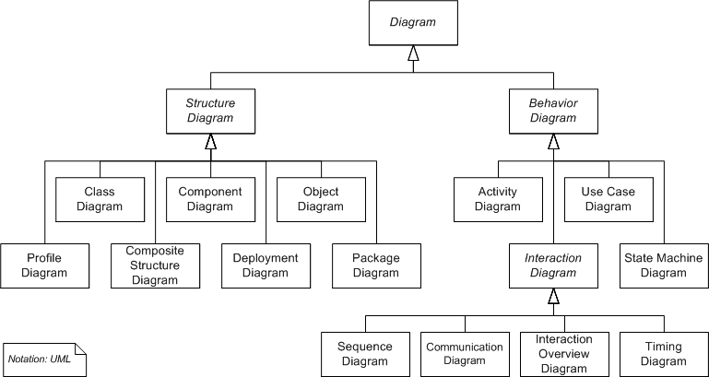
My project could also use a deployment diagram, an object diagram, and a package diagram.
The deployment diagram would be used to display how the software would be deployed to the servers and how it would run from the servers to the end user on their personal computer.
The object diagram would be used to display all of the parts that make up one object within the system.
The package diagram would display how the system would be divided into packages so that they can be interfaced for deployment.
- [10 pts] We reviewed UML and related concepts for automation in software systems engineering.
  - What is the relationship between UML and SysML?
SysML is dependent on UML.
  - What is executable UML?
Executable UML is a profile of the original UML that specifies the system graphically at the next highest abstraction.
- [10 pts] Describe how this course has helped you organize your team
  - Management
This course has helped organize my team management by showing us different ways to manage the team and give guidance on what should be done.
  - Architecture
This course has helped organize our architecture by showing us what a typical team architecture would look like in the industry.
  - Detail design
This course have helped organize our detail design by giving us feedback on how we have it setup so that changes can be made where they are needed.
  - Documentation
This course has helped organize our documentation by showing us what the standards are and how they should be used.

Bonus: [10 pts] List up to 10 aspects of this course you enjoyed/learned from the most?

