Subject: ACS 560- Software Engineering
Name: Ekaterina Schwartz
Subject: Guide to SWEBOK- Software Engineering Tools and Methods KA
Purpose: Summary of Software Engineering Tools and Methods KA
Advisor: Dr. John Tanik
Date: 10/10/2011

This KA defines software development tools as computer-based tools that are intended to assist the software life cycle processes. They are intended to make software engineering more systematic, with varying scope, from supporting individual tasks to the complete life cycle. Software engineering methods are described as the structure imposed on the software engineering activity with the goal of making such systematic, and therefore more likely to be successful. The Software Engineering Tools and Methods KA is related to every KA of the Guide. Following is a breakdown of topics for the Software Engineering Tools and Methods KA:
- Software Engineering Tools
The Software Engineering Tools section of the KA includes the following subsections: Software Requirements Tools, Software Design Tools, Software Construction Tools, Software Testing Tools, Software Maintenance Tools, Software Configuration Management Tools, Software Engineering Management Tools, Software Engineering Process Tools, Software Quality Tools, and Miscellaneous Tool Issues.
The Software Requirements Tools subsection lists two categories for dealing with software requirements: Requirements modeling tools and Requirements traceability tools. The Software Design Tools subsection covers tools for creating and checking software designs. The subsection of Software Construction Tools lists tools used to produce and translate program representation to enable machine execution. Such tools include:
- Program editors
- Compilers and code generators
- Interpreters
- Debuggers
Software Testing Tools include:
- Test generators
- Test execution frameworks
- Test evaluation tools
- Test management tools
- Performance analysis tools
The Software Maintenance Tools subsection of the KA covers tools particular to software maintenance, such as: Comprehension tools and Re-engineering tools. Reverse engineering tools are used by working backwards to create specification and design descriptions from an existing product.
The Software Configuration Management Tools subsection of the KA lists three categories:
- Defect, enhancement, issue, and problem-tracking tools
- Version management tools
- Release and build tools
Software engineering management tools are subdivided into three categories:
- Project planning and tracking tools
- Risk management tools
- Measurement tools
Software engineering process tools are further divided into:
- Process modeling tools
- Process management tools
- Integrated CASE environments
- Process-centered software engineering environments
Quality tools are divided into two categories:
- Review and audit tools
- Static analysis tools
The Miscellaneous Tool Issues subsection of the KA includes three categories of tools that are applicable to all classes:
- Tool integration techniques
- Meta-tools
- Tool evaluation

- Software Engineering Methods
The Software Engineering Methods section of the KA includes the following subsections: Heuristic Methods, Formal Methods, and Prototyping Methods.
Heuristic methods are categorized as follows:
- Structured methods
- Data-oriented methods
- Object-oriented methods
The Formal Methods subsection deals with mathematically based software engineering methods and is subdivided as follows:
- Specification languages and notations
- Refinement
- Verification/proving properties
The Prototyping Methods subsection of the KA is subdivided into:
- Prototyping styles
- Prototyping target
- Prototyping evaluation techniques

Figure 1. is a breakdown of topics for the Software Engineering Tools and Methods from the Guide to SWEBOK.
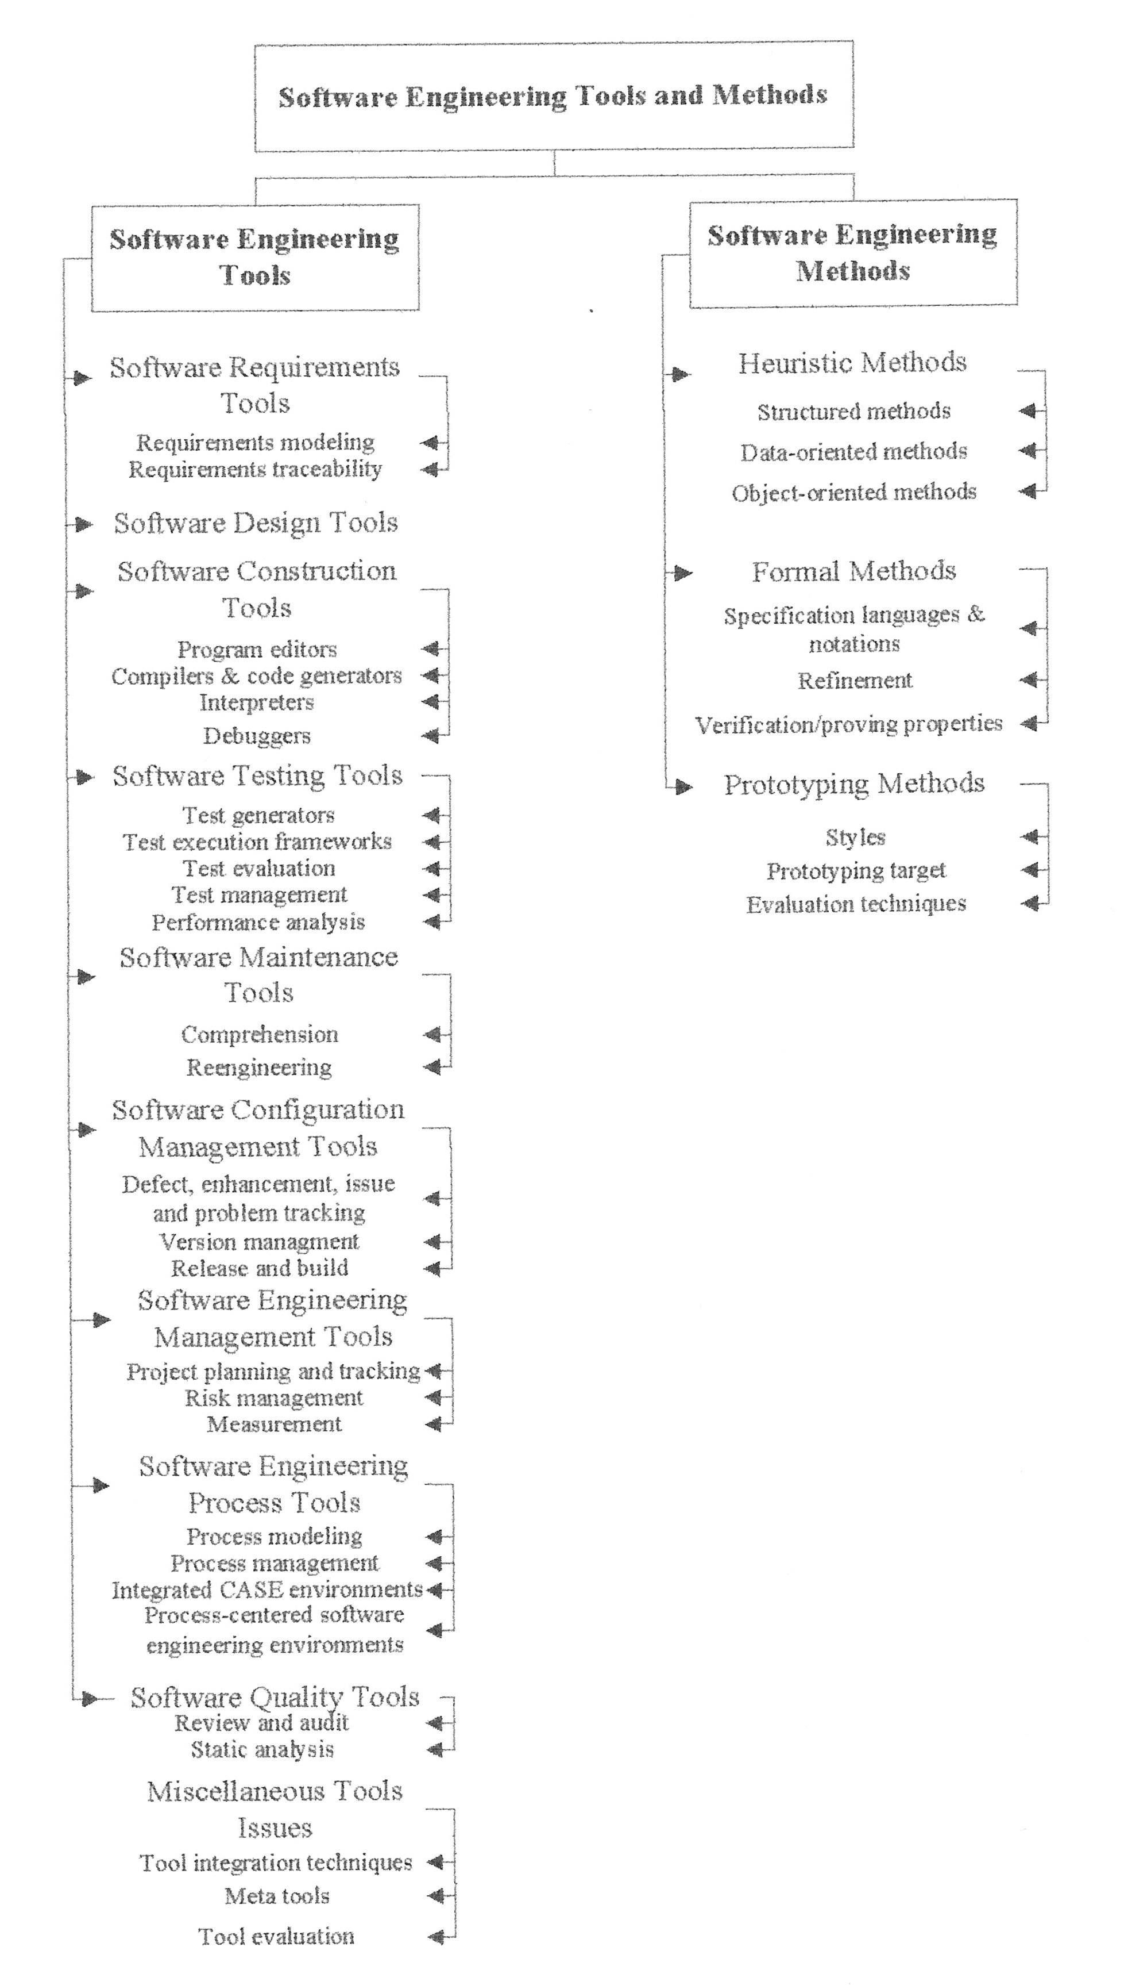

Figure 1. Topics for the Software Engineering Tools and Methods KA.

