Toia te Waka Te Matauranga (Haul the Canoe of Education)
Ma wai e to? (Who should haul it?)
Maku e to – (I should haul it-)
Mau e to – (You should haul it-)
Ma te whakarongo ake e to! (All within hearing should haul it!)

E nga mana (to people of mana)
E nga reo (the many voices)
E nga waka o nga hau e wha (the canoes of the four winds)
Tena koutou, tena koutou, tena koutou katoa (greetings to you all)
E nga Kaumatua, tena koutou (greetings to seniors)
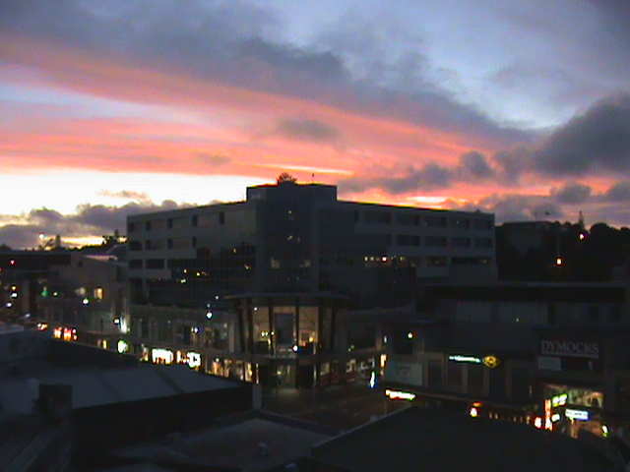
A place of significance to me
Tena koe …….(greetings to the leader or special guest)
Tena koe Te Whānau
Ko Maungakiekie te maunga (One Tree Hill is my mountain)
Ko Manukau te moana (Manukau is my sea)
Ko Ngati Pakeha te iwi (Pakeha is my tribe)
Ko French te hapu (French is my clan)
I wehe oku tupuna i Ingarangi (My ancestors come from England)

Ko Jillian toku ingoa.
Ko Jillian ahau (My name is Jillian)
No reira, tena koutou, tena koutou, tena koutou, katoa.

Whakautauki: My guiding proverb
Whāia e koe ki te iti kahurangi; ki te tūohu koe, me he maunga teitei.
Seek the treasure you value most dearly; if you bow your head, let it be to a lofty mountain. (Pursue excellence - should you stumble let it be to a lofty mountain)



