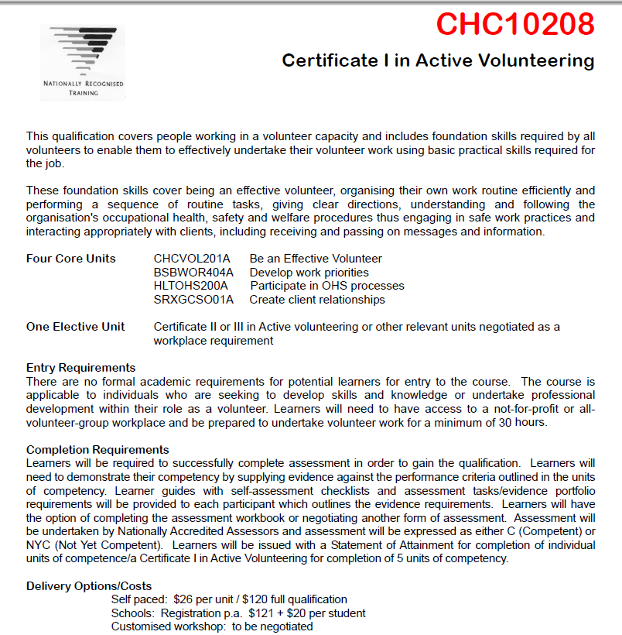
CHCVOL201A Be an effective volunteer
Descriptor This unit describes the understanding, knowledge and
skills required to be a volunteer
Employability Skills This unit contains Employability Skills
Application This unit may be applied in the orientation process for
volunteers to an organisation
ELEMENT PERFORMANCE CRITERIA
Elements define the essential outcomes
of a unit of competency.
The Performance Criteria specify the level of performance required
to demonstrate achievement of the Element. Terms in italics are
elaborated in the Range Statement.
1. Develop understanding of
the volunteering sector
1.1 Develop understanding of the definition and
principles of volunteering
1.2 Explain the scope of the volunteering sector
1.3 Develop understanding of what motivates people
to volunteer their time and expertise
1.4 Develop understanding of the diversity and
difference of clients/customers
1.5 Develop understanding of the importance of
diversity and difference in volunteer work teams
2. Apply the rights and
responsibilities of the
organisation and the
volunteer
2.1 Identify the rights and responsibilities of the
organisation and apply to work
2.2 Identify the rights and responsibilities of the
volunteer and apply to work
2.3 Discuss relevant policies and procedures and apply
to work
2.4 Explain the organisation structure, lines of
communication and authority and boundaries of
work roles
3. Work as a volunteer 3.1 Demonstrate ability to manage one’s own time and
organise one’s own work role
3.2 Apply understanding of the basic principles
required for working effectively in a team
3.3 Apply basic understanding of the communication
networks and processes and relationships between
paid and unpaid staff in relation to volunteer work
3.4 Apply basic understanding of support structures
available and how and when to access these
3.5 Work within relevant legislation/policies and
procedures
Community Services Training Package
CHCVOL201A Be an effective volunteer
♥ Commonwealth of Australia 2010 753
CHC08 Community Services Training Package Version 2.1 – to be reviewed by 5 December 2011
REQUIRED SKILLS AND KNOWLEDGE
This describes the essential skills and knowledge and their level required for this unit.
Essential knowledge:
The candidate must be able to demonstrate essential knowledge required to effectively do
the task outlined in elements and performance criteria of this unit, manage the task and
manage contingencies in the context of the identified work role
These include knowledge of:
• Understanding of own work role and responsibilities
• Volunteering as a choice and as being based on reciprocity
• How personal values and attitudes may impact on work as a volunteer
• Job role and accountability
• The need for relevant background checks to be undertaken by the organisation
• The need for undertaking relevant/mandatory training
• Organisation expectations of volunteers
• Valuing self as a volunteer
• Personal motivations for volunteering
• Personal expectations to be gained from volunteer work
• Understanding of the volunteering sector including the nature of volunteer work and the
importance of volunteer work to the community
• Understanding of organisation information including: various roles, rights and
responsibilities and organisation processes policies and procedures
• Understanding of relevant legislative and procedural requirements, including
requirements relating to mandatory notification where relevant
Community Services Training Package
CHCVOL201A Be an effective volunteer
754 ♥ Commonwealth of Australia 2010
CHC08 Community Services Training Package Version 2.1 – to be reviewed by 5 December 2011
REQUIRED SKILLS AND KNOWLEDGE
Essential skills:
The candidate must be able to effectively do the task outlined in elements and performance
criteria of this unit, manage the task and manage contingencies in the context of the
identified work role
These include the ability to:
• Follow organisation policies and protocols
• Liaise and report appropriately to supervisor
• Adhere to own work role and responsibilities
• Comply with a range of relevant legislative and procedural requirements
• Demonstrate the application of interpersonal relationships of organisation social, ethical
and operational standards and use of appropriate interpersonal styles and techniques
• Communicate in a clear and concise manner in both written and verbal modes
• Literacy skills to identify work requirements and process basic, relevant workplace
documentation
• Respond to routine problems related to the workplace, working under supervision -
appropriate to the job role
• Request advice, assistance, clarification and/or further information
• Seek and receive feedback
• Adhere to policies and procedures
• Work as part of a team with paid and unpaid staff
• Use information technology appropriate to specific tasks
• Follow instructions/directions
• Maintain confidentiality
• Relate to people in a way which appropriately acknowledges diversity
• Organise and manage one’s own time
• Demonstrate safe and effective use of workplace technology in line with occupational
health and safety (OHS) guidelines
Community Services Training Package
CHCVOL201A Be an effective volunteer
♥ Commonwealth of Australia 2010 755
CHC08 Community Services Training Package Version 2.1 – to be reviewed by 5 December 2011
RANGE STATEMENT
The Range Statement relates to the unit of competency as a whole. It allows for different work environments
and situations that may affect performance. Add any essential operating conditions that may be present with
training and assessment depending on the work situation, needs of the candidate, accessibility of the item, and
local industry and regional contexts.
Principles of volunteering may
include:
• Philosophy of volunteering
• Definition and principles of volunteering
• Awareness of:
- Volunteer Australia’s national standards for
involving volunteers in not-for-profit
organisations
- National Agenda on Volunteering: Beyond the
International Year of Volunteers
- Australasian Association for Volunteer
Administrators (AAVA)
• Volunteer infrastructure includes peak bodies at
state/national level, resource and referral centres,
websites and National Volunteer Skills Centre
Diversity may relate to
differences and may include:
• Languages
• Educational background
• Experience
• Skills and knowledge
• Gender
• Race or cultural origin
• Physical capability
• Age
• Socioeconomic status
• Religious affiliation
• Marital status
• Sexual orientation
• Personality styles
• Learning styles
• Working styles
• Motivations for volunteering
• Expectations of volunteer work
• People new to volunteering
Community Services Training Package
CHCVOL201A Be an effective volunteer
756 ♥ Commonwealth of Australia 2010
CHC08 Community Services Training Package Version 2.1 – to be reviewed by 5 December 2011
RANGE STATEMENT
Organisation may include: • Mission and vision statement
• Strategic and business plans (particularly relating to
the volunteer program)
• Structure of the organisation including lines of
communication, roles, responsibilities and authority
• Aim of volunteer involvement in the organisation
• Rights and corresponding responsibilities of the
organisation to volunteers
• Rights and corresponding responsibilities of
volunteers to the organisation
• Expectations of volunteers by the organisation
• Expectations of the organisation/volunteer work by
volunteers
Legislation/policies and
procedures may relate to:
• Policies and procedures including:
- OHS
- equal opportunity, harassment and discrimination
- privacy – personal, organisation and client
- confidentiality – personal, organisation and
client
- insurance – coverage
- risk management
- out of pocket expenses/reimbursement of
expenses
- grievance and disciplinary
- relationship/difference between paid and unpaid
staff
- use of motor vehicles
- duty of care
- orientation, education and training for volunteers
- employment and recruitment procedures of
volunteers
- minimum/maximum time commitments of
volunteer staff
- pre-employment reference audits/checks (i.e.
police etc)
- volunteer involvement, appropriate roles and
position descriptions
- orientation program for volunteers
- recognition of volunteer contribution to the
organisation
- support structures/mechanisms for volunteers
Volunteers may include: • Unpaid workers who are in paid employment
elsewhere – part-time or full-time
• Unpaid workers who are not in paid employment
Community Services Training Package
CHCVOL201A Be an effective volunteer
♥ Commonwealth of Australia 2010 757
CHC08 Community Services Training Package Version 2.1 – to be reviewed by 5 December 2011
RANGE STATEMENT
Appropriate persons volunteers
may relate to:
• Supervisors
• Paid and unpaid colleagues
• Trainer
• Clients/customers
• General public
Community Services Training Package
CHCVOL201A Be an effective volunteer
758 ♥ Commonwealth of Australia 2010
CHC08 Community Services Training Package Version 2.1 – to be reviewed by 5 December 2011
EVIDENCE GUIDE
The evidence guide provides advice on assessment and must be read in conjunction with the Performance
Criteria, Required Skills and Knowledge, the Range Statement and the Assessment Guidelines for this
Training Package.
Critical aspects for assessment
and evidence required to
demonstrate this unit of
competency:
• The individual being assessed must provide
evidence of specified essential knowledge as well as
skills
• It is recommended that assessment or information
for assessment will be conducted or gathered over a
period of time and cover the normal range of
workplace situations and settings
• This unit will be most appropriately assessed in the
workplace and under the normal range of workplace
conditions
• Where, for reasons of safety, space, or access to
equipment and resources, assessment takes place
away from the workplace, the assessment
environment should represent workplace conditions
as closely as possible
Access and equity
considerations:
• All workers in community services should be aware
of access, equity and human rights issues in relation
to their own area of work
• All workers should develop their ability to work in a
culturally diverse environment
• In recognition of particular issues facing Aboriginal
and Torres Strait Islander communities, workers
should be aware of cultural, historical and current
issues impacting on Aboriginal and Torres Strait
Islander people
• Assessors and trainers must take into account
relevant access and equity issues, in particular
relating to factors impacting on Aboriginal and/or
Torres Strait Islander clients and communities
Context of and specific
resources for assessment:
• This unit can be assessed independently, however
holistic assessment practice with other community
services units of competency is encouraged
• Resources required for assessment include access to:
- appropriate workplace where assessment can
take place
- relevant organisation policy, protocols and
procedures
- equipment and resources normally used in the
workplace
Community Services Training Package
CHCVOL201A Be an effective volunteer

