VFT - PORTFOLIO

Resources for Teacher Knowledge:
-Links to Google Earth with the pins with explanations at each pin
-Page with links to different types of plate movement, demonstrating those which happened in Big Bend
-with explanations
Timeline of events with pictures and explanations
Links to plate tectonics and Texas geologic history
-Plate Tectonic video – from NOAA
-good for easy intro to plate tectonics and earth structure
-types of plate movement
-has a couple really good activities
-Fault types animation
-normal, reverse, thrust, strike-slip
-Additional Fault types animation
-normal, reverse, strike-slip, thrust, and horst/graben
-Fault animation
-many different fault-types, as well as basin and range
-Pangaea video
This is an example of plate tectonics in a lava lake.
http://www.youtube.com/watch?v=PZjPGdXMMso
-Review Google Earth pushpins

History of formations:
Paleozoic Era
-Pennsylvanian time about 300 MYA the formation of Pangaea occurred and the South American plate collided with the North American plate and a thrust fault occurred
-South American plate material was pushed onto North America forming the Ouachita Mountain
range as well as the Caballos in the Marathon Basin.
-evidence of thrust fault visible at Persimmon Gap
-Maravillas Picture, Haymond Picture - Marathon
Collision between the North American and South American plates during the formation of Pangea in the late Paleozoic
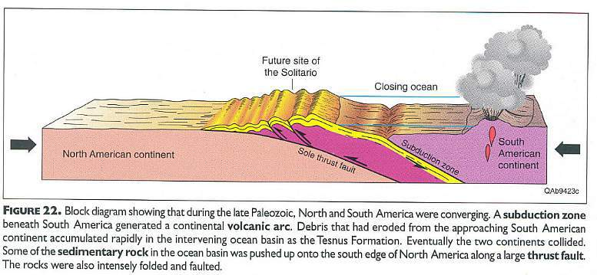
Above figure from Henry, 1998.
http://www.sunstar-solutions.com/sunstar/geology/BigBend/BigBendTX.htm

Rock formations
-formations from this time show much folding of the rock layers
-older layers thrust upon newer layers
-Texas was under the ocean so sedimentary rock layers appear as the depths of the ocean varied.

Late Cretaceous Era
-70-50 MYA
-North American and Farallon plate collided and the Farallon plate subducted the North American plate
-Also called the Laramide Orogeny
-Subduction video – from NOAA
-has activities that correspond
-because the subduction was at a slight angle rather than deep, the mountain-producing
episode was further inland
-caused large folds and faults
-produced Rocky Mountains – tip of which is Mariscal Mountain
also produced Sierra del Carmens

Continental Volcanic Arcs along western North America and Central America
Note how volcanic region falls within Basin and Range Province
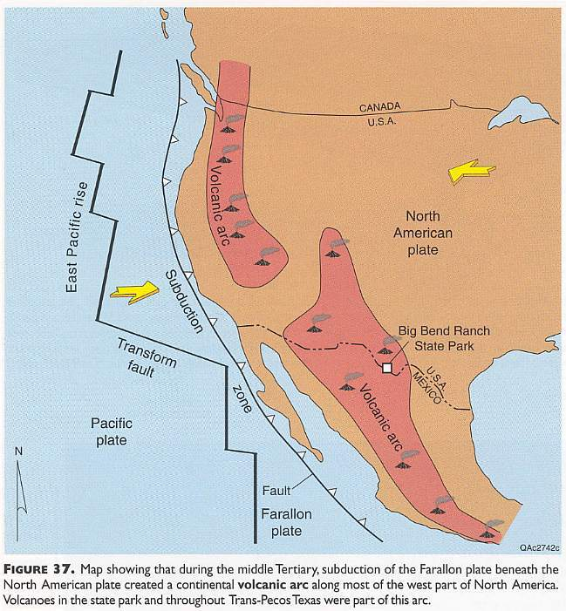
Above figure from Henry, 1998.
http://www.sunstar-solutions.com/sunstar/geology/BigBend/BigBendTX.htm

Cenozoic Era
-42 MYA
-Volcanic eruptions began caused by the previous subduction
-evidence in the igneous rock throughout Big Bend
-formed Chrismas mountains first - large portions of extrusive igneous rock
-Subsequent eruptions formed the Chisos Mountains, Pine Canyon, and Burro Mesa
-volcanic ash and lava layers
-Link to Baked Pen, Study Butte, and Willow Mountain Plug pictures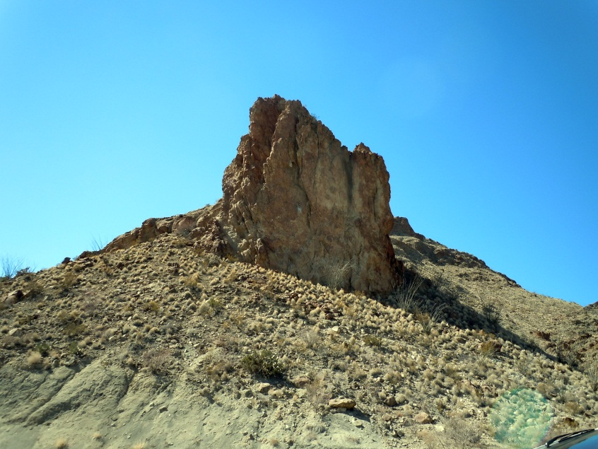Study Butte Volcanics

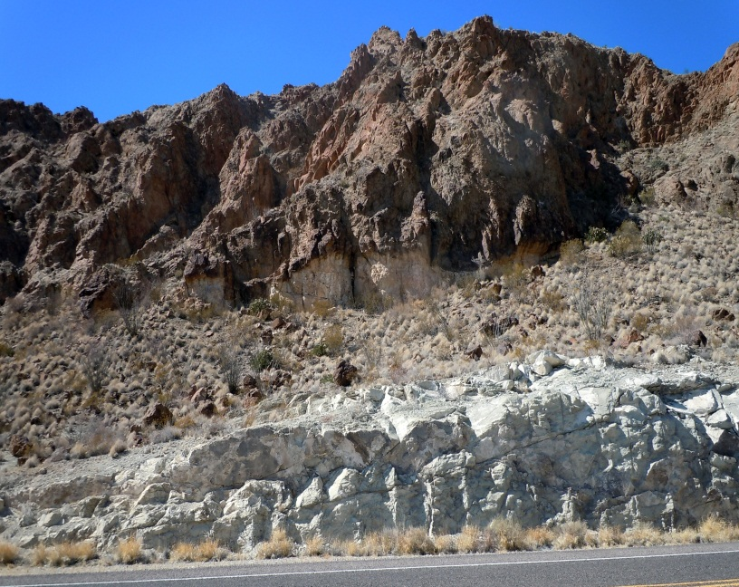 Study Butte Volcanics

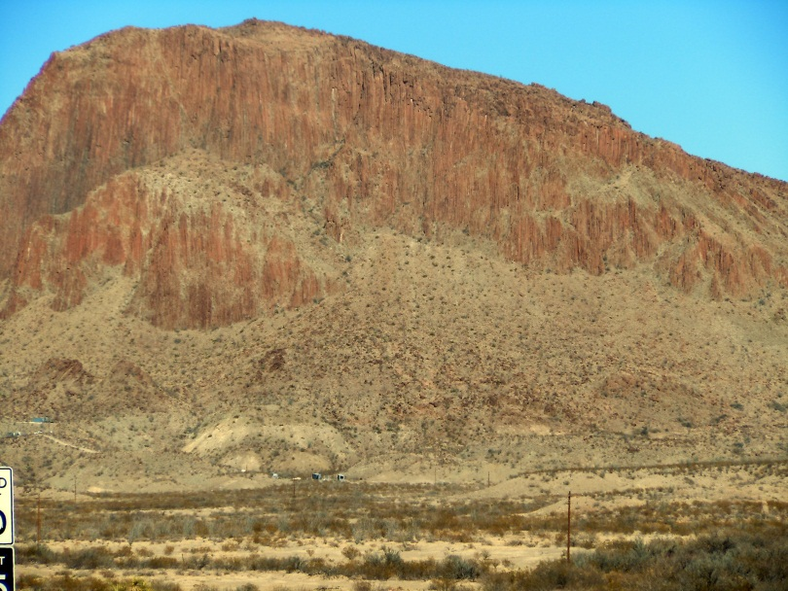 Willow Mountain Plug

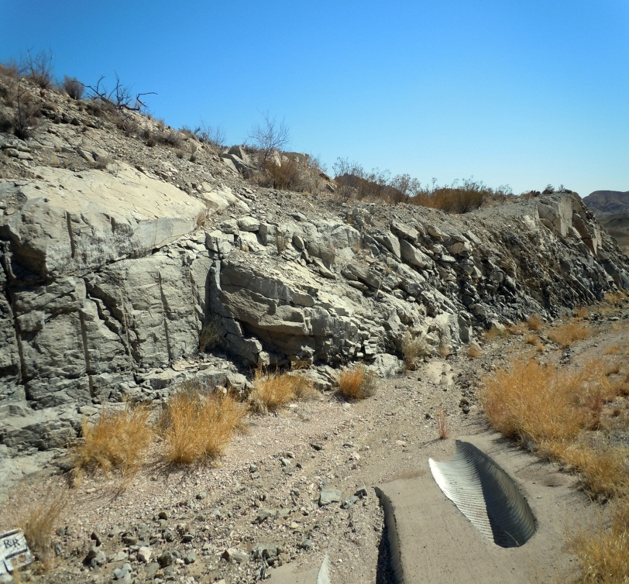 Baked Pen

-Also during this time large amounts of lava failed to reach the surface and produced intrusive igneous rock
which has now been exposed by erosion
-formed Maverick Mountain, Grapevine Hills, Nugent Mountain, and Pulliam ridge

Extrusive igneous rock formed:
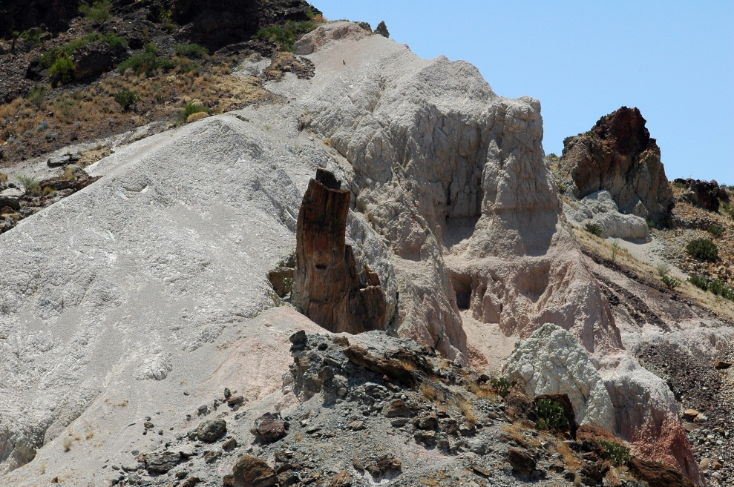
Grey-formation: Extrusive volcanic ash
Tree-like formation: intrusive volcanic vent exposed by erosion

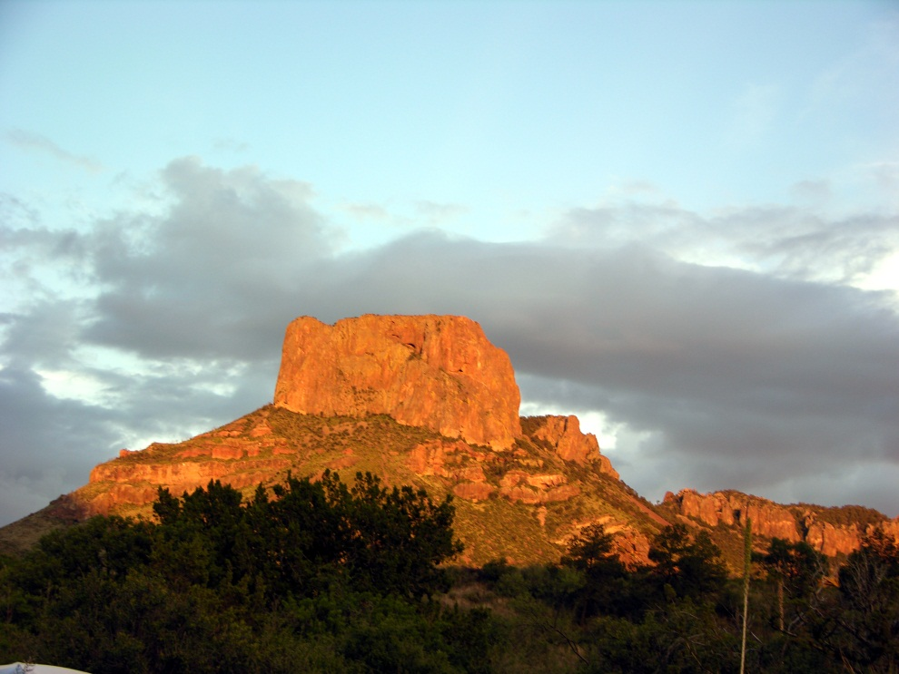 Casa Grande: Top of the Chisos Mountains, extrusive igneous rock

Rock types
-sedimentary rock baked by volcanics
-intrusive and extrusive igneous rock
-volcanic tuff

25 MYA
-Pacific plate grinding against North American plate caused crustal extension and down drop block,
basin and range
-Tension caused the crust to fracture and a large block of crust sank
-central part of Big Bend – Chisos Mountains – is the graven – or drop down
-the horst to the West is the Mesa de Anguila and Santa Elena Canyon and the East is the Sierra
del Carmen
-Left large active faults - Terlingua Fault
-Burro Mesa Fault

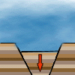

Basin and Range video

MiniLessons – for Teachers to use with students:
-Texas Geology Claymation
-Pangea links
-Lava flow to demonstrate plate movement – links
-Google Earth with pins (no information)
-links to different types of faults – animated or not
-links to examples – like car crash for plate collisions
-Photos and hand samples
-decide which to use (perhaps one for each major sites)
-Subduction video – from NOAA
-has activities that correspond
-Plate Tectonic video – from NOAA
-good for easy intro to plate tectonics and earth structure
-types of plate movement
-has a couple really good activities

Big Bend
http://www.maroon.com/bigbend/time/index.html
http://bigbendnationalpark.info/geology_history.html
http://www.nature.nps.gov/geology/parks/bibe/
http://www.lib.utexas.edu/geo/fieldguides/bigbendgeology.html

Big Bend video of dinosaur fossils collected
http://www.youtube.com/watch?v=zNy4pD0Rn1E

Plate Tectonics
http://www.youtube.com/watch?v=QDqskltCixA

Plate Tectonics Fault Normal
http://www.youtube.com/watch?v=vqWCpo-1jrU

Plate Tectonics Fault Reverse
http://www.youtube.com/watch?v=4b81nXSVA34

Plate Tectonics Fault strike-slip
http://www.youtube.com/watch?v=MrrLJ4vXHCs
http://www.youtube.com/watch?v=6wWcjNM_kRM

