“How is a geologist like a detective?”
Google Earth
Concept Map Activity
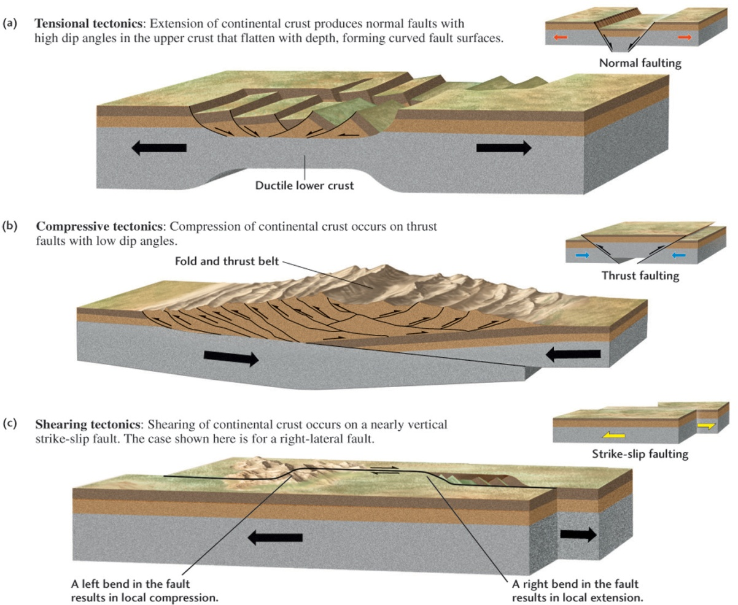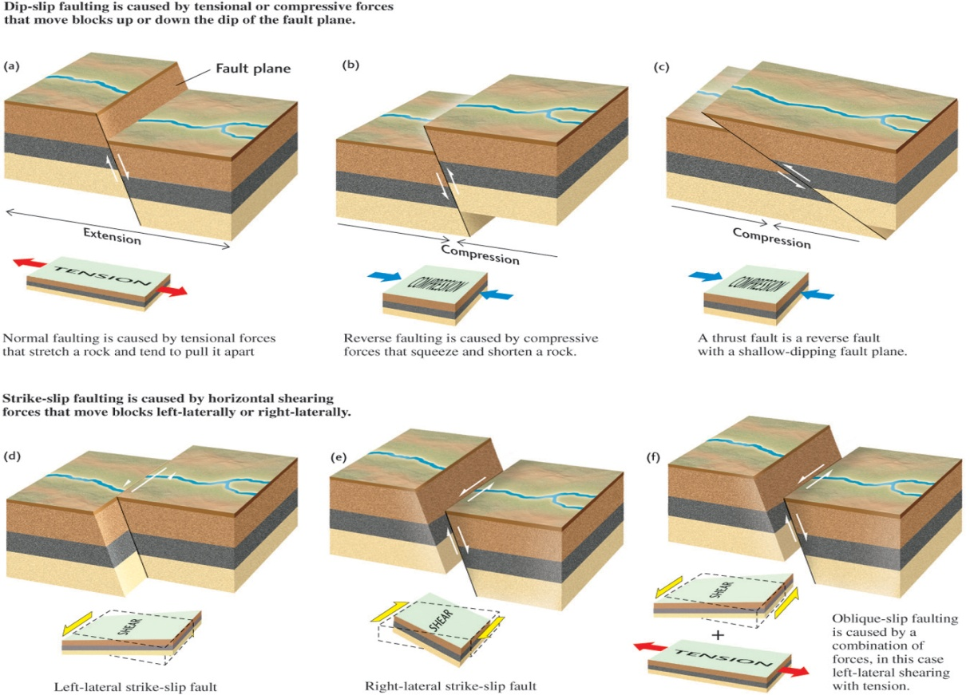

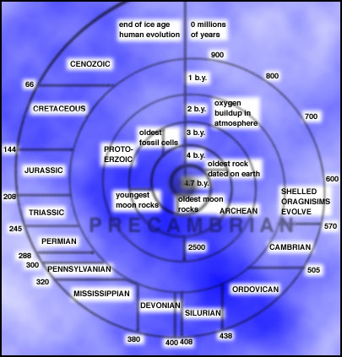
http://www.globalchange.umich.edu/globalchange1/current/lectures/first_billion_years/onebych.jpg
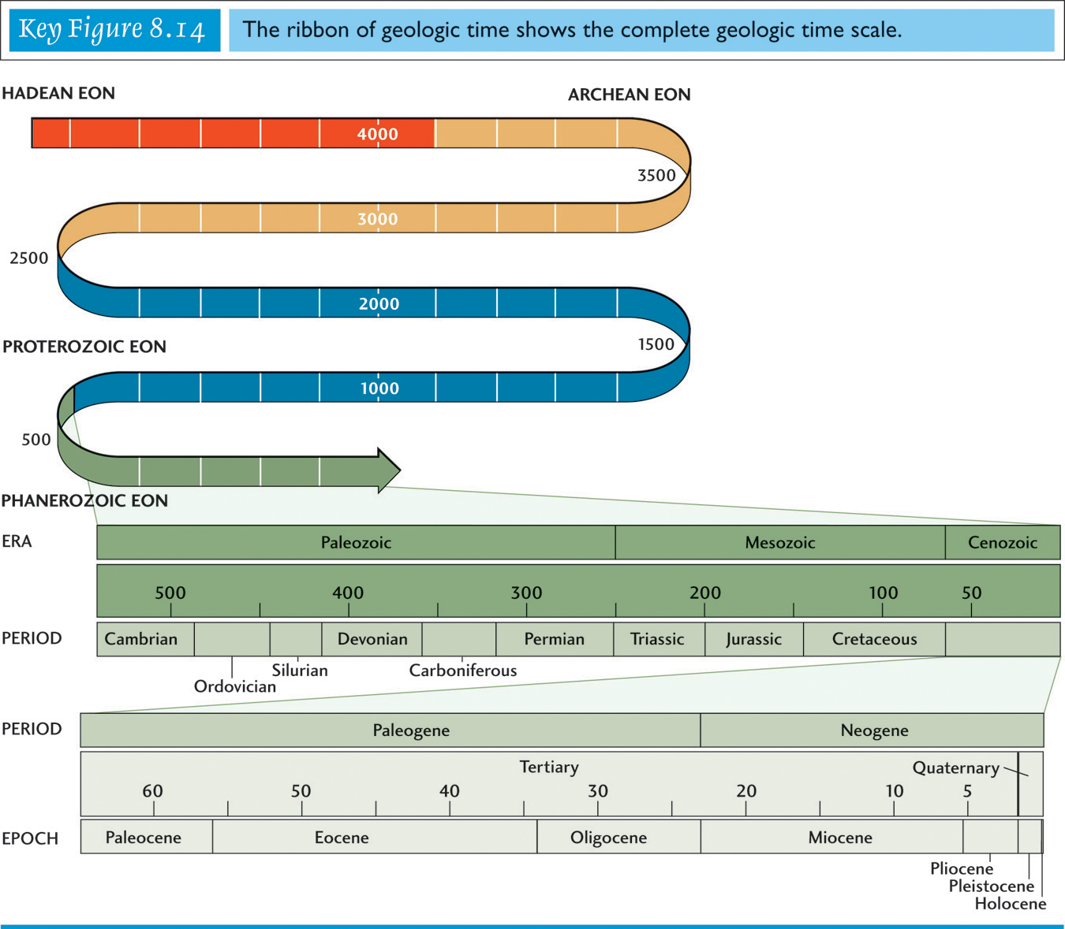
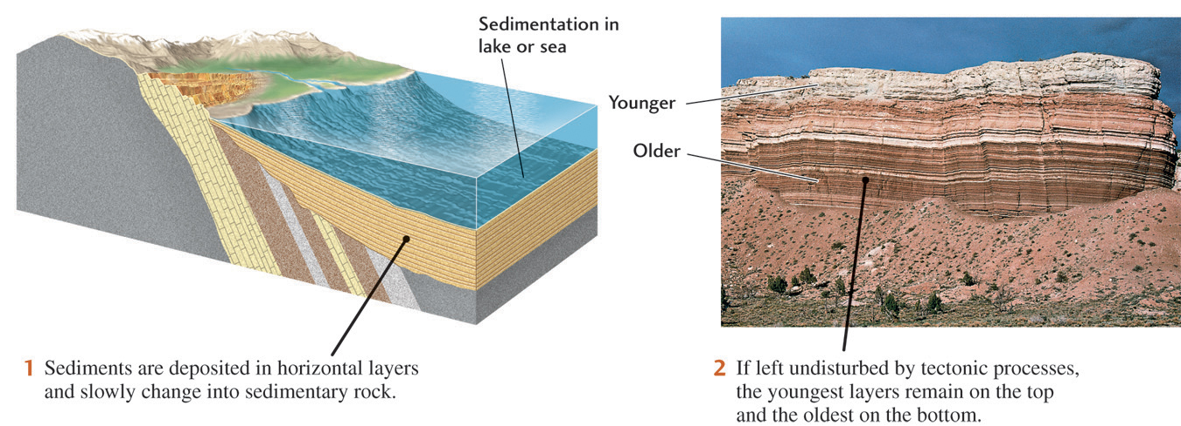
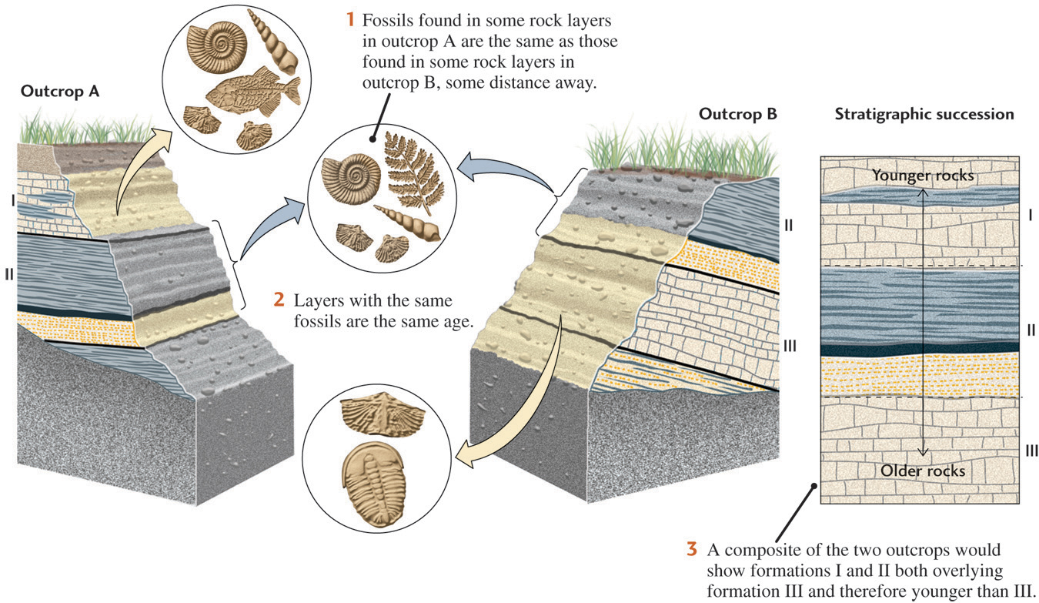
Radioactive Decay
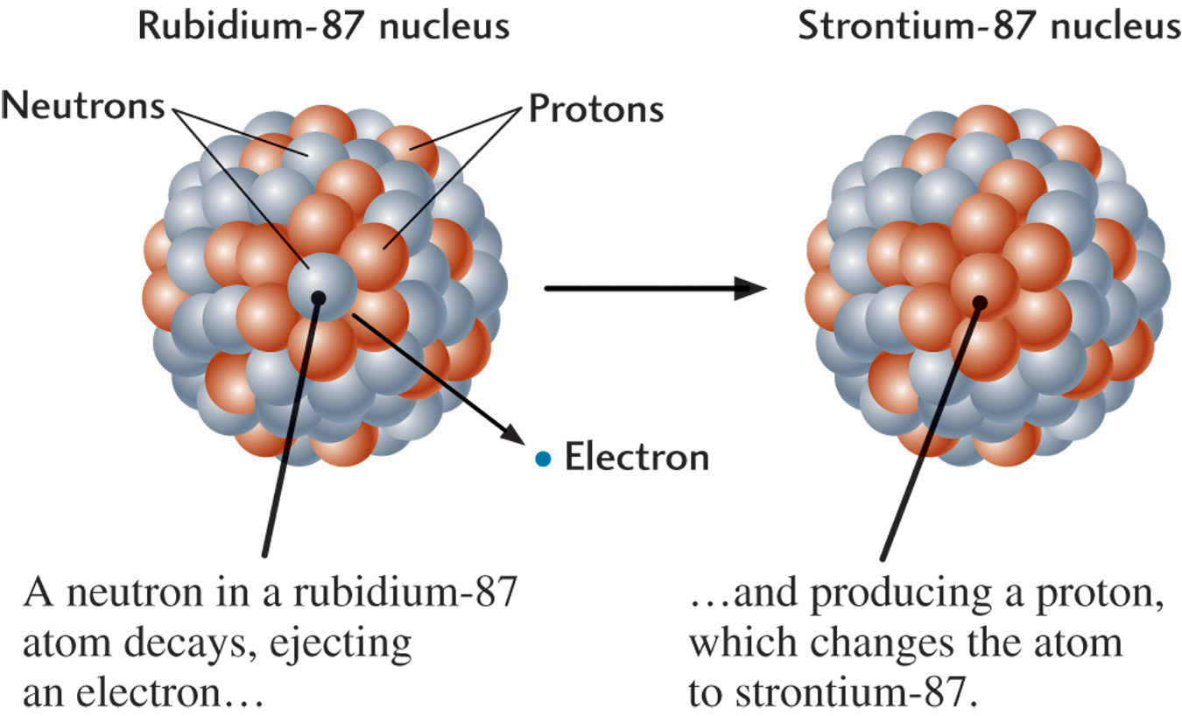
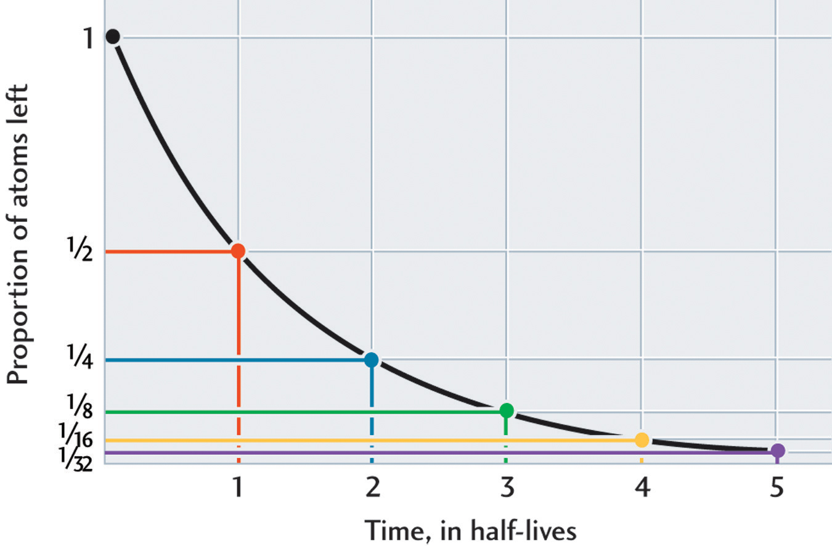
Half-Life Concept: Pennies/M&M’s activity
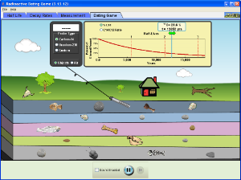
PHET: The Dating Game
http://phet.colorado.edu/en/simulation/radioactive-dating-game
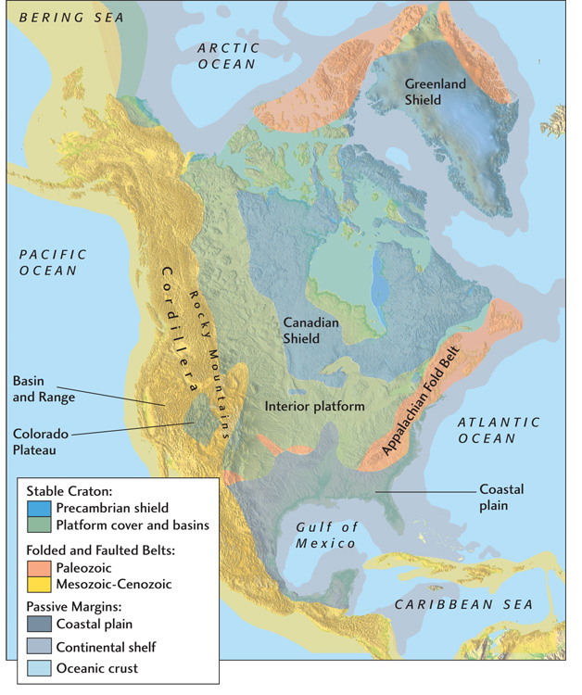
K-T Impact
http://www.psi.edu/projects/ktimpact/ktimpact.html
http://www.tufts.edu/as/wright_center/impact/impactc.html
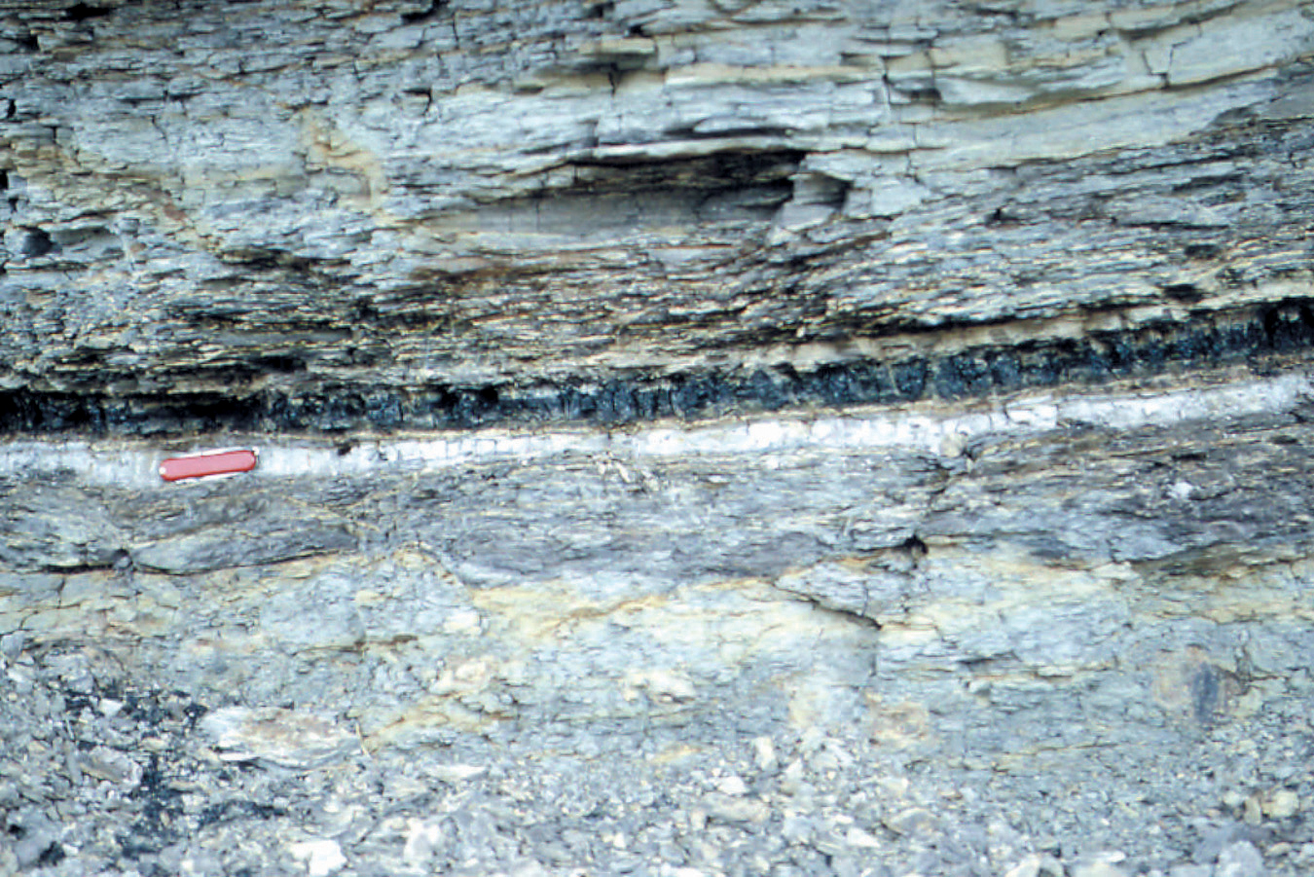
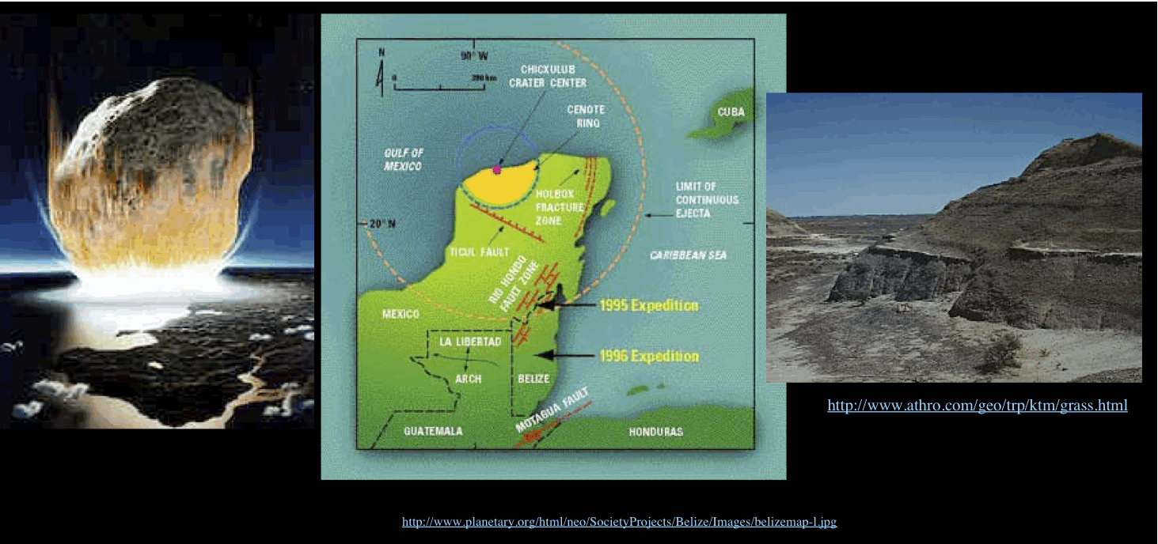
Gerda work disproves Yucatan crater idea?

