Your name is:________________________________________________________________________________
Spell your name! _____________________________________________________________________________
____________________________________________________________________________________________
____________________________________________________________________________________________

Level 3. Unit 1: pronouns, present to be, adjectives



Is he surprised or angry? He is very angry_________
Is the man wearing a blue t-shirt? He is wearing a __b
___________________________________________
The man has _________________ hair.

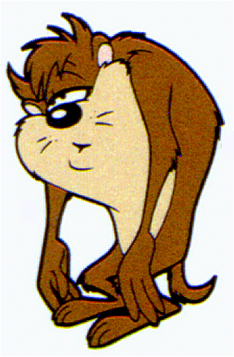

2. Taz is tired.____________ (happy or tired).
Is Taz ugly o beatiful? He is very ugly.


Is she surprised or angry? She is ________________.
She’s wearing a (black or white) ____________ shirt.
Is she ugly? ________________________________.


This is a ______________________ face.
It is ___________________ (yellow or red)

Level 3. Unit 2: The face

Is this an eye?
No. This is an ______
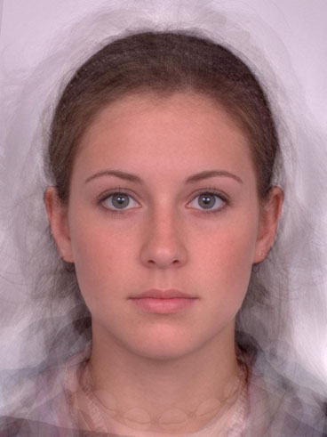
The ________
This is the ______. It has two lips
Is this the cheek or the neck?
This is __________________
The place between the mouth and the nose is the ______
The face has two____
The place between the eyes is the __________
These are the _________
The place between the ears and the ears is the_____________
The hair is _______
This is the _________
Level 3. Unit 3, 5, and 6: It is, they are, is it? are they? indefinite demonstratives, prepositions

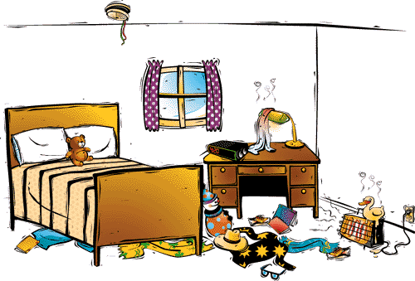
This is ___ bedroom. The teddy bear is ____ the ______. There is ___ hat ____ the floor, there is a black and _______ shirt. The teddy bear is ________ the pillows.

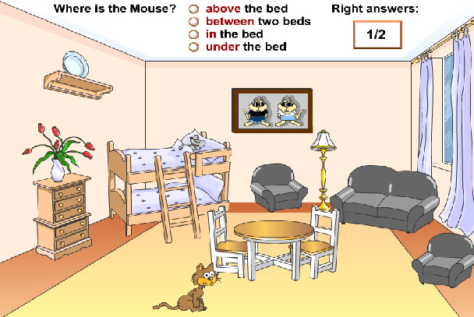
There is ___ a cat in the __________. The cat is ____________ the table. The lamplight is _________ the sofas. The vase is ___ the drawer. The mouse is ___ the bed.

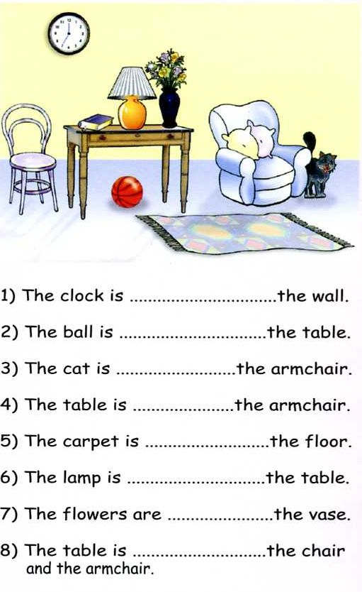

Level 3. Unit 4: Do you like, want, have?
Do you have a cell phone? Yes, _________________________________.
Do you like the pizza? No, _____________________________________.
Do you want an umbrella? Yes, _________________________________.
Do you like the sneakers? Yes, __________________________________.
Do you have blue eyes? No, ____________________________________.
Do you have earrings? Yes, _____________________________________.

Leve 3. Unit 7. My things, what is this? (demonstratives this, that, these, those)
She’s wearing...

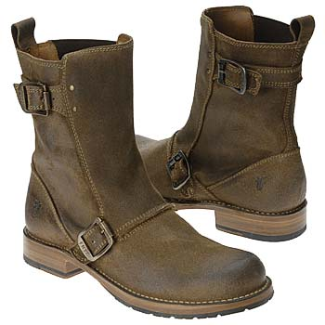
What are these? ________________
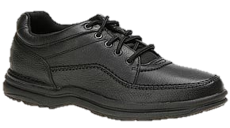
What is this? This is______________.
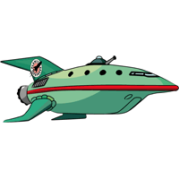
What is this? ____________________
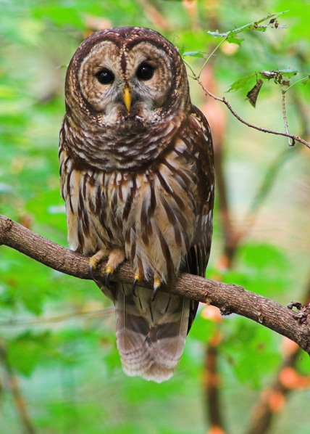
This is ___ owl.
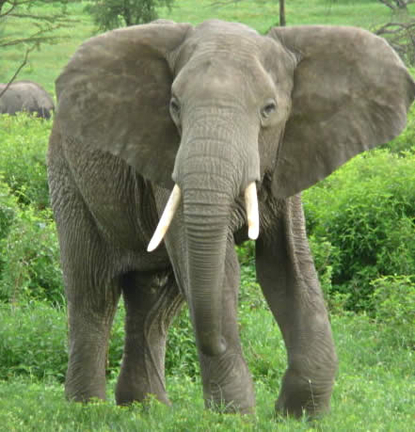
This is _______________.
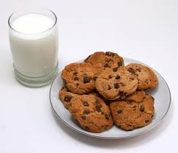
These are _______ and _________

