LOW SES TOWARDS AND INFORMED ,EVIDENCE BASED STRATEGIC CONVERSATION

WHY AM I DOING THIS ?
- BN&W strategic plan identifies the NE and the SW areas of the region as places in which there are the highest gaps between measured performance and Youth Transition program targets.
- BN&W PB team needs to have an agreed position about both the language of LOW SES and some evidence based examples of “ what works “ in similar contexts . people in partnership development
- My basic working hypothesis is
“People ; irrespective of the label we apply to stakeholder groups & sub-groups,hold valid experience based values beliefs,assumptions & make evidence based assertions about youth in poverty. This will engender rigorous debate about both the ends and means of intervention in so called LOW SES communities.”

WHAT RESULTS DO WE WANT ?
THE OPPORTUNITY TO INJECT EVIDENCE BASED OPTIONS TO EXPAND THE RANGE OF POSSIBLE OPTIONS EXPLORED BY PARTNERS.
A COMMON SET OF EVIDENCE BASED ASSERTIONS THAT WILL
- ASSURE THE DELIVERY OF A COMMON MESSAGE
- ALLOW EACH BN&W PB TO APPLY PROFESSION DISCRETION TO THE USE OF THE RESEARCH.
DRAFT STATEMENTS
CULTURAL DIFFERENCE IS A STRENGTH NOT A DEFICIT
THERE ARE A HIGH NUMBER OF INTERDEPENDENT FACTORS THAT UBNDERPIN THE LABEL “ LOW SES”
- PROTECTIVE FACTORS INCLUDE
- RISK FACTORS INCLUDE

HOW DID I ARRIVE AT THAT POSITION?

SITUATION
Poverty is growing faster in Australia than in most other developed nations so that: 11.2% of the population earns less than half the average wage.

LOW SES MAKE UP 15 per cent of tertiary entrance over the last two decades, despite this group making up 25 per cent of the broader population.

Controlling for education, region, wealth of the family and personal characteristics, one year of youth unemployment at the age of 22 in the range has a scarring effect of 13-21% twenty years later ( UK research )

COMPLICATION
Research ( on Low SES student /parent engagement in education)focussed largely on white, middle-class samples,which led to a skewed understanding of how parenting behaviors are affected by socioeconomic and other contextual factors, and limited awareness of how alternative behaviors by other groups might lead to positive child outcomes.

The longterm use of deficit models examine problems rather than the use of more strength-based models in the study of disadvantaged and ethnic minority families.
These models have characterized ethnic minority parenting practices as deficient rather than as “adaptive strategies responsive to unique environmental and historical demands”

Current education policy creates “random acts”of family involvement” (Gil Kressley, 2008) instead of building a coherent, comprehensive, continuous,and equitable approach to involvement.

The increasingly nuanced research about the involvement of economically disadvantaged and racial and ethnic minority families also suggests both that there is a strong desire to be involved in their children’s learning, and that when institutions reach out to engage them and address the barriers to involvement, families will be involved in ways that benefit their children’s academic success.

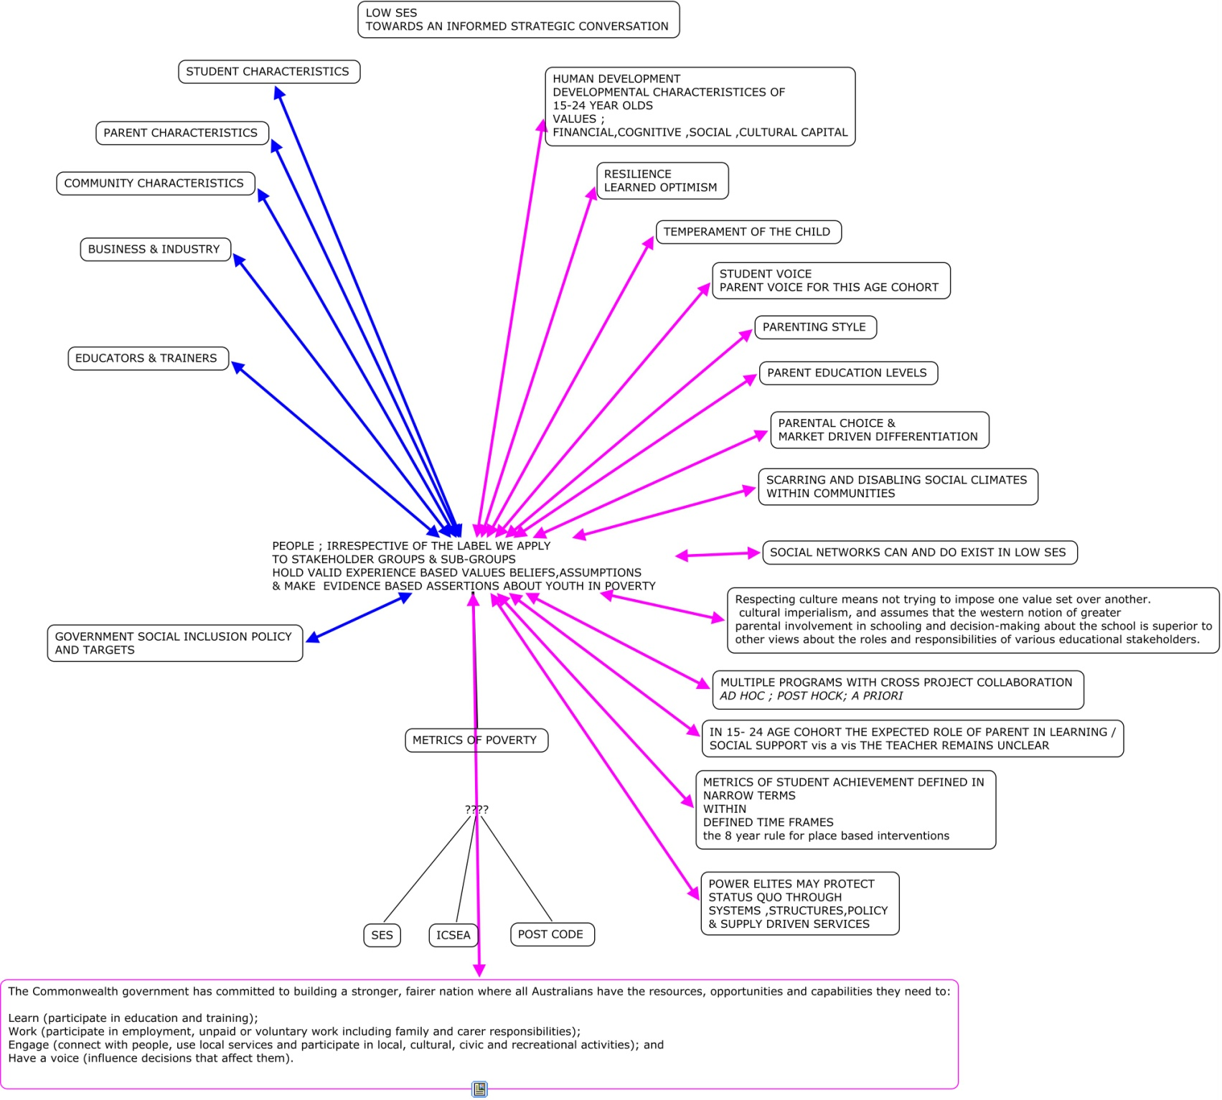

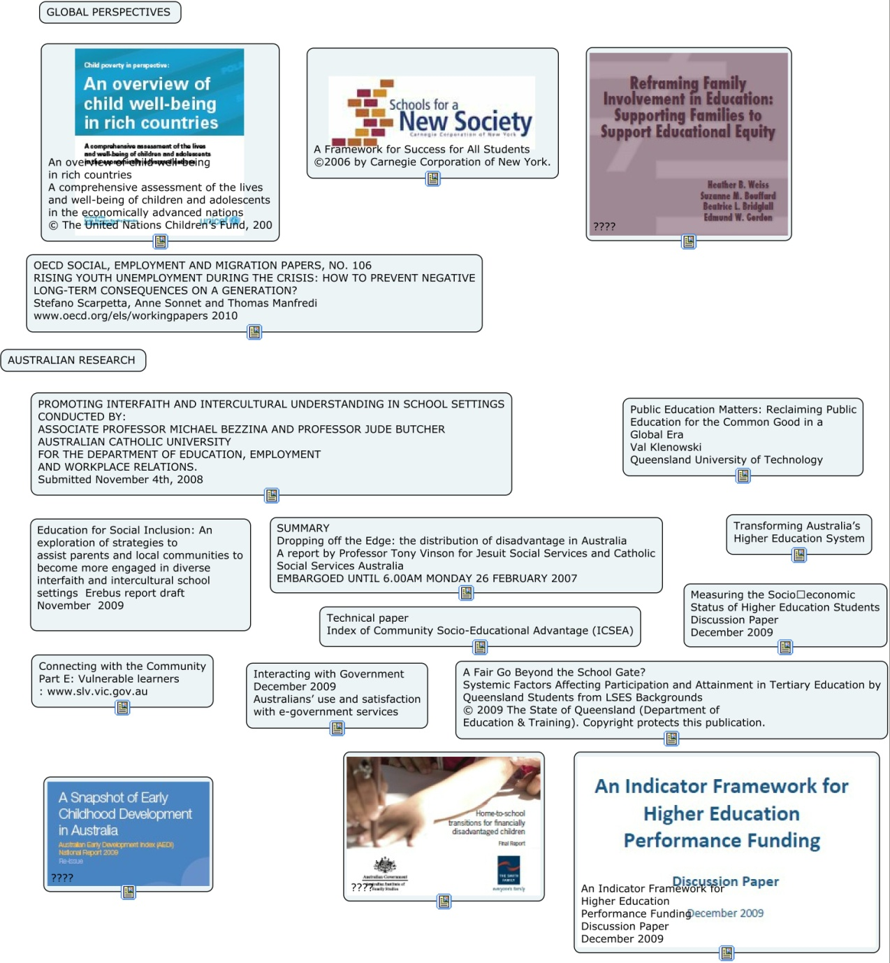

Research on poverty and on socioeconomic
disadvantage in particular has examined a number of
contextual factors and barriers to engaged parenting
and family involvement in learning (Garcia Coll &
Chatman, 2005; Moles, 1993). For example, research
by McLoyd (1990) and McLoyd, Jayaratne, Ceballo, and
Borquez (1994) exemplifi es how variability in parenting
strategies refl ects the way that families react to the
multiple stresses of poverty. Parents living in poverty
or in economic stress, for example, experience higher
levels of emotional strain and mental health problems
(McLoyd, 1990, 1998), which can impair their ability to
engage with and support children and increase their
likelihood of using harsh or punitive parenting practices
(Conger, Vonger, Elder, Lorenz, Simons, & Whitebeck,
1992; McLoyd, 1990, 1998). Poverty constrains families’
abilities to provide educational materials and activities.
Disadvantaged families also experience more logistical
barriers, such as lack of transportation and schedule
confl icts because low-income jobs afford less schedule
fl exibility, paid sick time, and paid vacation time
(Crosnoe, Mistry, & Elder, 2002; Elder, Eccles, Ardelt, &
Lord, 1995; Garcia Coll & Chatman, 2005; Heymann &
Earle, 2000; Jackson, Brooks-Gunn, Huang, & Glassman,
2000; McLoyd et al., 1994; Mistry, Vandewater, & Huston,
2002; Moles, 1993). This research suggests that efforts
to involve families in their children’s learning at home
and at school must address some of the povertyinduced
barriers to involvement and reconsider the
relationship between educational success and adequate
social welfare provision (Rothstein, 2004; Wells, 2006).
Another major factor infl uencing parenting and
family involvement is the discontinuity between
many ethnic minority parents’ indigenous cultural/
social capital and mainstream culture and institutions
(Delgado-Gaitan, 1991; Moll, 1994). Baca-Zinn and Wells
(2000) identify social location or social class as another
a minority person’s social
location (defi ned and shaped by racism, discrimination,
prejudice, and oppression) is typically maintained
by hegemonic institutions, policies, and practices.
Funds of knowledge is defined by researchers Luis Moll, Cathy Amanti, Deborah Neff, and Norma Gonzalez (2001) “to refer to the historically accumulated and culturally developed bodies of knowledge and skills essential for household or individual functioning and well-being” (p. 133). When teachers shed their role of teacher and expert and, instead, take on a new role as learner, they can come to know their students and the families of their students in new and distinct ways. With this new knowledge, they can begin to see that the households of their students contain rich cultural and cognitive resources and that these resources can and should be used in their classroom in order to provide culturally responsive and meaningful lessons that tap students’ prior knowledge. Information that teachers learn about their students in this process is considered the student’s funds of knowledge.
social
class differences in parents’ cultural capital infl uences
children’s cultural capital: working-class parents’ childrearing
philosophy of “the accomplishment of natural
growth” did not include the provision of academically
benefi cial and school-endorsed activitiesAs socioeconomic status is an abstract concept for which there is no agreed international method of measurement, it is particularly important that any measure of SES is closely aligned with causal factors associated with educational advantage and disadvantage (CSHE, 2008, p.19). CHOICE AND RESOURCES LINKS
The extent to which schools should serve the social needs of parents/families, and have a
role to play in community capacity building is perhaps debatable.
Neglectful parenting VS patronizing middle class values imposed
A recent national review of the participation
rates of people from LSES backgrounds in higher
education demonstrates that the interrelationships
and interactions between the multiple factors that
underlie LSES under-representation are complex and
require closer investigation (Universities Australia,
2008).
the potentially limited working knowledge
that parents of LSES students might be able to share
with their children in relation to how universities
operate and what might be expected of them.
METRICS & IDENTITY
The high correlation found between parents’ education levels and their children’s higher education participation (CSHE, 2008; James, 2002; Western et al., 1998) has been attributed to a number of cultural factors in the home. Factors such as role models, information resources, levels of encouragement to pursue educational goals and educational aspirations and expectations that are developed in the home have all been indicated as potential encouraging factors in highly educated homes (James, 2002; Western et. al., 1998; Williams et. al., 1993). by 2020, 20 per cent
of higher education enrolments at undergraduate level
should be people from low SES backgroundsIcsea BASED ON ABS BASED CCD METRICS NOT LCD placebased
policies to reduce social disadvantage must be given longterm
(at least 7 to 8year) timetables for success
As with parental education, the occupation level of parents is seen to affect participation through a number of factors such as role models, career aspirations and the provision of resources for education (James, 2002; Long et. al., 1999; Williams et. al., 1993)
This suggests that despite the clearly close relationship between wealth and parents’ education and occupation, wealth still exerts an influence on participation rates and entry to higher education over and above the other influences of parents’ education and occupation (Long et. al., 1999, p. 72; Williams et. al., 1993, p. 52).
Key factors in the success of the pilot were:
• embedding IIU within the curriculum and life of the school;
• funding both resource focussed professional learning and interschool cooperation;
• adopting a place based approach for the implementation of IIU; and
• promoting a safe place approach for people’s engagement across different cultures and religions
HE Funding will be provided to help universities develop
partnerships and programs with schools and vocational
education and training providers
libraries are core connectors
Tertiary Education Quality and Standards Agency (TEQSA). TEQSA will accredit providers, evaluate the performance of institutions and programs, encourage best practice, simplify current regulatory arrangements and provide greater national consistency.

