Jeanne d’ Arc (1412-1431)

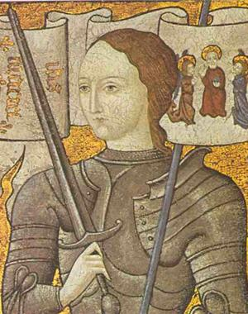
Jeanne d’ Arc was a simple peasant girl who claimed to hear voices in her head which said that she is the one to evict the English people from France. Charles VII sent Jeanne to Orleans and she managed to fight the Englishmen with success. Jeanne seemed to have an immense ability of inspiring other people. The army which was lead by Jeanne d’ Arc was so motivated that they finally went to Reims, defeated the Englishmen and got Charles VII crowned as the king of France in the cathedral of Reims. Jeanne d’ Arc was captioned and burned at stake in the old market square in Rouen. The French army defeated the last remaining English cities which were located in Normandy. Calais was all which remained in English hands. This was the end of the war.

