Imágenes mamíferos

|  |  |
| --- | --- |
| http://www.bio-logia.com.ar/fotos/animales/vertebrados/mamiferos/camello.jpg | http://www.bio-logia.com.ar/fotos/animales/vertebrados/mamiferos/cebras.jpg |

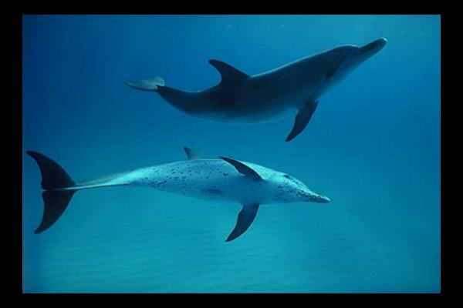

[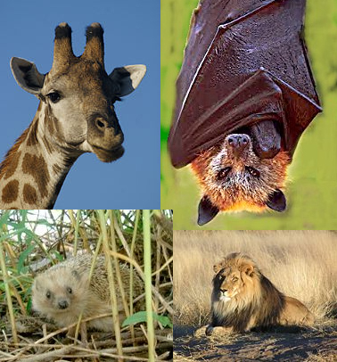](http://upload.wikimedia.org/wikipedia/commons/a/a5/Mam%C3%ADferos.jpg)

[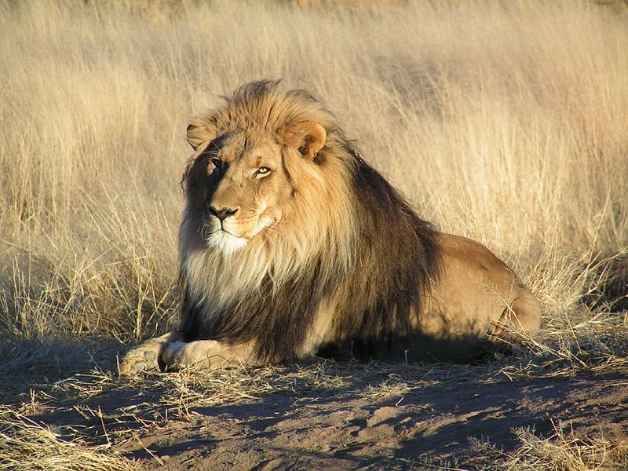](http://upload.wikimedia.org/wikipedia/commons/1/10/Lion_waiting_in_Nambia.jpg)