Hi! My name is Clara.
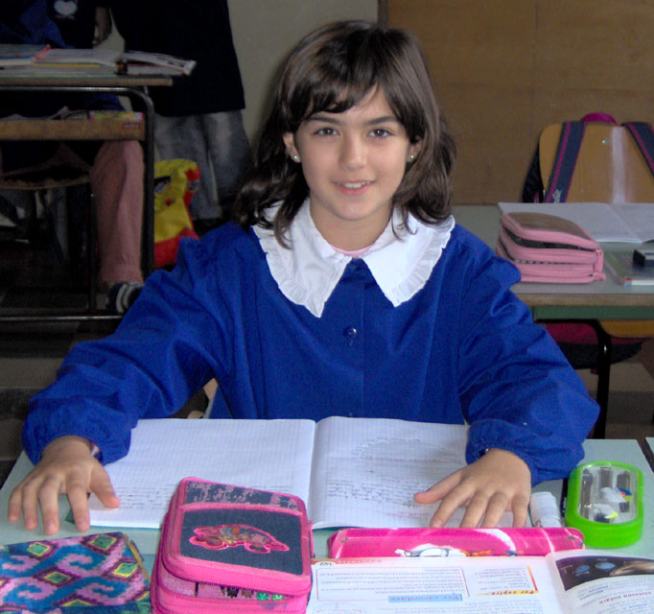
I'm ten yers old . I live in Bernalda , a country inside the Italy. I'm thin and tall, I've got brown hair and brown hair and brown eyes. I' ve got a sister , her name is Carola . She is my best friends.
My favourite singer is Nek , he is an italian singer he is a beautiful man.
I have listened to the TV that he is very famous olso in Spain : Do you know his songs? My favourite sport is basketboll and what is your favourite sport? I like vegetables, ice cream and cholate. I don' t like cheese. Do you like chees? What is your favourite food? If you come to Italy, you will be my guest in Bernalda.

WITH LOVE CLARA.

