Silvia
Hi!My name is Silvia, I’m a girl, I’m ten years old. I’ve got brown and green eyes.
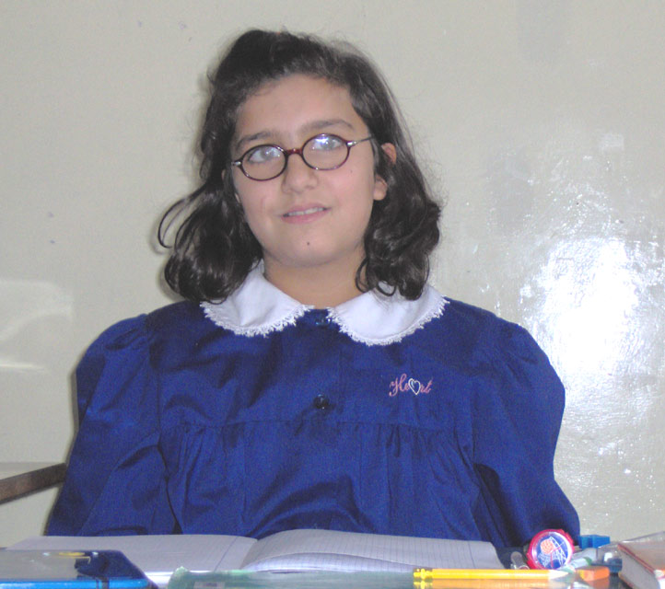
I’ve got glasses I’m tool and thin.
I’live in Bernalda ,a small town in the south of Italia. I’have got a sister but I haven’tgot a brother.
I have got a small dog. My favourite food is hamburger but Idon’T like is crackers.My favourite subyectis are italian and english. My favourite singer is Gigi D’alessio .My favourite sport is vollyball. My favourite friends Roberta and Nunzia .My favourite footballer is Adriano.
LOVE SILVIA P.S.WRITE ME SOON.

