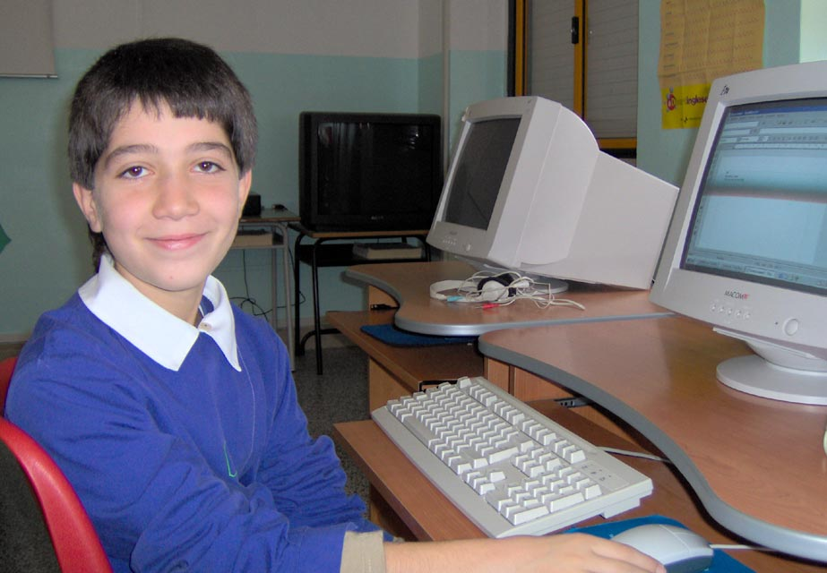
Hi!
My name is Mino
I'm ten yers old; my birhtday in the februry
I'm tall and thin
I've got brown hair and brown eyes.
I've got two sister
I live in Bernalda a small town in the south of Italy.
My favourite sport is basket
I like pizza . My favourite actor is Alexander Pixfull
I like hamburger and cola.

Hello
mino

