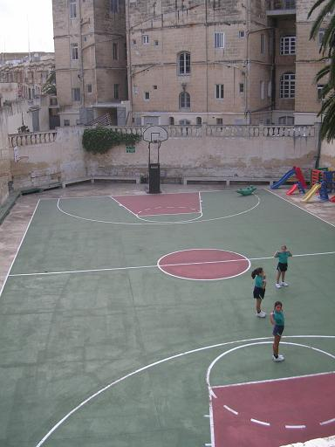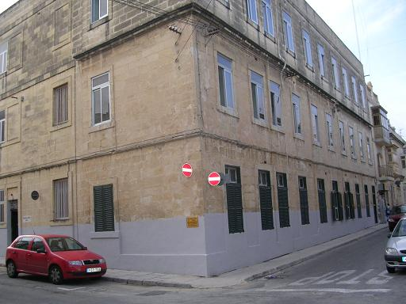St.Joseph, Mater Boni Consilii Paola, Malta caters for 264 mixed ability girls. We have 9 classes starting from Pre-Grade (4 years) till Senior II (12 years). We have two classes participating in the e-twinning project World Wide Maps namely, Grade 2 (6-7 years) and Grade 4 (8-9 years).

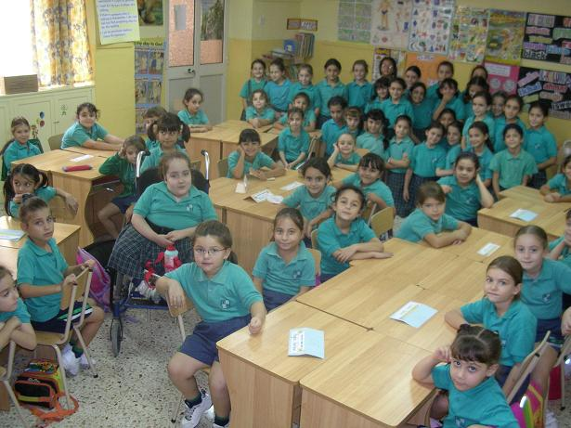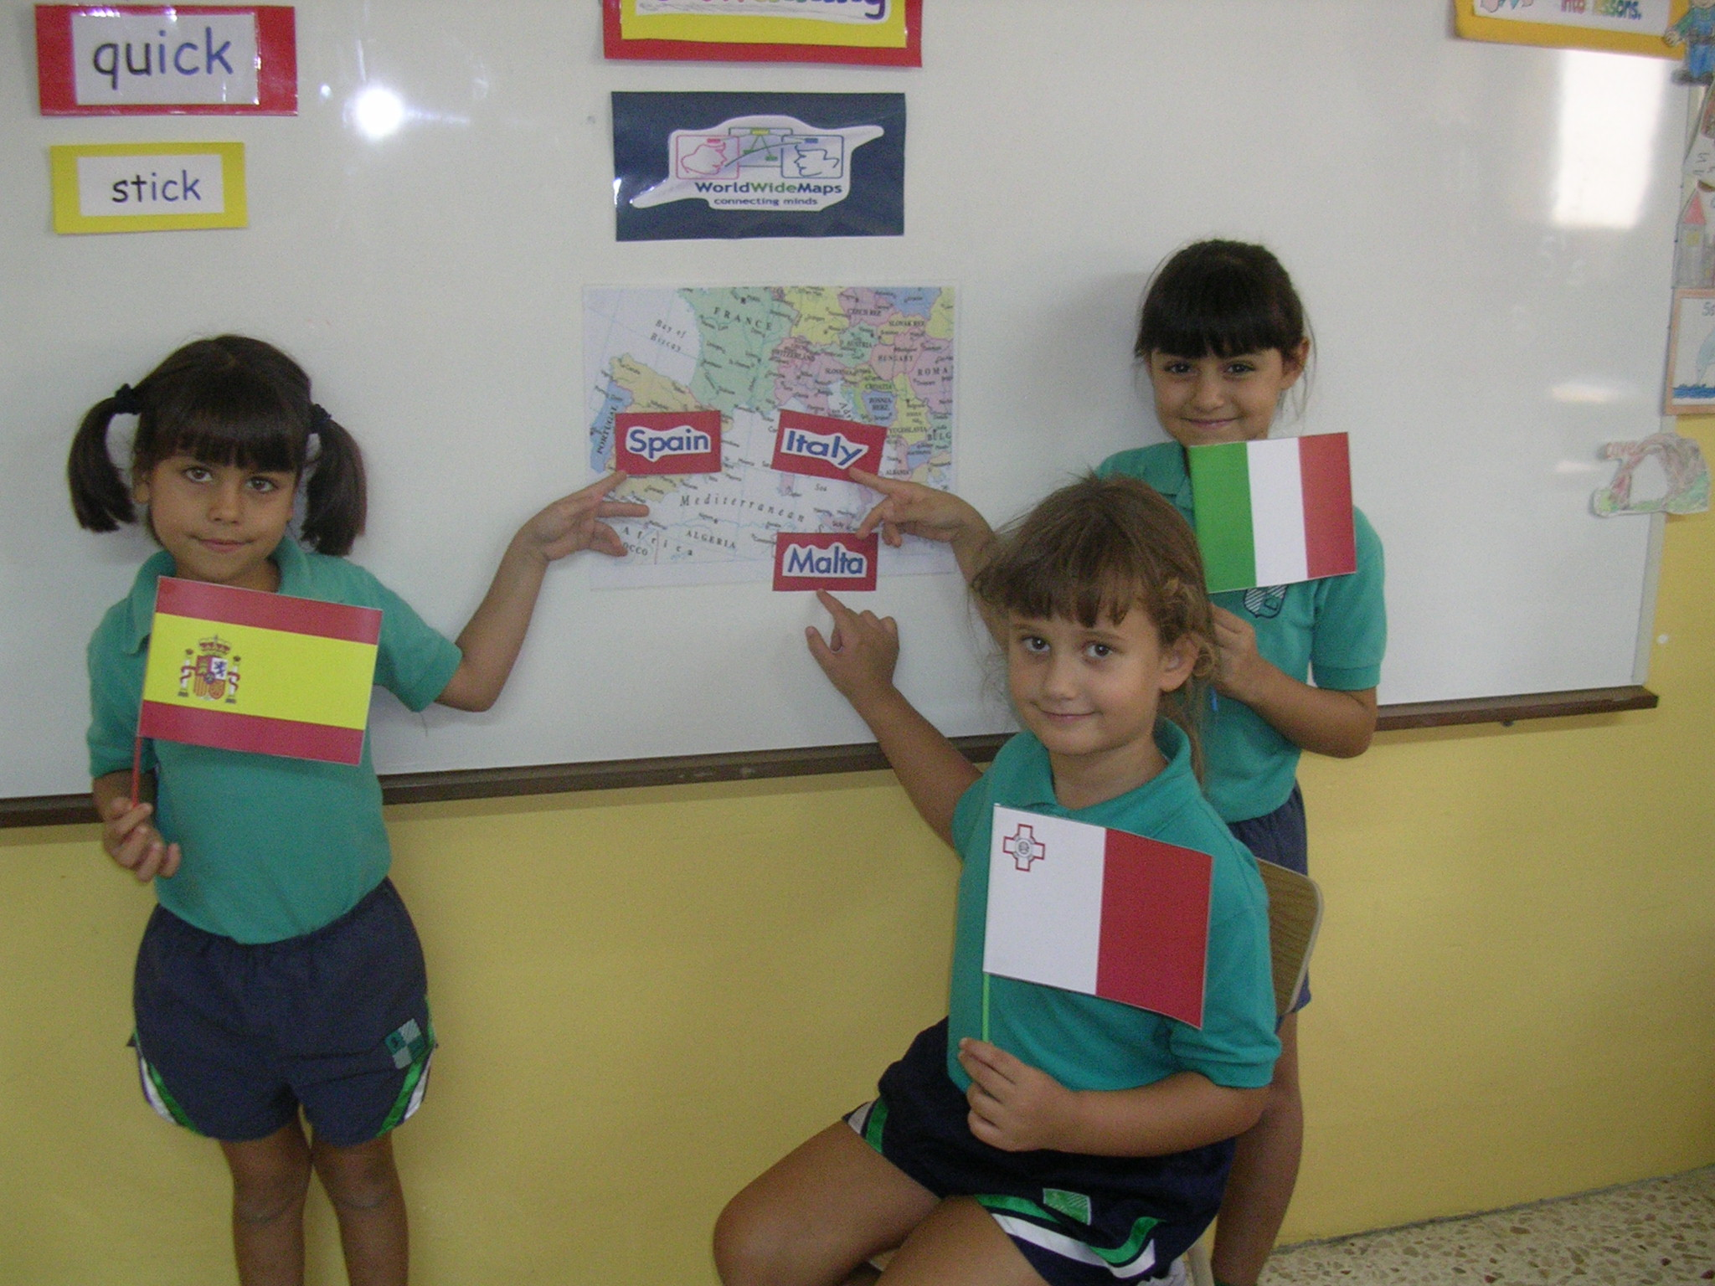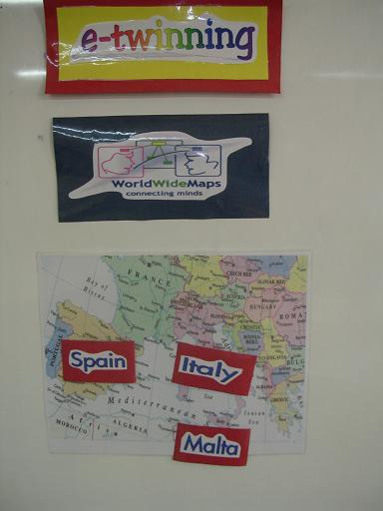In fact, we introduced this project to the two classes together. We started off with a brainstorming activity regarding the word “e-twinning”. The children came up with ideas such as “something similar”, “twins”, and “something connected”. This proved that the word in itself led the children on the right track. After explaining that we were going to work with other European countries, we encouraged the girls to mention how they thought we were going to communicate with these countries which were far away from us. Surprisingly, the children immediately blurted out “through the computer”, “through internet”. Here, we also explained why this European partnership project is in fact called “e-twinning”. We noted that the children, though still very young, were familiar with words like “internet” and “e-mail”. Some of the girls suggested that we were going to make use of “chatting”, and it was here that we introduced our e-twinning project “World Wide Maps”. We had another brain storming session about the title of our project and the girls suggested that we were going to construct road maps to compare our island with other European countries. Here, we explained what concept maps are and that we were going to use these maps to collaborate and extend our knowledge about particular themes. We also explained that Grade 4 would be working on Citizenship while Grade 2 would be working on Materials. We also stated that Italy have already started to work on this theme, while showing them on a map were Italy and Spain are in Europe.
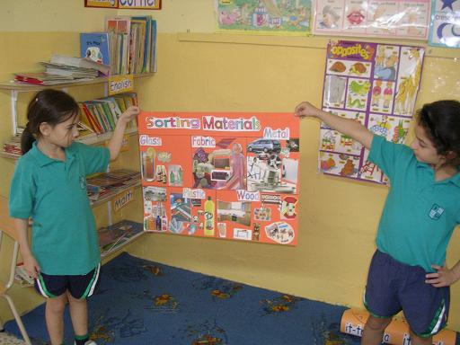
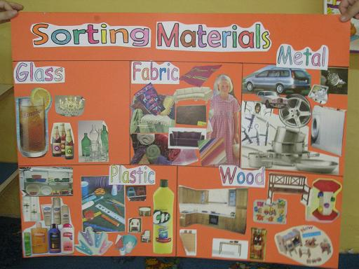During this week, Grade 2 has been discussing the theme “Materials”. We mentioned different kinds of materials, and some of their properties. However, emphasis was put on sorting things made from different materials. This topic has integrated well with the present cross-curricular theme tackled in our class, namely HOMES. In fact, we have discussed and talked about different kinds of homes and what they’re made of and in this way we came across different materials. This was also carried out with the help of a Power Point Presentation displaying different houses such as a house in Malta, a house abroad, igloo, kennel, tepee, cave, tree etc… We also listened to the story of The Three Little Pigs on a cassette and discussed the three different materials used by the pigs to build their houses. We also discussed which of the three houses was the strongest and why. A class activity related to “sorting materials” was then carried out. The children were grouped into 5 groups and each group was given a particular material namely: glass, wood, fabric, plastic, and metal. They were also given various magazines and each group had to find pictures of things made out from the material assigned to them. The pictures found by each group were stuck onto a cardboard by the children for a final product.

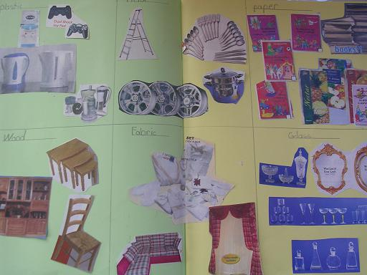This activity was then carried out on an individual level where the girls had find pictures form magazines and stick them on their scrap books. To reinforce what was learnt at school the girls were asked to do some research at home with the help of their parents. The information they got was discussed in class and the new information learnt was added to the map created by Rivoli, Italy about materials. The drawings done by the children from Rivoli were turned into a Power Point presentation so that all the children in the class could see what the Italian children had learnt.
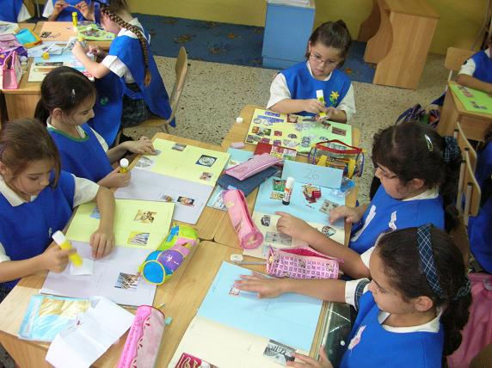

Furthermore, an e-twinning space has been created in the classroom to keep everyone updated with the progress of this project.

