HI!
My name is Riccardo.
I'm ten years old.
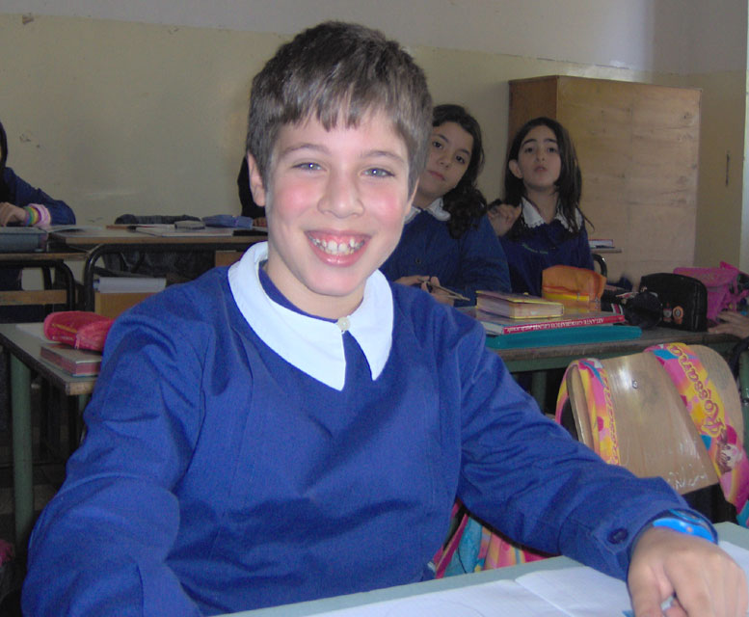
I'm tall and thin.
My birthday is on the twenty of july.
I've got a brother. I've got brown hair and green eyes.
I live in BERNALDA.
I like pasta but I don't like fish.
My favourite pet is cat.
My favourite singer is Mark Knophfler.
My favourite colour is blue.
My favourite subjet is science.
My favourite friend is CHICCO.
I like swim.

Write me soon.
Bye bye.
Love RICCARDO.

