Silvia A
Hy! My name is Silvia,I'm 10 years old.
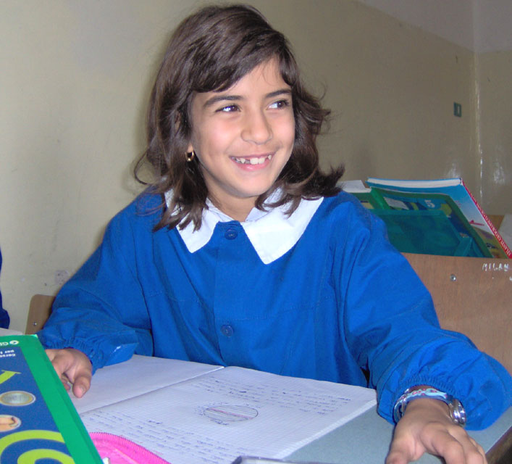
I live in Bernalda. I'm one brother and my birthday is on twentyeight.
I'm brown eyes and brown hair
I like pizza, fish... i don't like vegetbles
I like swim. I lke a actor Bred Peet
My favourite color is red.
My best friend is Alessandra.
I have got one dog.
I like English

hi!
Write me soon
Love Silvia

