Hi !
My name is ANDREA,
I'm ten yars old, my birthday is on the fourth of Februay.
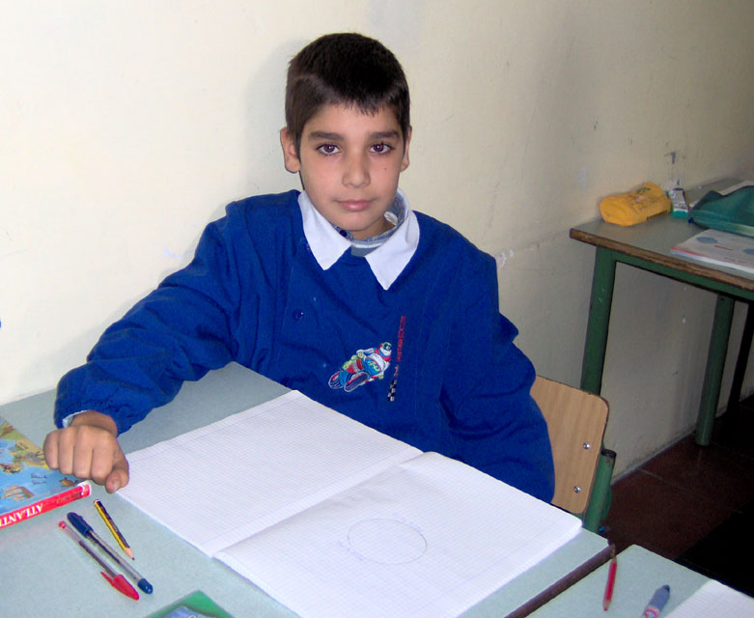
I'm thin and tall, I've got brown hair and dbrown eyes.
I've got two sisters.
I live in BERNALDA, a small town in the souht of ITALY
My favourite sport is basket, my favourite actor is Jhon Cena.
I like juices and pasta with tomatoes souce, I love pizza.

P.S.Write me soon

SINCERELY, ANDREA.

