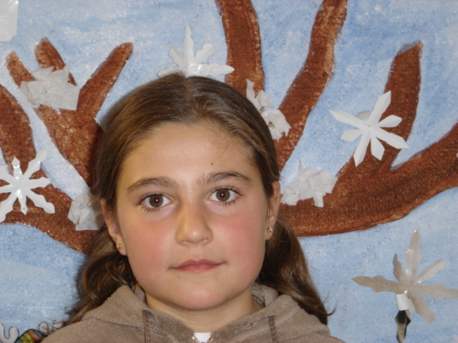Hello . My name is Patricia .

FLOWERS :

INGREDIENTS

3 Eggs
1 Glass of sugar
1 Glass of milk
0 , 5 Glass of sugar

Mix the ingredients well .
You need a special mould to make the flowers .
Introduce it in the mixture of all the ingredients inorder
To impregnate it and then fry it
In very hot oil in a frying pan ( till trey´re light brown )
Finally sprinkle some sugar on the flowers .

THE END

