Module 4 B: Concept Mapping

Maria Dolores Frew

Excelsior College

May 8, 2006

Identify a concept and develop a simple concept map to illustrate the concept. Discuss the possible attributes of the concepts that could be but are not included in the map.

Concept Mapping

In 1989, Graves and Corcoran published a classic work that describes the study of

nursing informatics (NI). The article contributes two major thoughts to NI. Only the first

contribution will be mentioned here. The first contribution is an information model that

identifies data, information, and knowledge as key components of NI practice. Graves

and Corcoran (1989) draw from Blum (1986) to define the three concepts as follows:

Data are discrete entities that are described objective rely without interpretation,

Information is data that are interpreted, organized, or structured, and Knowledge is

information that is synthesized so that relationships are identified and formalized.

Nurses have been recognized as primary processors of information for over 30

years (Jydstrup and Gross, 1966; Zielstroff, 1981). Recently, the concept of nurses a

information managers has been expanded to the idea that nurses are knowledge workers.

One of tools that used for more generation of knowledge is through concept mapping

which has more advantages than brainstorming. This tool enables one to capture more

knowledge, then represented or coded to make it machine readable and then later on

produce more knowledge for research or any end user that is impossible to generate with

just one or 10 people.
According to Wikipedia, Concept mapping is a technique for visualizing the
relationships between different concepts. A concept map is a diagram showing the
relationships in between concepts. Concepts are connected with labeled arrows, in a
downward-branching hierarchical structure. The relationship between concepts is
articulated in linking phrases, e.g., "gives rise to", "results in", "is required by," or
"contributes to". Concept mapping serves several purposes. One, which takes place via
knowledge elicitation, is to represent the mental models, i.e., the cognitive map of
individuals, teams and organizations. Another, which takes place by knowledge capture,
is to represent the structure of knowledge gleaned from written documents. The addition
of knowledge resources, e.g., diagrams, reports, other concept maps, spreadsheets, etc., to
the concept nodes (attached during or after construction) has been found to significantly
improve the level of meaningful learning of the concept mapper. Educators are
increasingly realizing the utility of such maps and have started using them in the
classroom.
Another source states that “Concept-Mapping" is a tool for assisting and

enhancing many of the types of thinking and learning that is required to do in any class.

To do a Map, write the main idea in the centre of the page -- it may be a word, a phrase,

or a couple of juxtaposed ideas, for example -- then place related ideas on branches that

radiate from this central idea.
The advantages of Mapping as opposed to brainstorming maybe stated as such.
Mapping may be seen as a type of brainstorming. Both Mapping and brainstorming may
be used to encourage the generation of new material, such as different interpretations and
viewpoints: however, Mapping relies less on intentionally random input, whereas, during
brainstorming, one may try to think up wild, zany, off-the-wall ideas and connections.
Brainstorming attempts to encourage highly divergent "lateral" thinking, whereas
Mapping, by its structure, provides opportunity for convergent thinking, fitting ideas

together, as well as thinking up new ideas, since it requires all ideas to be connected to
the centre, and possibly to one another. Paradoxically, the results of brainstorming
usually appear on paper as lists or grids -- both unavoidably linear structures: top to
bottom, left to right. Mapping is less constrictive -- no idea takes precedence arbitrarily
(eg. by being at the "top" of the list). It clearly defines the central idea, by positioning it
in the centre of the page.
More Advantages of Concept Mapping:
- It allows you to indicate clearly the relative importance of each idea.
- It allows you to figure out the links among the key ideas more easily. This is particularly important for creative work such as essay writing.
- It allows you to see all your basic information on one page.
- As a result of the above, and because each Map will look different, it makes recall and review more efficient.
- It allows you to add in new information without messy scratching out or squeezing in.
- It makes it easier for you to see information in different ways, from different viewpoints, because it does not lock it into specific positions.
- It allows you to see complex relationships among ideas, such as self-perpetuating systems with feedback loops, rather than forcing you to fit non-linear relationships to linear formats, before you have finished thinking about them.
- It allows you to see contradictions, paradoxes, and gaps in the material -- or in your own interpretation of it -- more easily, and in this way provides a foundation for questioning, which in turn encourages discovery and creativity.
One of the most important points to remember in concept mapping is to “not look at
the material or literature” but do it from memory and write questions down. Forget
outlining thoughts or putting thoughts in paragraphs or sentences. Concept mapping is an
excellent tool for generating more knowledge than what one already knows.

Concept: Arterio-Venous Fistula

Concept Mapping of arterio-venous fistula:

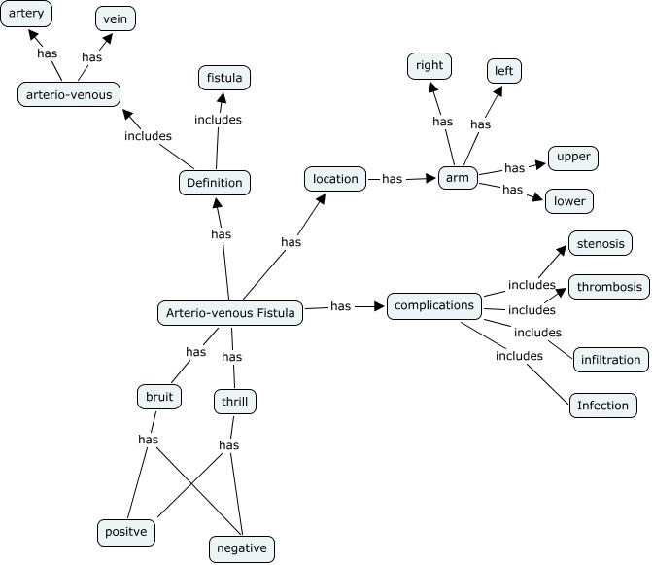

The above concept mapping of the chosen concept “arterio-venous fistula” is not

exchaustive. The concepts found within the concept itself need to be mapped further

until criteria for terminology systems are met (i.e. atomic composition, etc).

Relationships that exist among the concepts have to be recognized – hierarchical and

non-hierarchical, partitive or generic. In theory, there is an unlimited number of
relationships between concepts (de Keizer, 2000). However, in practice only a small
portion of relationships, those determined by human’s knowledge and experience, is

widely useful (de Keizer,2000).

On the presented concept map, the attributes that may still be included but not in the

map are:

- Visual characteristics of an arterio-venous fistula (AVF)
- Locations of anastomoses of an AVF
- Signs and symptoms of the complications involving AVF
- Definitions of each concepts within the concept (AVF) including the actual definition of AVF itself
- Care of an AVF which will produce another concept map
- The relationships between the absence or presence of a bruit or thrill to the complications of AVF
- Other complications of an AVF like aneurysms and prolonged bleeding
- Assessment of an AVF
Pre-dialysis
During dialysis
Post-dialysis
- Life span of an AVF in relation to age of the patient and the disease process the patient has on either their veins or arteries

Just this one concept can produce multiple concept maps that will enable a computer

to recognize what is an arterio-venous fistula. Concept mapping shows how new

knowledge maybe derived as well as the fact that the way human beings think is very

complex. This complexity of thinking has to be unraveled bit by bit so as to make a

computer think like us. Thereby, help man in searching for the elusive solutions that

even a number of experts cannot find. With the history of man, one may think that we

have actually mapped the way man thinks and then we surprise ourselves.

Sources:

Learning Skills Program – Concept Mapping (2003). Counseling Services, University of Victoria, http://www.coun.uvic.ca/learn/program/hndouts/map_ho.html

http://en.wikipedia.org/wiki/Concept_mapping

American Nurses Association (2001). Scope and Standards of Nursing Informatics Practice, 5th printing, 2005. p. 5-8.

de Keizer, N. et al.(2000). Understanding Terminological Systems 1: Terminology and Typology. Methods of Information in Medicine 39. 69-21.

Gerald, B., MD, PhD (2002). Hemodialysis Training Program – Vascular Access. RMS Lifeline

