Identify a concept and develop a simple concept map to illustrate the concept. Discuss the possible attributes of the concepts that could be but are not included in the map.

Mixing the perfect martin may not necessarily be a “nursing” concept, but can certainly lead to a wide variety of potential “health related” problems and situations. This concept map contains some elements of humor (laughter IS the best medicine!) and is not meant to offend anyone.

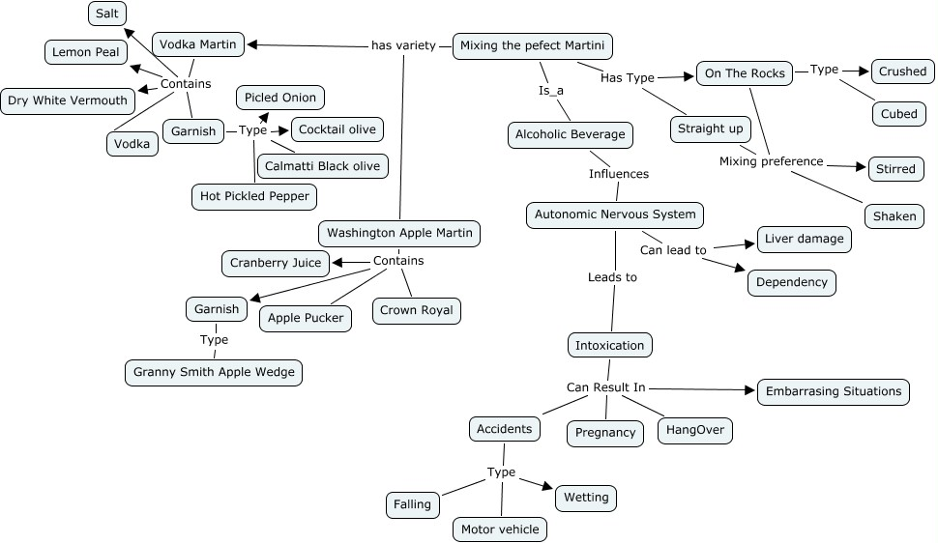

This map could be expanded to include:
- More types of martinis
- Expand on negative health/social impacts
- Include agencies designed to assist with the negative health/social impacts
- Legal issues involved with MVA/DUI

