Name: ________________________________( ) Class: _______ Date: __________

1. The displacement-distance and displacement-time graphs of the same wave motion are given below:

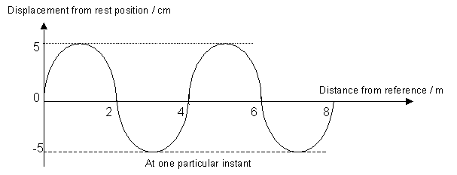

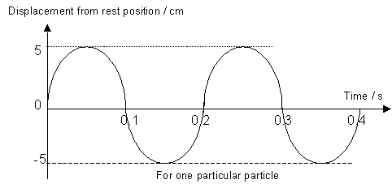
(a) What is the amplitude of the wave motion?

(b) What is the wavelength of the wave motion?

(c) What is the frequency of the wave motion?

(d) What is the speed of the wave motion?

(e) If the wave motion were to carry more energy, which quantity would increase?

(f) If the wave source were to vibrate faster, which quantity would increase?

2. The length between a trough and the nearest crest of a sea wave is 2 m and 8 waves passing a float every 10 s. What is the speed of the sea wave?

