Name: ________________________ ( ) Class: _________ Date: _________

1. The diagram shows a transverse wave.
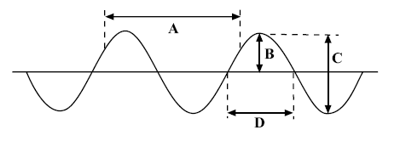
(a) Which of A, B, C or D is:

(i) the wavelength; ......................

(ii) the amplitude? ......................

(b) What is meant by a transverse wave?

(c) What is meant by a longitudinal wave?

(d) Measure the wavelength with a ruler. _______________

(e) Measure the amplitude with a ruler. _____________

