Matthew Rasler
9/26/2011
CS 360
SWEBOK Knowledge Area 9 – Software Engineering Tools and Methods
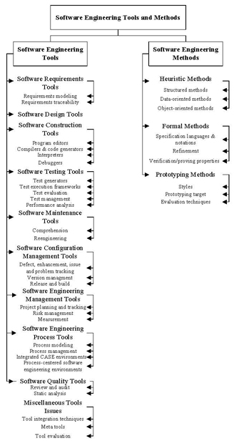
Software engineering tools are computer-based tools that assist in the development of software, allowing for repetitive tasks to be automated, and to increase efficiency throughout the software life-cycle. These tools include tools specific for modeling software requirements, creating and checking software designs, program editors, compilers and code generators, testing tools, maintenance tools, configuration management tools, engineering management tools, process tools, quality tools, among others. Tools utilize software engineering methods including structured, data-oriented, and object-oriented methods, prototyping methods, and formal methods.
We have used various tools in the development of our project thus far, including design tools: Aclarro Axiomatic Design Tools, Visio, and Project to implement structured, data-oriented, and object-oriented methods.

