Matthew Rasler
9/26/2011
CS 360
SWEBOK Knowledge Area 7 – Software Engineering Management
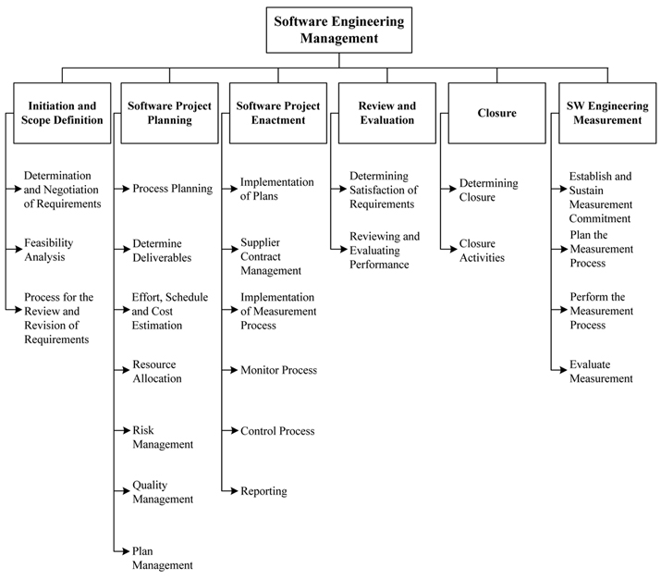
“Software Engineering Management can be defined as the application of management activities—planning, coordinating, measuring, monitoring, controlling, and reporting—to ensure that the development and maintenance of software is systematic, disciplined, and quantified (IEEE610.12-90).”
SWEBOK states that the determination and negotiation of requirements, feasibility analysis, and process for review and revision of requirements are all important to the success of the company in the software engineering discipline and must be determined with accuracy.
The management of the software product must also determine appropriate processes, deliverables, scheduling, and resources. Part of the planning includes risk management, quality management, and plan management. Once plans become enacted, they must be controlled, monitored, measured, and reported upon. At critical points, satisfaction of requirements should be determined and performance reviewed.
Through the enactment of a project manager, through the use of Microsoft Project to measure, assign, and monitor progress, and through the deadlines set by the program manager, we have utilized concepts in this knowledge area to assure the highest level of success of our project.

