[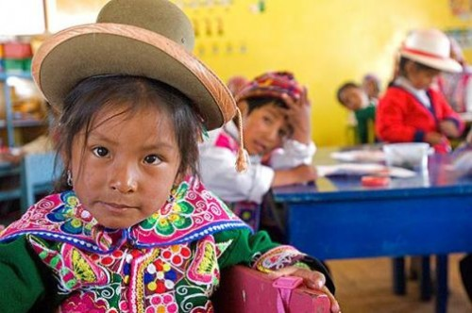](http://www.google.com.pe/url?sa=i&rct=j&q=&esrc=s&source=images&cd=&cad=rja&uact=8&ved=0ahUKEwjG2fKHh-fKAhUF5iYKHVQKDIcQjRwIBw&url=http%3A%2F%2Fdiario16.pe%2Fnoticia%2F44949-unicef-destaca-educacion-lengua-originaria-que-imparte-peru&psig=AFQjCNEsAI24amIdt7pLgn2YdRXUf8XqDw&ust=1454982684802027)