CHARLEMAGNE’S CORONATION
Two days later it was Christmas. St. Peter’s Basilica was full of people wearing colorful clothing and shiny ornaments. Charlemagne entered, wearing sandals and dressed in the Roman style with a long tunic and cloak. He proceeded to the altar, where he knelt down and prayed for a long time in silence. Leo III, the pope, walked towards him and placed a golden crown on his head. All the people cheered and shouted three times: ‘To the Emperor Charles Augustus, crowned by God, noble and peaceful emperor of the Romand, life and victory!’ The noise was very loud. The pope knelt before the emperor and kissed his cloak. Charlemagne became the emperor of the West. He was the first since the fall of the Roman Empire in 476.
F. LEBRUN
The days of Charlemagne (adapted)

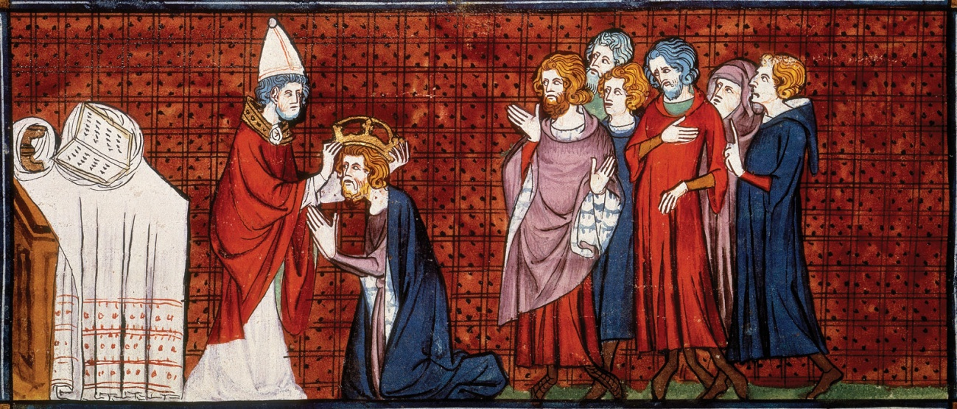

- What do the underlined words mean? Try to guess and then check in a dictionary.
- What was Charlemagne wearing for his coronation?
- What did he do when he entered the church?

