Open the website- http://www.explorelearning.com.
  - Login and search the bolye’s law.
  - Click “Exploration Guide” and Read the direction carefully.

A. Boyle's Law – Effect of pressure on the volume of gas.
  - Do the simulated experiments with Boyle’s Law at the temperature of 273K. Change the pressure step by step from 5kg(147.15N/m²) to 50kg(1471.5n/m²). Make sure that you open the table and record the data every time like the following picture.
  - Take the snapshot of the table and the graph after finishing the experiments. => If you want to know how to take snapshot and use it, read the following “Help”.
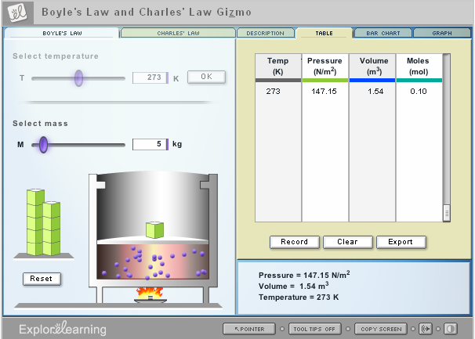

B. Charles' Law – Effect of temperature on the volume of gas.
  - Do the simulated experiments with Charles’ Law at the pressure of 10kg. Change the temperature step by step from 100K to 500K. Make sure that you open the table and record the data every time like the following picture.
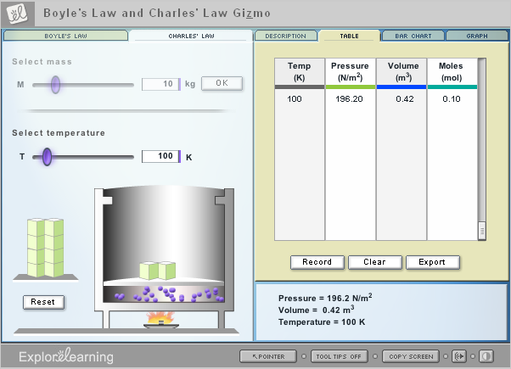
  - Take the snapshot of the table and the graph after finishing the experiments.
4. Data

A. Boyle's Law – Effect of pressure on the volume of gas.
- Paste your data tables here.
- Paste your graphs here.

B. Charles' Law – Effect of temperature on the volume of gas.
- Paste your data tables here.
- Paste your graphs here.
5. Analysis of Data
- What pattern did you notice with respect to the effect of the pressure on the volume of gas?
- How would you describe the relationship between the pressure and the volume of gas at the same temperature mathmatically?
- What pattern did you notice with respect to the effect of the temperature on the volume of gas?
- How would you describe the relationship between the temperature and the volume of gas at the same pressure mathmatically?

6. Discussion and Conclusion
      - How would you explain the volume of gas?
      - Why and how does the volume of gas change depending on the pressure?
      - Why and how does the volume of gas change depending on the temperature?
      - Would you give me examples of our life that use the Boyle’s law and Charles’ law?

