Matthew Rasler
CS460-Senior Capstone Project
EARL Group
2/1/2012
PMBOK-Knowledge Area 3: Overall Change Control
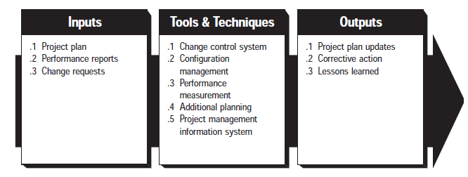
The PMBOK Knowledge Area of Overall Change Control details 3 factors: influencing in a positive direction the factors which create change, understanding and detailing when change occurs, and managing these changes as they happen. It requires insuring that performance measurement baselines and project scope are reflective and accurate, and that changes are reflected in other knowledge areas as they apply, when they occur.
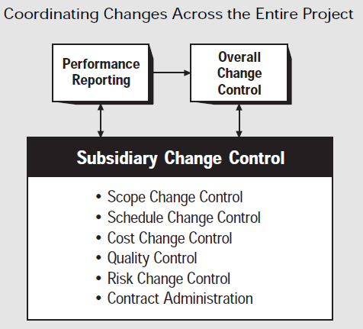
This knowledge area is broken up into 3 subsections: Inputs to Overall Change Control, Tools and Techniques for Overall Change Control, and Outputs from Overall Change Control. Inputs to Overall Change Control include the Project Plan, Performance Requirements, and Change Requests. Tools and Techniques for Overall Change Control include: a Change control system, configuration management, performance measurement, additional planning, and a project management information system. Outputs from Overall Change Control include: Project plan updates, Corrective actions, and Lessons learned.

