Matthew Rasler
9/26/2011
CS 360
SWEBOK Knowledge Area 8 – Software Engineering Process
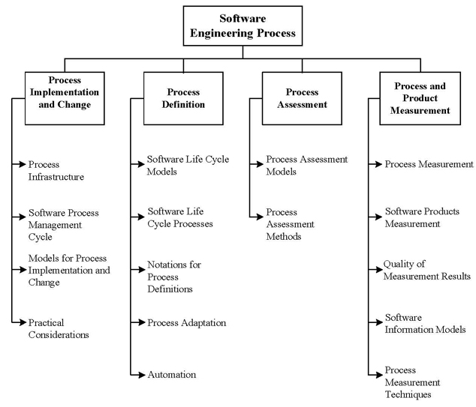
This knowledge area focuses on the definition, implementation, assessment, measurement, management, change and improvement of the software life-cycle processes. This is done through the creation of a process infrastructure, with feedback received through an iterative process management cycle. The software life-cycle processes are given definitions by software life cycle models, and software life cycle processes. Processes must then be assessed using assessment models following specific assessment methods. The quantitative information collected from the process is then collected and measured by size, structure, and quality.
For this project, we have used both the waterfall and v-methods to insure quality in the processes of the software development life-cycle.

