Cyber-physical systems are systems that utilize a combination of computational and physical elements. These systems have been around for a long time, but under a different name. Past cyber-physical systems were more embedded rather than cyber-physical. Embedded systems are computer systems that can be found in devices such as watches, televisions, cars, and microwaves. Embedded systems focus more on the computations then combining computations with physical processes [1].
One of the first modern embedded systems was the Apollo Guidance Computer. This system was developed at MIT by Charles Stark Draper. This project was considered the riskiest part of the Apollo project because it used to the, at the time new, monolithic integrated circuits to decrease the system’s size and weight. The earliest mass-produced embedded system was the Autonetics D-17 computer that was used as the guidance system for the Minuteman missile in 1961. This system featured transistor logic and a hard disk used as the main memory. This computer was replaced in 1966 with the development of the Minuteman II missile. Embedded systems are computers that are designed for very specific functions within a larger system, usually control functions. When used for control functions, these systems often use the constraints on real-time computing. Since these systems are only made to handle very specific tasks, they can be designed in a way that minimizes the size and cost while increasing the performance and reliability [2].
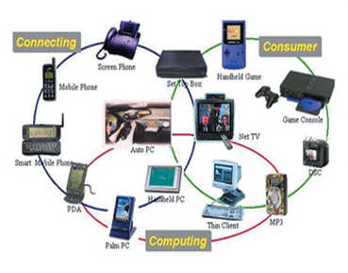
Figure 1: Examples of consumer products using embedded systems.
Cyber physical systems have evolved significantly since the days of embedded systems. While embedded systems are still widely used, there are a few consumer devices using cyber-physical systems. An example of this is a smartphone, like an Android or iPhone. Cyber-physical systems at present are widely used in sensor networks and the UAVs used by military departments around the world. With the current evolution of electronics, it is still clear that cyber-physical systems will be at the forefront of this evolution [1].
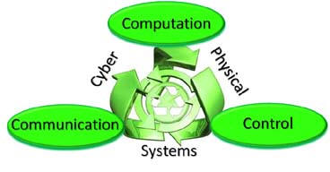
Figure 2: This figure shows the relationship among the three primary concepts behind a cyber-physical system.
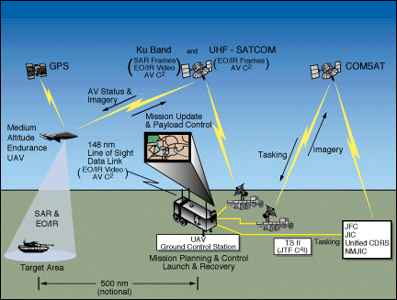
Figure 3: A diagram showing the communication network used by a UAV.
The future of cyber-physical systems is a bright one. Continued research in the area of cyber-physical will yield systems that have more adaptability, autonomy, efficiency, functionality, reliability, safety, and usability and systems used today. This evolution could lead to systems that allow us to work in more dangerous places which could enhance our current search and rescue techniques, and respond faster which could give rise to systems to avoid collisions. In addition, these systems could also be more precise, efficient, provide a large-scale coordination, augment human abilities, and enhance the overall wellbeing of a population [3].
I think that cyber-physical systems will greatly impact the world in the future. If research into cyber-physical systems continues, the chances that we will have systems for enhancing normal human abilities and possibly even have systems that can be used to assist the disabled, like helping paraplegics walk again.
The topic in cyber-physical systems that most interests me is sensor networks. This is an interesting topic to me because the current system for traffic control is made up of embedded systems. If these systems were changed over to cyber-physical systems, they could analyze the current flow of traffic to ensure that lights stay green long enough to allow the most traffic flow through a given light without the need for surveys to be done to analyze traffic flow.

