Skill Shortages in the Moreton Bay Region

Definition of Skill Shortages
Skill shortages have been defined by Trendle (2005) as, ‘the existence of a shortage of skilled workers who possess the ability to perform a productive task at a certain level of competence expected by their employers at the prevailing wages and working conditions’. In the long run, wages will either rise, supply will increase (through greater numbers undertaking training for the necessary qualifications), or firms will undertake capital investment, either so that jobs can be performed by workers with lower skills, or to replace workers with capital equipment. This capital intensification has occurred in Australia in both the Wholes and Finance and Insurance industries (and to a lesser extent in the Mining and Manufacturing industries).

Australian Experience with Skill Shortages
In a perfect market wages would adjust to the point that supply and demand for specific skills would be back in equilibrium, however this doesn’t happen in part due to institutional rigidities that don’t allow wages to adjust quickly. The wage leadership model of wage determination suggests that workers and unions are focussed on changes in wage relativities, therefore changes in certain awards to reflect the scarcity of certain skills may lead industrial action or unsustainable increases in wages. With a history of centralised wage setting, wage relativities in Australia are fairly rigid, ensuring that wages are unlikely to adjust to provide a strong incentive for workers to move into industries where they would be most valued.
There is evidence across Australia, and across Queensland of skill shortages in key industries. These eased considerably through the ‘Global Financial Crisis’ (GFC) as firms concentrated attempts on trying to retain their key staff, but due to the large success of such measures there has been a limited rise in unemployment, which peaked at 5.9% in July 2009. Since then labour markets have tightened significantly, with the unemployment rate dropping to 5% in December 2010. This has coincided with increasing numbers of people re-entering the labour force in search of increased opportunities. This caused the national participation rate to rise to the highest point ever recorded in November 2010 at 66.1%. As part of their six-monthly reporting on skill shortages in Australia, the Department of Education, Employment and Workplace Relations (DEEWR) suggest that over the nine months to June 2010 there were strong signs of recovery in demand for skills and shortages have become more widespread.

Skills Shortages in the Moreton Bay region
Skills shortages are particularly difficult to quantify, and while an effort has been made to do so on a State and National level by DEEWR (alluded to above), it is unlikely to be attempted on a regional level. However, there is significant anecdotal and indirect evidence to draw reasonable inferences as to the level (if any) of skill shortages in the Moreton Bay region. In recent years, the Moreton Bay region has had a limited pool of surplus labour with very low unemployment rates, which have remained lower than the state average over the past few years. In the September quarter 2008, the Moreton Bay region had an unemployment rate 2.3%, significantly lower than what most economists would term ‘full employment’. The labour market has moderated throughout the GFC reaching a peak of 5.1% in the March quarter 2010, however as the economy bounces back with above trend growth this is causing the labour market to tighten again, reaching 4.6% by the September quarter 2010. As the region continues to expand rapidly, this is likely to increase the need for skilled workers in the region as new estates and businesses are developed within the region.
Figure 3.1 Unemployment Rate (smoothed series) for Moreton Bay region and Queensland

(a) Figures are smoothed synthetic estimates based on Australian Bureau of Statistics labour force estimates and Census 2006 data and Centrelink Newstart and Youth Allowance (Other).
(b) Smoothed data (data based on a four quarter average) are not available prior to March quarter 2008.
(c) Based on ASGC 2006 boundaries.
Source: Department of Education, Employment and Workplace Relations, Small Area Labour Markets Australia.
Within the Moreton Bay region, 52.2% of persons aged over 15 years have no post-school qualification. This is significantly greater than the South East Queensland average of 47.9%. Only 9.9% of those aged over 15 in the region hold a Bachelors degree or higher, compared to 15% in South East Queensland. The region does have a greater proportion of those with a certificate level qualification than the South East Queensland region, reflecting the nature of the workforce in the region. In 2009, there were 21,974 people undertaking Vocational Education and Training (VET) studies in the Moreton Bay region, which is 8.1% of those undertaking VET studies in the State, less than the region’s proportion of the population (8.4%).
Anecdotal evidence from engagement with the local business community suggests recruitment broadly is not an issue with a high volume of response to advertisements. Some businesses are struggling to recruit motivated, committed and enthusiastic apprentices and lower level staff, with engaging school based apprentices seen as complex by many businesses. In particular job seekers need to improve basic employability skills, including resume writing and personal presentation.
Attempts to combat skill shortages in the Moreton Bay region have been made through the establishment of specific industry linked secondary school programs. The best example of this is the Laboratory Trade Training Centre launched at Redcliffe State High School. The Australian Trade College provides school based apprenticeships across eight trade areas, as well as managing Industry Reference Groups for the metal and automotive trades.

References
Department of Education, Employment and Workplace Relations 2010, Skill Shortages Australia: June 2010, Department of Education, Employment and Workplace Relations, Canberra.
Quain, A 2009, Redcliffe – Dakabin Corridor Skills Formation Strategy, Initial Research Report, Moreton Bay Regional Council, Moreton Bay region.
Trendle, B 2005, Perspectives on Skill Shortages, Working Paper No.33, Queensland Department of Employment and Training, Brisbane.
Trendle, B 2008, Skill and labour shortages – definition, cause and implications, Working Paper No.54, Queensland Department of Employment and Training, Brisbane.

Industry and Development
In the 12 months ending 31 March 2010, there were 4,298 dwelling units in new residential buildings approved in Moreton Bay Regional Council, which represented a total of $908.2 million.
The total value of agricultural production in the Moreton Bay Regional Council in 2005–06 was $167.6 million, 1.9 per cent of the total value of agricultural production in Queensland.
In 2006–07, there were 24,669 businesses in Moreton Bay Regional Council, 6.1 per cent of all Queensland businesses.
At the time of the 2006 Census, there were 64.6 per cent of all occupied private dwellings in the region with an internet connection.

SMALL AREA LABOUR MARKETS
The number of unemployed persons aged 15 years and over (based on a smoothed series) in Moreton Bay Regional Council Local Government Area (LGA) in March quarter 2010 was 9,393 persons. This represented an unemployment rate of 5.1 per cent, compared with Queensland which had a smoothed unemployment rate of 5.6 per cent.

EMPLOYMENT BY INDUSTRY
At the time of the 2006 Census, Retail Trade was the largest industry of employment for Moreton Bay Regional Council Local Government Area (LGA) usual residents, with 18,565 persons or 12.5 per cent of the region's employed labour force. Other industries with relatively large numbers of employed persons included Manufacturing (17,433 persons or 11.7 per cent) and Health Care and Social Assistance (16,163 persons or 10.9 per cent).
The highest specialisation ratios in the region occurred in the industries of Transport, Postal and Warehousing (1.24), Manufacturing (1.18) and Other Services (1.14).

VALUE OF AGRICULTURAL PRODUCTION
The total value of agricultural production in Moreton Bay Regional Council Local Government Area in 2005–06 was $167.6 million, 1.9 per cent of the total value of agricultural production in Queensland. Crops accounted for $124.4 million or 74.3 per cent of the regions total value of agricultural production, livestock slaughtering accounted for $33.5 million (20.0 per cent) and livestock products were valued at $9.6 million (5.8 per cent of the total).
The region produced 3.0 per cent of the total value of crops in Queensland, and 0.8 per cent and 2.3 per cent of the total value of Queensland livestock slaughtering and livestock products respectively.

BUSINESS COUNTS BY EMPLOYMENT SIZE
In 2006–07, there were 24,669 businesses in Moreton Bay Regional Council Local Government Area (LGA), 6.1 per cent of all Queensland businesses. Of these businesses, 23,811 were small businesses (96.5 per cent of the total, compared with 95.5 per cent in Queensland), 771 were medium businesses and 87 were large businesses.
Moreton Bay Regional Council LGA contained 6.2 per cent of all small businesses in Queensland, 4.9 per cent of all medium businesses and 3.2 per cent of all large businesses.

BUSINESS COUNTS BY TURNOVER RANGE
In 2006–07, there were 24,669 businesses in Moreton Bay Regional Council Local Government Area (LGA), 6.1 per cent of all Queensland businesses. Of these the region contained 11,610 businesses with a turnover under $100,000 and 11,019 businesses with a turnover between $100,000 and $1 million. There were 2,040 businesses with a turnover of $1 million or more (8.3 per cent compared with 11.1 per cent for Queensland).
Moreton Bay Regional Council LGA contained 6.6 per cent of all businesses in Queensland with a turnover less than $100,000 and 4.5 per cent of all businesses with a turnover of $1 million or more.

Central Moreton Business Life
Situated within the Moreton Bay region, the Redcliffe-Dakabin Corridor has benefitted from the significant growth experienced within the region in the past five years. when compared to South East Queensland, at 9.6%. With an estimated GRP of $8.9 billion in 2007-2008 the region is well poised to provide all the economic benefits of a capital city to its residents and investors (source: AEC Group 2010).
Based on data from the Australian Bureau of Statistics, the business community is dominated by small to medium sized businesses with 91.7% of businesses employ 19 or fewer employees and 67.8% employing fewer than 4 people. The retail sector is by far the largest in the area in terms of employment and economic impact.
The business sectors which are the key drivers of the Moreton Bay region economy in terms of regional exports, employment, value-added and local expenditure on goods and services are summarised below:
The total economic output for the Moreton Bay region is $19,917.194 million. This figure represents the gross revenue generated by businesses and organisations in Moreton Bay region and breaks down in to the following industry sectors:
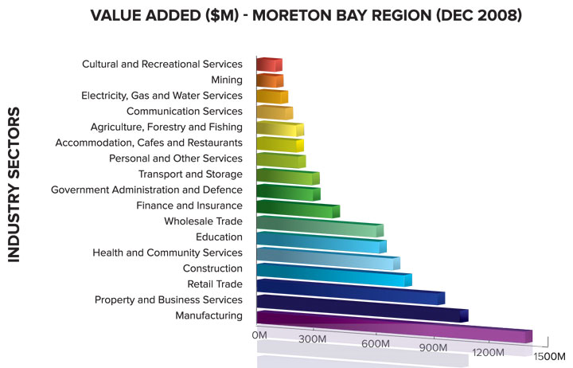
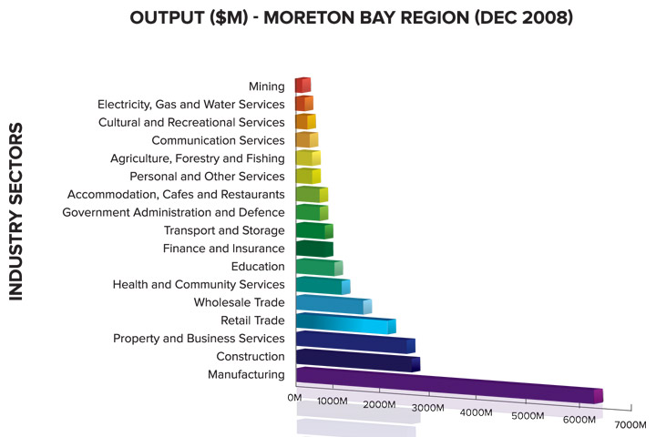
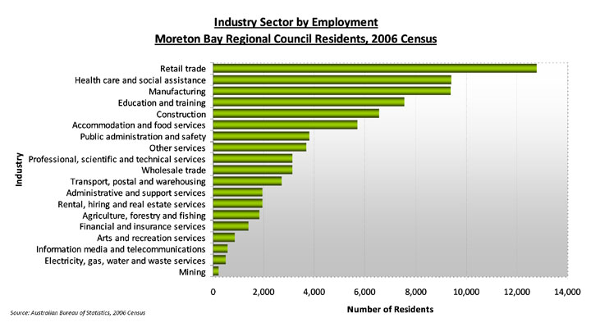

A Ready Workforce
The top five industry sectors in the Moreton Bay region are summarised in the points below:
- Retail trade largest industry of employment, (12,794 persons or 16.6)
- Health care and social assistance (9,417 or 12.2 per cent),
- Manufacturing (9,380 or 12.2 per cent),
- Education and training (7,569 or 9.8 per cent)
- Construction (6,554 or 8.5 per cent).
Source: Australian Bureau of Statistics, Census of Population and Housing, 2006.

Federal Gov Skill Shortage List – Dept of Immigration

All Australian States
- Automotive Electrician  - Fitter  - Furniture Upholsterer  - Metal Fabricator (boilermaker)  - Metal Mechanist (first class)  - Motor Mechanic | - Panel Beater  - Pastry Cook  - Sheet Metal Worker (first class)  - Toolmaker  - Vehicle Painter  - Welder (first class)

Queensland
- Auto Electricians  - Electronics Technicians  - Electricians  - Refrigeration mechanics  - Boilermakers  - Carpenters  - Diesel Fitters  - Mechanics  - Tradesperson -all  - Bricklayers  - Fitters & Tuners  - IT Specialists  - Plumbers  - Tilers  - Welders  - Automotive Trades  - Building Trades  - Air Conditioning Mechanics  - Architectural Associate  - Building Engineering Associate Professional  - Chef  - Civil Engineering Associate  - Cooks  - Diesel Mechanics  - Electrical Engineers  - Electrical Engineering Associate  - Electrical Engineering Technician  - Electrical or Electronic Engineering Technologist  - Electricians | - Mechanical Engineering Associate  - Mechanical Engineering Technologist  - Painters  - Panel Beaters  - Plumbers  - Cabinetmakers  - Dental Technicians  - Electrical Mechanics  - Motor Mechanics  - Pressure Welders  - Refrigeration Mechanics  - Building Inspector  - Pastry Chefs  - Plasterers  - Boat Builders  - Metal Machinist (laser cutting & sheetmetal qualifications & experience  - Sheetmetal workers  - Spray Painters  - Construction Trades  - Bakers  - Business Machine Mechanic (photocopier Technician)  - Gas Fitters  - Hairdressers  - Metal Fabricators

Moreton Bay Region Schools

The Moreton Bay Region has 12 State High Schools and 11 Colleges, 1 Flexi School and 1 Special School delivering VET in Schools.
The most popular VET Subjects:
Certificate I in Information Technology with 8 Schools/Colleges delivering,
Certificate II in Business with 10 Schools/Colleges delivering, Certificate II in Information Technology with 11 Schools/Colleges delivering and Certificate III in Children Services with 11 Schools/Colleges delivering.

VET in schools
Schools registered to deliver VET through the QSA may deliver VET to students in Years 10-12.
Most Queensland secondary schools offer VET certificates within the Australian Qualifications Framework, Australia's system of nationally accredited vocational education and training. Schools generally offer VET at Certificate I and II levels, and some schools also offer Certificate III qualifications.
VET certificates can provide credits towards a QCE.
Authority subjects with embedded VET may be used in the calculation of Overall Positions (OPs) and Field Positions (FPs) for tertiary entrance purposes.
Students who are ineligible for OPs may have their VET certificates and school-based apprenticeships and traineeships considered as part of the tertiary selection process.

Certificate | Totals | Aust Trade College | Albany Creek SHS | Arethusa College | Bray Park SHS | Bribie IS SHS | Cab Speci School | Caboolture SHS | Clontarf Beach SHS | Dakabin SHS | Deception Bay Flexi | Deception Bay SHS | Genesis Christian | Grace Lutheran | Morayfield SHS | MT Maria College | Mueller College | Narangba Valley SHS | North Lakes State | Northside Christian | Northpine Christian | Pine Rivers SHS | Redcliffe SHS | Southern Cross C | St Columbans | Tullawong SHS
Certificate I in Automotive | 2 |  |  |  |  |  |  |  |  |  |  | x |  |  |  |  |  |  |  |  |  |  | x
Certificate I in Business | 3 |  |  |  |  |  |  |  |  |  | x |  |  |  |  |  |  |  | x |  |  |  | x
Certificate I in Community Recreation | 1 |  |  |  |  |  |  |  |  |  |  | x
Certificate I in Construction | 5 |  | x |  |  |  |  |  | x |  |  |  |  | x | x |  |  | x
Certificate I in Creative Industries | 5 |  |  |  |  |  |  |  |  |  |  | x
Certificate I in Engineering | 4 |  |  |  |  | x |  | x |  |  |  |  |  |  |  |  |  |  | x |  |  | x
Certificate I in Furnishing | 4 |  |  |  |  | x |  |  |  |  |  | x |  |  | x |  |  |  | x
Certificate I in General Construction | 3 |  |  |  |  |  |  |  |  |  |  | x |  | x |  |  |  |  |  |  |  | x
Certificate I in Hospitality | 2 |  | x |  |  |  |  |  |  |  |  |  |  |  |  |  |  |  | x
Certificate I in Hospitality (Kitchen Operations) | 2 |  |  |  |  |  |  |  |  | x |  |  |  |  |  |  |  |  |  |  |  | x
Certificate I in Information Technology | 8 | x |  |  |  | x |  |  |  | x |  | x |  |  | x |  |  |  | x |  |  | x | x
Certificate I in Media | 2 |  |  |  |  | x |  |  |  |  |  |  |  |  |  |  |  |  |  |  |  | x
Certificate I in Retail Operations | 1 |  |  |  |  |  |  |  |  |  |  | x
Certificate I in Rural Operations | 1 |  |  |  |  |  |  |  |  | x
Certificate I in Work Education | 8 |  |  | x | x |  |  |  | x | x | x | x |  | x |  |  |  |  |  |  |  | x
Certificate II in Animal Studies | 1 |  |  |  |  |  |  |  |  | x
Certificate II in Applied Fashion Design and Technology | 1 |  |  |  |  |  |  |  |  |  |  |  |  |  |  |  |  |  |  |  |  |  |  | x
Certificate II in Automotive Electrical Technology | 1 |  |  |  |  |  |  |  |  |  |  |  |  |  |  |  |  |  |  |  |  |  |  | x
Certificate II in Automotive Mechanical | 6 |  |  |  |  |  |  | x | x |  |  | x |  |  |  |  |  |  | x |  |  |  | x |  |  | x
Certificate II in Business | 10 | x |  |  |  | x |  |  |  |  |  | x |  | x | x | x | x |  | x |  |  | x |  |  |  | x
Certificate II in Community Pharmacy | 1 |  |  |  |  |  |  |  |  |  |  |  |  |  |  |  |  |  |  |  | x
Certificate II in Community Recreation | 5 |  |  |  | x |  |  |  | x | x |  |  |  |  |  |  |  |  | x |  |  |  | x
Certificate II in Creative Industries (Media) | 3 | x |  |  |  |  |  |  |  |  |  |  |  |  |  |  |  |  | x |  |  |  |  |  |  | x
Certificate II in Electro technology (Career Start) | 2 |  |  |  |  |  |  |  | x |  |  |  |  |  |  |  |  | x
Certificate II in Horticulture | 2 |  |  |  |  |  | x |  |  |  |  |  |  |  |  |  |  |  |  |  |  |  |  | x
Certificate II in Horticulture (Landscape) | 2 |  |  |  |  |  |  |  |  |  |  |  |  |  |  |  |  |  |  |  |  |  | x |  |  | x
Certificate II in Hospitality | 8 |  | x |  |  |  |  | x |  |  |  | x |  |  | x |  |  | x | x |  |  |  | x |  |  | x
Certificate II in Information Technology | 11 |  | x |  |  | x |  | x | x |  |  | x | x | x | x |  | x |  | x |  |  |  |  | x
Certificate II in Live Production, Theatre and Events | 1 |  |  |  |  |  |  |  |  |  |  | x
Certificate II in Meat Processing (Food Services) | 1 |  |  |  |  |  |  |  |  | x
Certificate II in Nail Technology | 1 |  | x
Certificate II in Outdoor Recreation | 2 | x |  |  |  |  |  |  |  |  |  |  |  |  |  |  |  |  |  |  |  | x
Certificate II in Racing (Stablehand) | 2 |  |  |  |  |  |  |  |  |  |  |  |  |  |  | x |  |  |  |  |  | x
Certificate II in Retail | 6 |  |  |  |  | x |  | x |  | x |  | x |  |  | x |  |  | x
Certificate II in Retail Operations | 2 |  |  |  |  |  |  |  |  |  |  | x |  |  | x |  |  | x
Certificate II in Sampling and Measurement | 1 |  |  |  |  |  |  |  |  |  |  |  |  |  |  |  |  |  |  |  |  |  |  |  |  | x
Certificate II in Tourism | 2 |  |  |  |  |  |  |  |  |  |  |  |  |  |  |  |  |  |  |  |  |  | x |  |  | x
Certificate II in Transport and Logistics (Warehousing | 1 |  |  |  |  |  |  | x
Certificate II in Visual Arts and Contemporary Craft | 2 |  |  |  |  |  |  |  |  | x |  | x
Certificate II in Workplace Practices | 5 | x | x |  |  |  |  |  |  |  |  |  |  | x |  | x |  |  |  |  |  | x
Certificate III in Agriculture | 1 |  |  |  |  |  |  |  |  | x
Certificate III in Allied Health Assistance | 1 |  |  |  |  |  |  |  |  |  |  |  |  |  |  |  |  | x
Certificate III in Automotive Mechanical Technology | 1 |  |  |  |  |  |  |  |  |  |  |  |  |  |  |  |  |  |  |  |  |  |  | x
Certificate III in Business | 6 | x |  |  | x | x |  |  | x |  |  |  |  |  |  | x |  |  |  |  |  |  |  |  |  | x
Certificate III in Business Administration | 3 |  |  |  |  |  |  |  |  |  |  |  |  | x | x |  |  | x
Certificate III in Carpentry | 4 | x |  |  |  |  |  | x |  |  |  |  |  |  |  |  |  |  |  | x |  |  |  |  | x
Certificate III in Children's Services | 11 |  | x |  |  |  |  |  | x | x |  | x |  |  | x |  |  | x |  | x |  | x | x |  | x | x
Certificate III in Christian Ministry and Theology | 1 |  |  |  |  |  |  |  |  |  |  |  |  |  |  |  | x
Certificate III in Community Recreation | 3 |  |  |  |  |  |  |  |  |  |  |  |  |  |  | x |  |  |  |  |  |  |  | x | x
Certificate III in Design Fundamentals | 1 |  |  |  |  |  |  |  |  |  |  |  |  |  |  |  |  |  |  |  |  |  |  | x
Certificate III in Engineering - Fabrication Trade | 2 | x | x
Certificate III in Engineering - Mechanical Trade | 1 | x
Certificate III in Financial Services (Accounts Clerical) | 2 |  |  |  |  |  |  |  |  |  |  | x |  |  |  |  |  |  | x
Certificate III in Fitness | 3 |  |  |  |  |  |  |  |  |  |  |  |  |  |  |  |  |  |  |  |  |  |  | x | x | x
Certificate III in Furniture Making (Cabinet Making) | 1 |  |  |  |  |  |  |  |  | x
Certificate III in Hairdressing | 7 |  | x |  | x | x |  | x |  |  |  |  |  |  |  |  |  |  | x | x |  |  |  | x
Certificate III in Hospitality | 4 |  |  |  |  |  |  | x |  |  |  |  |  |  |  |  | x |  | x |  |  |  |  | x
Certificate III in Hospitality (Commercial Cookery) | 3 |  |  |  |  |  |  |  |  |  |  |  |  |  |  |  | x |  |  |  |  |  | x | x
Certificate III in Information Technology | 2 |  |  |  |  |  |  |  |  |  |  |  | x |  |  |  |  |  |  |  |  |  |  |  | x
Certificate III in Laboratory Skills | 2 |  |  |  |  |  |  |  |  |  |  |  |  |  |  |  |  |  | x |  |  |  | x
Certificate III in Meat Processing (Meat Retailing) | 1 |  |  |  |  |  |  |  |  |  |  |  |  |  |  |  |  |  |  |  |  |  | x
Certificate III in Multimedia | 3 |  |  |  |  |  |  |  | x |  |  | x |  |  |  |  |  |  |  |  |  |  |  |  |  | x
Certificate III in Tourism | 3 |  |  |  |  |  |  | x |  |  |  |  |  |  |  |  | x | x
Certificate III in Visual Arts and Contemporary Craft | 4 |  |  |  |  |  |  |  |  | x |  |  | x |  | x |  |  | x
Certificate III in Youth Work | 1 |  |  |  |  |  |  |  |  |  |  |  |  | x
Certificate IV in Interior Decoration | 1 |  |  |  |  |  |  |  |  |  |  |  |  | x
Certificate IV in Visual Arts and Contemporary Craft | 1 |  |  |  |  |  |  |  |  |  |  |  |  |  |  |  |  | x
Diploma of Accounting | 1 |  | x
Diploma of Building Design and Technology | 1 |  | x
Diploma of Children's Services (Early childhood education | 1 |  |  |  |  |  |  |  |  |  |  |  |  | x
Diploma of Nursing (Enrolled/Division 2 nursing) | 1 |  | x

Productivity Places Program
Under the Skilling Australia for the Future initiative, the Australian Government has funded the Productivity Places Program (PPP) which will deliver 711,000 qualification commencements over 5 years. These qualifications are being delivered in an industry-driven system, ensuring that training is more responsive to the needs of businesses and participants.
Of the qualifications, 392,000 will be allocated to existing workers wanting to gain or upgrade their skills, and 319,000 will be allocated to job seekers, including 25,000 under the Structural Adjustment Places (SAP) element of the program.
PPP training places are being delivered to Australians in the following ways:

The Mainstream PPP
The Australian Government delivered mainstream PPP job seeker training places from April 2008 to
30 June 2009.
The state and territory governments have progressively assumed delivery of mainstream job seeker and existing worker PPP training places through 2009. This is in accordance with the Council of Australian Governments' negotiated National Partnership (NP) Agreement for PPP, which was signed by seven state and territory governments. The Victorian Government has signed a separate agreement.
The delivery of job seeker and existing worker training places by the state and territory governments from 1 July 2009 will incorporate the training commitments identified by the Compact with Young Australians and the Compact with Retrenched Workers.

Certificate II, III in Asset Maintenance (Carpet Cleaning), II, III in Asset Maintenance (Cleaning Operations) // Certificate III, IV in Aged Care Work // Certificate II, III in Hairdressing
Certificate II, III in Automotive Mechanical // Certificate III in Carpentry // Certificate IV in Competitive Manufacturing // Certificate II, III in Food Processing
Certificate II in Community Services Support Work, II, III, IV in Community Services Work // Certificate III in Children's Services, Diploma of Children's Services
Certificate III in Civil Construction (Plant Operations) // Certificate III in Engineering - Fabrication Trade, III in Engineering - Mechanical Trade
Certificate III, IV in Disability Work // Certificate III in Home and Community Care // Certificate III, IV in Youth Work
Certificate II, III, IV in Financial Services, III in Financial Services (Accounts Clerical), IV in Financial Services (Accounting), IV in Financial Services (Bookkeeping)
Certificate III, IV in Fitness // Certificate II, III, IV in Outdoor Recreation // Certificate II, III in Horticulture //Certificate III in Painting and Decorating // Certificate III in Wall and Ceiling Lining
Certificate II, III, IV in Hospitality, II, III in Hospitality (Operations), III in Hospitality (Commercial Cookery) // Certificate II, III, IV in Customer Contact //
Certificate IV in Human Resources // Certificate IV in Occupational Health and Safety // Certificate III in Investigative Services
Certificate III in Information Technology // Certificate IV in Project Management// Certificate IV in Training and Assessment
Certificate II, III, IV in Local Government, II Operational Works, III Health& Environmental , III School Support Services
Certificate II, III in Retail, II, III in Retail Operations, III in Retail Supervision, IV in Retail Management, Diploma of Retail Management // Certificate IV in Small Business Management
Certificate II in Security Operations, II, III in Security Operations, IV in Security and Risk Management, II, III in Technical Security, Diploma of Security and Risk Management
Certificate II, III in Tourism, III in Tourism (Operations), III in Tourism (Retail Travel Sales), III in Tourism (Tour Wholesaling), III in Tourism (Visitor Information Services)
Certificate II, III in Transport and Distribution (Road Transport), II, III, IV in Transport and Distribution (Warehousing and Storage), II, III in Transport and Logistics (Road Transport) , II in Transport and Logistics (Warehousing and Storage)

Skilling Queenslanders for Work projects offer jobseekers customised employment and training assistance and helps Queensland to meet the demands of the labour market for a skilled workforce.
Certificates and partial Certificates can include:
Senior First Aid, White Card Construction
Certificate I in Business, Retail.
CertII Transport, Construction, Volunteering, Horticulture, Hospitality
CertIII Aged Care,
CertIV Training & Assessment

Australian Red Cross (Queensland Division) They will be offered job preparation activities and accredited training in Senior First Aid, White Card Construction and competencies from Certificate I in Business, Retail Operations or Foundation Skills.
STEPS Training Participants will undertake a Certificate III in Aged Care and a vocational placement with local aged care centres for practical work experience.
CAYS Participants will also receive accredited training in selected modules from Certificate II in Construction.
Queensland Transport Selected accredited training modules will be delivered from Certificate II in Transport and Logistics training packages and licences will be issued to participants who successfully complete their driver training.
Moreton Bay Regional Council Additional training will also be offered in Senior First Aid, Certificate II in Active Volunteering and the development of a personal career portfolio.
Moreton Bay Regional Council Participants will also undertake job preparation activities and will undertake accredited training in competencies from Certificate II in Horticulture, First Aid Certificate and Induction White Card.
Caboolture Community Learning Centre Accredited training to be delivered includes 30592QLD Course in Volunteer Community Adult Literacy Tutoring, Certificate IV in Language, Literacy and Numeracy Assessment and Training and/or Certificate IV Training and Assessment
MURRIAJABREE Accredited training will be delivered in areas such as machinery operators’ licences, horticulture, and hospitality, Construction White Card, First Aid, Responsible Service of Alcohol and Responsible Gaming.
Redcliffe Area Youth Service Participants will undertake accredited training in competencies from Certificate II in Horticulture, Certificate II in Community Services, Certificate II in Retail and Certificate II in Transport and Logistics (Warehousing and Storage).
Deception Bay Community Youth Programs Association Inc. All participants will receive job preparation support and non accredited training through a mix of traditional and ‘on the job’ training, outdoor education and activities focused on vocational learning such as basic scientific research and reporting methods, skill requirements for a Boat Licence, Senior First Aid and White Card Construction.

