The Battle of Agincourt (1415)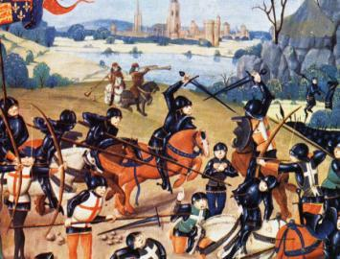
This was a bloody fight from beginning to end. The Frenchmen could hardly move on the muddy ground and were tremendously defeated by the English longbowmen. Henry V ordered to kill all captives as his army was too small to control the captives. This victory was a triumph over the Frenchmen as the new peace treaty of Troyes (1420) declared Henry VI (son of Henry V) as the king of both England and France.

