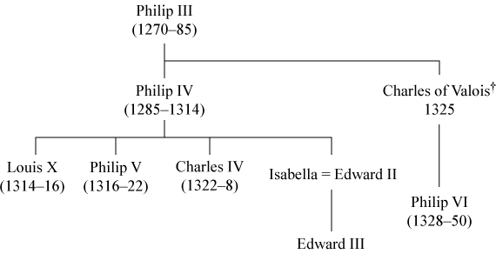
Charles IV died without any heir to the French throne. From now on a crisis over the French succession began as both France and England claimed to have the legitimate heir to the throne. The English king Edward III was Charles’ closest living male relative, and the only surviving male descendent of Philip IV. The English interpretation of the feudal law made Edward III the legitimate heir to the throne of France.
The French however believed in the Salic Law, which said that no royal blood can be passed through a female. Consequently they didn’t accept Edward III as a legitimate heir as his mother was the only link to the royal family. In the eyes of the French nobility Philip VI (grandson of Philip III) was the legitimate candidate. In 1928 Philip de Valois was crowned King of France.

