The Battle of Sluys (1340)

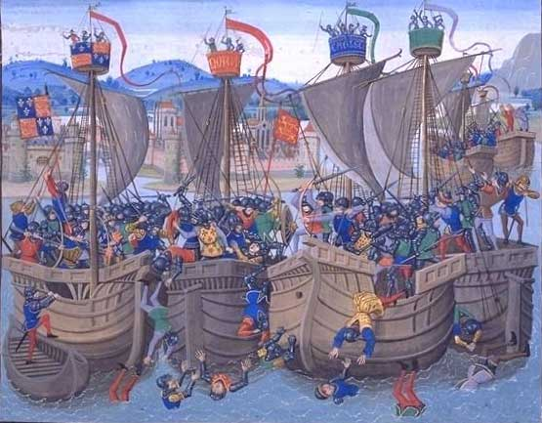
The naval Battle of Sluys was one of the opening conflicts of the Hundred Years’ War. This battle was very important for the English people as it brought the destruction of most of France’s fleet, consequently it was impossible for France to invade England.

